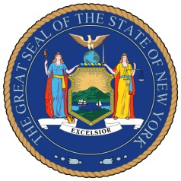
NEW YORK STATE SENATE
OFFICE OF SENATOR MICHAEL GIANARIS

For Immediate Release Contact: Anna Adams-Sarthou
October 13, 2011 718-728-0960
sarthou@nysenate.gov

SENATOR GIANARIS APPLAUDS INSTALLATION OF
FREE WI-FI IN ASTORIA PARK

Queens, NY – Senator Michael Gianaris is pleased to welcome the installation of free Wi-Fi in Astoria Park, one of five New York City park locations offering free wireless service, provided by AT&T and the City of New York. The addition of this new digital network will allow western Queens residents to enjoy the outdoors while browsing the Internet without extra charges to their cell phone or cable bills.

“We must continue to make it easier for New Yorkers to live their lives in a rapidly-changing world, and the expansion of Wi-Fi service to our public spaces is a great way to do just that,” Senator Gianaris said. “I am thrilled that western Queens residents are among the first to receive this service and look forward to its expansion throughout our city in coming months.”

The launch is part of a five-year digital initiative between AT&T and the city to provide free wireless service at 26 locations in 20 parks across all five boroughs. The service is free for all users and grants Internet access to park visitors’ laptops, smartphones, tablets and other electronic devices that have Wi-Fi capabilities.

The Astoria Park Wi-Fi service was launched on October 11. It is expected to expand to more locations in the coming months.

###

http://www.scribd.com/SenatorMikeGianaris

www.gianaris.nysenate.gov

