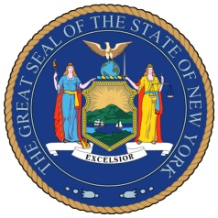

NEW YORK STATE SENATE

OFFICE OF SENATOR MICHAEL GIANARIS

For Immediate Release Contact: Anna Adams-Sarthou

October 14, 2011 718-728-0960

[sarthou@nysenate.gov](mailto:sarthou@nysenate.gov)

**STATEMENT FROM STATE SENATOR MICHAEL GIANARIS ON AGREEMENT TO REBUILD ST. NICHOLAS GREEK ORTHODOX CHURCH**

“For more than a decade, Greek-Americans have been without our place of worship in one of the most significant locations in this country. This long-awaited deal reminds the world of New York’s emphasis on religious freedom and the value of reconstruction as we continue to remember all we lost on September 11th. I look forward to celebrating the rebuilding of Saint Nicholas with my fellow Greek-Americans and all New Yorkers. I thank the Greek Orthodox Archdiocese of America, Governor Cuomo and the Port Authority for their hard work to bring about today’s agreement.”

*###*

[*http://www.scribd.com/SenatorMikeGianaris*](http://www.scribd.com/SenatorMikeGianaris)

[*www.gianaris.nysenate.gov*](http://www.gianaris.nysenate.gov)