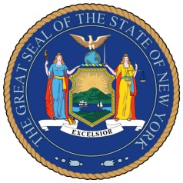
NEW YORK STATE SENATE
OFFICE OF SENATOR MICHAEL GIANARIS

For Immediate Release Contact: Anna Adams-Sarthou
October 28, 2011 718-728-0960
sarthou@nysenate.gov

SENATOR GIANARIS ENCOURAGES WESTERN QUEENS RESIDENTS TO APPLY FOR HOME HEATING ASSISTANCE PROGRAM

Queens, NY – As winter approaches, Senator Gianaris reminds western Queens residents of a federal program offering low income households assistance to pay their energy bills. The program, Low Income Home Energy Assistance Program (LIHEAP), particularly helps those households with the lowest incomes paying a high proportion of household income for energy.

“During these difficult economic times, energy costs are an increasing burden for all New Yorkers, particularly for those in need,” Senator Gianaris said. “Programs like LIHEAP are vital to many members of our community who struggle to keep warm during the cold winter months. I strongly encourage all who are eligible to see how this program can help their families.”

LIHEAP provides assistance in several ways, including making bill payments and helping with energy crises, weatherization and other energy-related home repairs. The program is particularly beneficial to the community’s seniors, young children and disabled who are at a higher risk of life-threatening diseases due to lack of sufficient heat in their homes.

For more information about LIHEAP, visit the New York State office website at http://liheap.ncat.org/profiles/NY.htm, and the federal website at http://www.acf.hhs.gov/programs/ocs/liheap/index.html. Interested applicants can also call the National Energy Assistance Referral (NEAR) project at 1-866-674-6327 Monday through Friday.

###

http://www.scribd.com/SenatorMikeGianaris

www.gianaris.nysenate.gov

