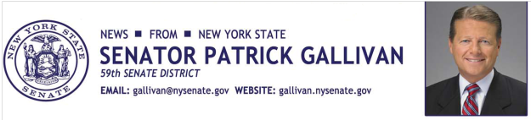

March 21, 2014

For Immediate Release

Contact: AJ Baynes

518.455.3471

SENATOR GALLIVAN ASKS FOR LOCAL NOMINATIONS FOR VETERANS HALL OF FAME

Annual Hall of Fame pays tribute to New Yorkers who served in the U.S. Armed Forces

Senator Patrick M. Gallivan (R,C,I – Elma) today invites local residents, from the 59th Senate District, to nominate for recognition colleagues, friends, and neighbors in the New York State Senate Veterans' Hall of Fame. This was created to honor and recognize outstanding veterans from the Empire State who have distinguished themselves both in military and civilian life.

Each and every year the New York State Senate pauses to acknowledge the sacrifice of these brave men and women from our area and throughout the state. A ceremony honoring these veterans will be held in Albany. The honoree from each senate district will have their photograph and biography displayed as part of a special exhibit of these outstanding veterans.

Past recipients from the 59th Senate District include Mark O’Brien of Marilla, Ted Wilkinson of Warsaw, and Marlene Roll of Alden.

“The New York State Senate Veterans Hall of Fame is just one small way to recognize these men and women who chose to wear the uniform and traveled half-way around the world to fight our enemies,” said Senator Gallivan. “Their meritorious service to our nation deserves special recognition, as a fitting expression of our gratitude and admiration.”
If you would like to nominate a veteran who lives in the 59th Senate District, which includes parts of Erie, Monroe, and Livingston Counties, and all of Wyoming County, please complete the attached form and email to Eileen Hopkins at Eileen@senatorgallivan.com or mail to 2721 Transit Road, Suite 116, Elma, NY 14059. Nominations must be received by April 14, 2014.
###
Photo Credit: New York State Senate

