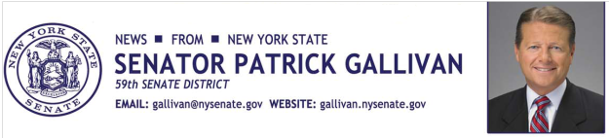

March 18, 2014

For Immediate Release

Contact: AJ Baynes

518.455.3471

SENATOR GALLIVAN INVITES NOMINATIONS FOR PRESTIGIOUS “WOMAN OF DISTINCTION” AWARD
Annual New York State Senate Program Honors Women’s Outstanding Contributions to the 59th Senate District
Senator Patrick M. Gallivan (R,C,I – Elma) today invites local residents from the 59th Senate District to nominate colleagues, friends, and neighbors whose exceptional work on behalf of their communities make them deserving of special recognition as a New York “Woman of Distinction” by the New York State Senate.
Every year, each of New York’s 63 state senators nominate one individual from their district as a “Contemporary Woman of Distinction” to be displayed alongside the many historical women whose contributions continue to impact and shape modern-day New York State. Some of these trailblazing females include: Susan B. Anthony, Lucille Ball, Harriet Tubman, and Emma Willard, among others, all with strong links to New York State.
A ceremony honoring the distinguished woman from each Senate District will be held in Albany. The honoree from each senate district will have their photograph and biography displayed as part of a special exhibit showcasing the contributions of exemplary New York women. Past recipients from the 59th Senate District include Janet Miller of Arcade, Kate Kingsley of Geneseo, and Karen O’Hara of Springville.
“Honoring and recognizing contemporary women displays the direct connection between New York State’s pioneering women of yesterday with their modern counterparts, whose contributions continue to enrich New York State’s quality of life. During my short tenure in the Senate, it has been a privilege to already honor three amazing and impressive women,” Gallivan said.
“I very much look forward to receiving the nominees of outstanding women who have made a significant difference to our community,” said Senator Gallivan. If you would like to nominate a woman who lives in the 59th Senate District, which includes parts of Erie, Monroe, and Livingston Counties, and all of Wyoming County, please send an email to Eileen Hopkins at Eileen@senatorgallivan.com. Nominations must include a brief biography of approximately 300 words detailing the reason your nominee should be selected as this year’s Woman of Distinction. Nominations must include the town or city of residence and phone number of the nominee. Those making nominations should also include their own name and contact information. Nominations must be received by March 31, 2014.
###
Photo Credit: New York State Senate

