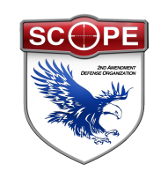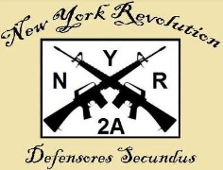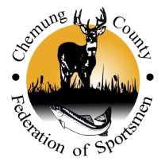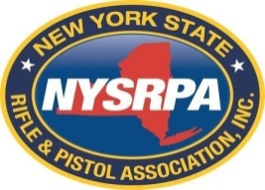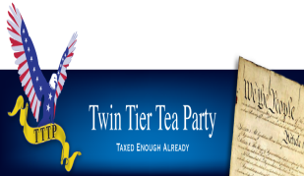
2nd Amendment Rally – Horseheads, NY
Hosted by the Chemung County Federation of Sportsmen
DATE: Saturday, March 8, 2014
TIME: 12:00 pm to 4:00 pm
PLACE: American Legion, 71 Old Ithaca Rd, Horseheads, NY
Dinner: 4:00 pm til sold out (Pulled Pork Dinner - $10.00)

Master of Ceremonies and Speaker:
Melody Burns, Conservative Talk Show Host, Albany, NY

Speakers:
George Curbelo, NY Revolution
Assemblyman Christopher Friend
Denver Jones, Team NY, “A Sea of Visual Protest”
Tom King, President, NYS Rifle and Pistol Association
Brad Lytle, Twin Tier Tea Party
Mike Mastrogiovanni, Second Vice President, SCOPE, Inc.
Sheriff Christopher Moss, Chemung County
Senator Thomas O’Mara
Carl P. Paladino, Businessman and Political Activist
Assemblyman Phillip Palmasano
Congressman Thomas Reed
Tom Santulli, Chemung County Executive
1SG Daniel J. Smith, US Army Retired
Rodney Strange, Chairman, Chemung County Republican Party
More Speakers to be Announced.
Come join the Rally.
Learn what these individuals and organizations are doing to fight for your rights.
Learn what you can do to help them fight for your rights.
REGISTER TO VOTE and VOTE.
Video for YouTube & Media By MERT

