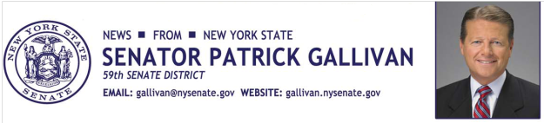

March 24, 2014

For Immediate Release

Contact: AJ Baynes

518.455.3471

SENATOR GALLIVAN SUPPORTS JOB OPPORTUNITIES FOR VETERANS

Gallivan sponsors new initiative to specifically help service-disabled veterans

Today the New York Senate has approved the “Service-Disabled Veteran-Owned Business Act” which will create a six percent state contract set-aside for service-connected disabled- veteran owned small businesses. This builds upon new tax credit legislation passed by the Senate last year to encourage employers across the State to provide job opportunities to New York’s courageous veterans.

“All Americans owe a debt of gratitude to the men and women who have worn the uniforms of the United States Armed Forces,” Senator Gallivan said. “Our Servicemen and women, and their families, never need to be reminded of the sacrifices they’ve made for our flag, for their fellow soldiers, and for the American people. This Service-Disabled Veteran-Owned Business Act will help New York’s service-disabled veterans pursue successful new business ventures.”

A three-way agreement on the bill was announced during the Governor’s Veterans and Military Families Summit held last week in Albany. Modeled after a highly successful federal initiative, New York’s new law will establish a new contract preference “set-aside” for service-disabled veterans.
According to the United States Department of Veterans Affairs, New York State is home to nearly 900,000 veterans, 600,000 of whom have served during periods of conflict. According to Governor Andrew Cuomo, there are roughly 106,000 service-connected disabled veterans in New York State.
These heroic individuals have sacrificed so much to serve our nation, and we owe them a debt of gratitude that can never truly be repaid.
This important new law will provide an enormous boost to our service-disabled veterans, opening the door to major new business opportunities. It will also help send a loud and clear message that when New York’s servicemen and women return home, they will be welcomed with the promise of economic opportunity.
###
Photo Credit: New York State Senate

