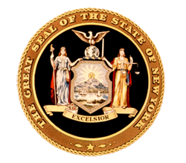
News from Senator
Toby Ann Stavisky

16th Senate District
Queens County

District Office • 144-36 Willets Point Boulevard, Flushing, New York 11357 • 718.445.0004
***FOR IMMEDIATE RELEASE***
Contact: Elizabeth Wu – Senator Stavisky’s office (718) 445-0004

Senator Stavisky Applauds Enactment of New Shark Fin Ban

Flushing, NY—Senator Toby Ann Stavisky (D-Flushing) applauded Governor Andrew M. Cuomo’s signing of legislation that makes the possession, sale or distribution of shark fin illegal in New York State.

Under current law, it is illegal to “fin” a shark, a catch-and-release tactic that usually results in the shark’s death from suffocation or blood loss. The new law also criminalizes possession and distribution and aims to remove New York State from international shark fin distribution chains.

“I thank the Governor for his support of this legislation which cracks down on this dangerous environmental practice. Sharks are a critical species to maintaining a vital ocean ecosystem and I am glad that New York State can join governments around the country and around the world to stand up against this extremely harmful practice,” said Sen. Stavisky.

Shark fin is the main ingredient in shark fin soup, a traditional Chinese delicacy sometimes served on special occasions. An informal poll of downtown Flushing restaurants performed by the Senator’s office turned up no restaurants with shark fin soup on their regular menu.

“I would also like to thank the patrons and owners of Chinese restaurants in Flushing for their part in stopping this practice and protecting shark populations around the world,” Sen. Stavisky concluded.

###

