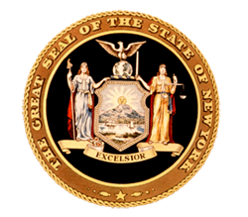
News from Senator
Toby Ann Stavisky

16th Senate District
Queens County

District Office • 142-29 37th Avenue, First Floor, Flushing, NY 11354 • 718.445.0004
***FOR IMMEDIATE RELEASE***
Contact: Elizabeth Wu – Senator Stavisky’s office (718) 445-0004

Stavisky Honors Gujarati Samaj of New York on their 40th Anniversary

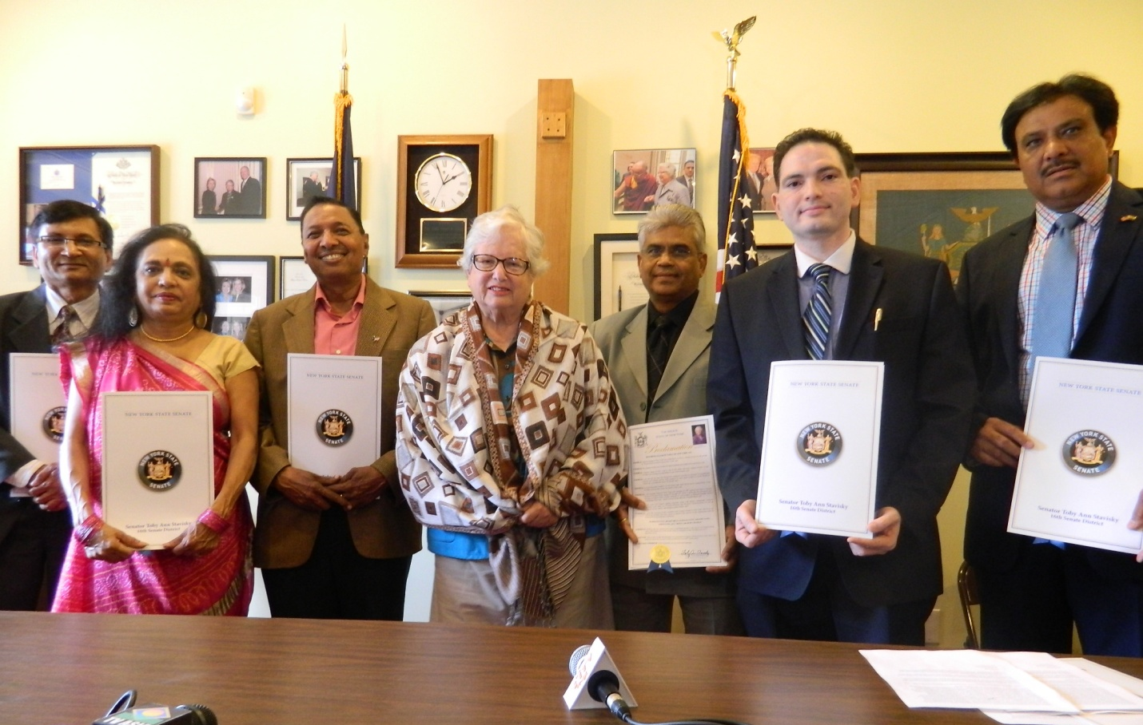
Senator Stavisky dons a ceremonial shawl as she presents the President and Board of Directors of the Gujarati Samaj of New York with proclamations celebrating their 40th anniversary and long tradition of service to the community. From left to right: Vice Chair Khandu Patel, Program Manager Bharati Desai, Chair of the Board of Trustees Raman Patel, Senator Stavisky, President Harshad Patel, Chairperson Dilip Chauhan and President of the Society of Indo American Engineers and Architects Mihir Patel.

Flushing, NY—Senator Toby Ann Stavisky (D-Flushing) honored the President and Board of Directors of the Gujarati Samaj of New York on their 40th anniversary for their nearly half century of service to the community. Since 1974, the Gujarati Samaj has been dedicated to preserving and celebrating the traditions, language culture of the State of Gujarat in India, famous as the home of Mahatma Gandhi and India’s current prime minister Narendra Modi.

The Samaj solidified their roots in the Queens community in 1985 when they opened a community center in Fresh Meadows, which has since been the meeting place for hundreds of community events such as religious festivals and community healthcare programs.

To commemorate the anniversary, Senator Stavisky presented a Senate proclamation to President Harshad Patel, Program Manager Bharati Desai, Chair of the Board of Trustees Raman Patel, Vice Chair Khandu Patel, President of the Society of Indo American Engineers and Architects Mihir Patel, Community Advocate Jitu Mehta and Chairperson Dilip Chauhan.

“I want to congratulate the Gujarati Samaj on their 40 years of devoted service to the community. The wonderful thing about living in Queens is your neighbors are often from distinct and diverse parts of the world. Community groups like the Gujarati Samaj are critical to preserving this diversity because they are a place where people who share the same language, culture and traditions can come together and celebrate their common history. I thank the Samaj for their longstanding dedication to preserving and fostering Gujarati culture here in Queens,” said Senator Stavisky.

On behalf of the Gujarati Samaj, Chairperson Dilip Chauhan said, “We are very proud and honored to receive this proclamation from Senator Stavisky. This honor is shared not only with the Gujarati people of New York State, but also the 55 million Gujarati people in India. This strong relationship between the Samaj and the Senator brings the borders of our two countries closerand together we strengthen business and social ties between the two regions, particularly in areas like IT, infrastructure, education and healthcare.”

###

