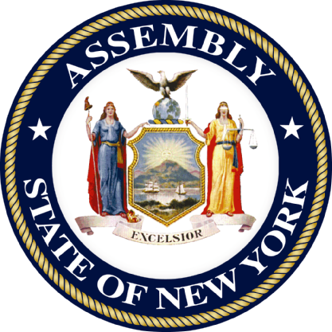
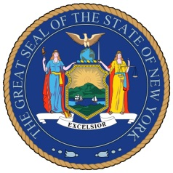

News Release: Contact:
August 15, 2011 Anna Adams-Sarthou, 718-728-0960
Loren Amor, 718-545-3889

GIANARIS-SIMOTAS BILL SIGNED BY GOVERNOR
New law protects law enforcement officials from “hidden dangers”

QUEENS, N.Y. – Senator Michael Gianaris and Assemblymember Aravella Simotas announced that Governor Cuomo has signed a bill they sponsored cracking down on criminals who attempt to impede felony investigations through the use or installation of explosive devices and other hazardous materials.

The law takes effect amid a nationwide surge in felons – specifically narco-traffickers – “booby-trapping” the transport and storage locations of illegal goods. This practice endangers law enforcement personnel seeking to prevent the spread of contraband in our communities.

Senator Gianaris said, “Now more than ever, our police need the full protection of the law as they conduct vital investigations necessary to ensure public safety. I am proud we were able to safeguard our law enforcement personnel with this new law."

Assemblymember Simotas said, “Our public safety is contingent on law enforcement officials being able to investigate criminal activity without the risk of being harmed by rigged devices intended to prevent them from discovering illegal products or activities. This law holds individuals who use these devices – and those who enable them – accountable and provides the men and women who serve and protect our communities with an added measure of security.”

The Gianaris-Simotas bill adds “obstruction of governmental duties by means of a bomb, destructive device, explosive, or hazardous substance” to the New York State penal law. The penalty for this new offense is a Class D felony.

###

