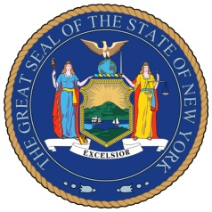
NEW YORK STATE SENATE
OFFICE OF SENATOR MICHAEL GIANARIS

For Immediate Release Contact: Anna Adams-Sarthou
August 16, 2011 718-728-0960
sarthou@nysenate.gov

SENATOR GIANARIS HERALDS NEW ETHICS LAW

Queens, NY – Senator Michael Gianaris applauded the passage of a new ethics reform law, the Public Integrity Act of 2011, which was signed into law by Governor Cuomo. Senator Gianaris voted in favor of the bill when it was brought to a vote in the Senate during this legislative session. The law increases transparency, establishes more stringent disclosure requirements, and creates a new, independent ethics panel to oversee elected officials.

“Despite Senate Democrats’ best efforts to pass a stronger set of ethics reforms this session, this new law is a good first step towards reforming Albany’s culture,” Senator Gianaris said. “We must continue to build on this success to enact more reforms, such as independent redistricting, that would increase accountability and improve government for the people of New York.”

Provisions of the Public Integrity Act of 2011 include:

- Increased financial disclosure from elected officials;
- Greater access to those appearing as a representatives before any state government body;
- Additional financial disclosures for registered lobbyists;
- Forfeiture of pensions for public officials convicted of a felony;
- Creation of the Joint Commission on Public Ethics, replacing the existing Commission on Public Integrity;
- New regulations issued by the state board of elections clarifying independent expenditures;
- Increased penalties for violations of filing requirements and contribution limits.

###

http://www.scribd.com/SenatorMikeGianaris

www.gianaris.nysenate.gov

