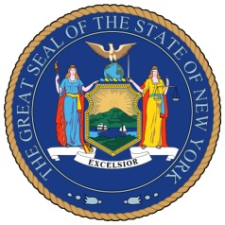
NEW YORK STATE SENATE
OFFICE OF SENATOR MICHAEL GIANARIS

For Immediate Release Contact: Anna Adams-Sarthou
August 26, 2011 718-728-0960
sarthou@nysenate.gov

SENATOR GIANARIS PRAISES JOB CREATION THROUGH
INCREASE IN FILM AND TV PRODUCTIONS

Queens, NY – Thousands of New Yorkers have been hired by the television and film industry, due to the New York State Film Production Credit championed by Senator Michael Gianaris. New York City is currently the production site for a record 23 television shows, including 8 new primetime series. New York City’s media and entertainment industry employs 100,000 New Yorkers and generates $5 billion per year for the city’s economy.

“The ability for this industry to film in New York and create so many jobs during these difficult economic times is a testament to the success of our film tax credit, which is the most prolific job creation program in recent years,” Senator Gianaris said. “Right now, there is nothing more important than creating jobs, and I am glad western Queens is able to reap the benefits of this booming industry.”

While in the State Assembly, Senator Gianaris was a lead supporter of legislation creating and later expanding the state film tax credit. New York State’s Film Production Tax Credit Program now is fully funded until 2014, which will result in the creation of thousands of jobs and generate $10.5 billion in direct spending in the state.

The mayor’s office announced that 23 television series and 140 news, talk and reality shows are being filmed in New York City for the 2011-2012 season. In addition, 4,000 local businesses support productions that shoot on location throughout the city.

Senator Gianaris’ western Queens district is home to three major production companies, Silvercup Studios, Kaufman Astoria Studios and Broadway Stages, which produce the bulk of New York City’s film and television projects.

###

http://www.scribd.com/SenatorMikeGianaris

www.gianaris.nysenate.gov

