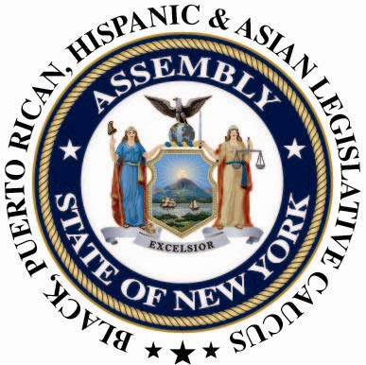

THE NEW YORK STATE BLACK, PUERTO RICAN, HISPANIC AND ASIAN LEGISLATIVE CAUCUS
CONTACT: | Nantasha Williams  (518) 455-5327  bphacaucuspress@gmail.com | For Immediate Release:  April 5, 2013

Caucus Statement on the Nomination of Sheila Abdus-Salaam to the Court of Appeals
Assemblyman Karim Camara, Chair of the New York State Black, Puerto Rican, Hispanic, and Asian Legislative Caucus issues a statement after Governor Andrew Cuomo nominated Sheila Abdus-Salaam to the Court of Appeals:
Albany, NY – "We applaud Governor Cuomo for nominating Sheila Abdus-Salaam. It is fitting that she will be the first Black woman to serve. Justice Abdus-Salaam has already showed her commitment to defending our legal system throughout her decades of service. We congratulate her on her nomination and history making achievement. We believe Ms. Abdus-Salaam is highly qualified and deserves a swift confirmation."

###

