

COMMUNITY BLOOD DRIVE
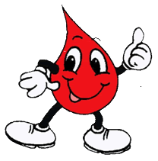
Every three seconds, someone needs blood. The demand for blood is greater than ever today and our community’s supply constantly needs replenishment. Your friends, neighbors, loved ones and even complete strangers need your help.

Give Blood …the “Gift of Life”

TUESDAY ~ OCTOBER 26

10:00A.M. - 2:00 P.M.

7408 5TH AVENUE

HOSTED BY:
NYS SENATOR MARTY GOLDEN

FOR MORE INFORMATION OR
TO SCHEDULE AN APPOINTMENT CALL:
718-238-6044

QUESTIONS ON DONOR ELIGIBILITY CALL 718-616-4460

ID REQUIRED REFRESHMENTS SERVED

