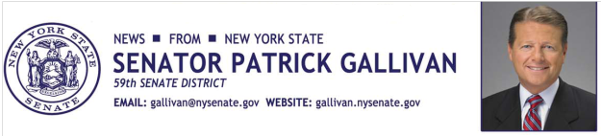

October 17, 2014
For Immediate Release
Contact: Jim Ranney
716.656.8544
716.256.9001

SENATOR GALLIVAN APPLAUDS NEW STATE LAW TO PROTECT YOUNG VICTIMS OF HUMAN TRAFFICKING

BUT MORE MUST BE DONE TO HOLD TRAFFICKERS RESPONSIBLE

Senator Patrick M. Gallivan (R-C-I, Elma) says a new state law will protect young victims of human trafficking by ensuring they receive the help and treatment they need. Gallivan supports the law (S.6804 & A.8749-A) signed this week by Governor Cuomo, but says a more comprehensive bill passed by the Senate should also become law.
“This new law is a great start when it comes to assisting the thousands of innocent victims of human trafficking, many of whom are young females. The courts will have the authority to ensure these victims have access to housing and community-based programs to help them escape these horrendous circumstances. Now it’s time to go even further in our efforts to end human trafficking in New York,” Gallivan said.
Gallivan is co-prime sponsor of legislation (S5879) called the “Trafficking Victims Protection and Justice Act” which would toughen existing laws and hold accountable sex and labor traffickers and others who organize, promote, support and patronize the trafficking industry. The measure would make sex trafficking a Class B violent felony and certain cases of labor trafficking a Class D violent felony. It would also make it a felony to patronize a minor for prostitution. The bill received unanimous support in the Senate in 2013 and 2014, but died in the Assembly.
“It is time to pass comprehensive legislation to crackdown on this despicable crime. We must do more to protect and assist the thousands of victims of human trafficking and go after those who are fueling the growth of this underground industry,” Gallivan said.
In addition to providing consistency within the Penal Law when dealing with human trafficking, the bill provides for increased awareness among law enforcement agencies to identify cases of human trafficking and available victim services.

Gallivan anticipates the legislation will be re-introduced in the legislative session that begins in January.

-30-

