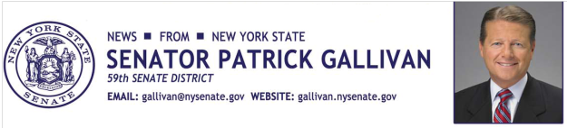
August 12, 2014
For Immediate Release
Contact: Jim Ranney
716.656.8544
716.256.9001

SENATOR GALLIVAN INTRODUCES LEGISLATION TO TOUGHEN PENALTY FOR THREATS OF VIOLENCE AGAINST A SCHOOL

BILL MAKES ALL THREATS OF MASS VIOLENCE A FELONY

Senator Patrick M. Gallivan (R-C-I, Elma) has introduced a bill in the Senate (S-7931) that would toughen the penalty for those who threaten mass violence against a school. The legislation amends the current law to include all threats, regardless of the method.

“Anyone who makes a violent threat against a school, its students or staff must be dealt with seriously and should be charged accordingly,” Gallivan said.

Under current law, an individual who makes a threat of fire, explosion or release of a hazardous substance on school grounds can be charged with a class D felony for falsely reporting an incident. But other types of threats are not treated the same under the Penal Law. For example, while making a bomb threat would be considered a felony; other threats against a school might be considered a misdemeanor. This bill would amend the law to make all threats of mass violence against a school a felony.

“The current law is inadequate and must be expanded. Any threat of violence against a school creates fear for students, faculty, staff and parents. It also disrupts the learning process, often forcing schools to go into lockdown or cancel activities, not to mention the enormous strain it puts on law enforcement. Individuals who cause such chaos should face the harshest penalty possible,” Gallivan said.

In the years since the original law was enacted, the nature and types of threats facing schools have changed, making it necessary to expand and strengthen the law.
The legislation, which has been introduced in the Assembly by Joseph Lentol (D-North Brooklyn), is endorsed by the New York State School Boards Association and the New York State Council of School Superintendents.
"School boards throughout New York State thank Senator Gallivan and Assembly Member Lentol for responding so rapidly to deter threats of any kind in our schools," said Timothy Kremer, executive director of the New York State School Boards Association. "No student can learn if he or she feels unsafe at school. We hope that by making threats against students a felony, this legislation will boost both school safety and student learning."
“This bill is important to assist school districts and law enforcement in keeping schools safe for students and faculty. This proposed legislation will help to fill a loophole not anticipated by the Legislature when the original law was passed. Most importantly, it will help to ensure anyone found guilty of making such a threat against a school never has the chance to carry it out,” said Dr. Robert Reidy, Executive Director of the New York State Council of School Superintendents.
The legislation is also supported by the Police Benevolent Association of the New York State Troopers, which represents more than 6,000 active and retired, uniformed members of the New York State Police.

-30-

