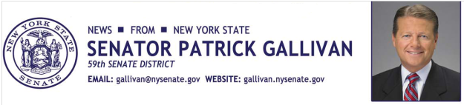

May 19, 2015
For Immediate Release
Contact: Jim Ranney
716.656.8544
716.256.9001

SENATOR GALLIVAN HONORS LOCAL VETERAN

HENRIETTA MAN IS NAMED TO THE NEW YORK STATE SENATE
VETERANS HALL OF FAME

Senator Patrick M. Gallivan (R-C-I, Elma) honored Western New York Veteran Franklin “Bob” Harder Jr. Tuesday during a ceremony at the State Capitol. The Henrietta resident has been named to the New York State Senate Veterans Hall of Fame.

Harder entered the United States Air Force in 1965 and trained as an aircraft electrician. He was deployed to Viet Nam and was stationed at Tuy Hoa, where he served for one year. During that time, Harder was awarded the National Defense Service Medal, Republic of Viet Nam Campaign Medal and the Air Force Good Conduct Medal. He continues to serve his country today by assisting veterans and their families.

“Bob proudly served his country in the Air Force and continues to honor veterans and their families through his work with the Patriot Guard Riders,” Gallivan said. “His dedication to the veterans of our community is worthy of recognition.”

Harder has provided comfort and assistance to local veterans and their families over the past several years as a member of the Patriot Guard Riders (PGR), who attend the funeral services of fallen American military personnel. Harder currently serves as a Captain of the Patriot Guard Riders, overseeing the group’s missions and performance at the funerals of veterans.

Harder is also active in the PGR’s Help on the Homefront program, which helps wounded veterans and families in need.

-30-

