New York’s Definitive Cyberbullying Census

June 2012
Key Facts and Findings
Students from 45 New York State Counties and over 350 schools participated in the First Ever New York Cyberbully Census
94.2% of students identified at least one form of cyberbullying when asked
47.8% of students know someone who has been cyberbullied
For students who do report cyberbullying, they are most comfortable talking to a parent
69.5 % of students think cyberbullying should be illegal
Only 1 in 5 New York Students actually reported their cyberbully incident

Introduction
In the fall of 2011, a young boy from Williamsville, New York took his life after what his parents claim was years of cyberbullying. In the winter of 2012, a young lady from Staten Island whose family says she was cyberbullied, jumped in front of a city bus and died. Approximately two weeks later, a father from Orange County took his life a year after his son killed himself due to cyberbullying. While many may suggest that cyberbullying was not the only motive for these suicides, in all of these cases cyberbullying or some form of electronic harassment appears to have played some part in these tragic situations. That is why in light of recent reports of cyberbullying in our communities and suicides attributed to cyberbullying, the Independent Democratic Conference (IDC) committed itself to finding out what was going on in the computers, phones and digital devices of our New York students. To do this, the IDC created the first ever cyberbullying census for New York, an anonymous tool to find out what was really occurring in our youth population. Close to 10,000 New York students participated from all parts of the state to give us the first comprehensive view of what students are dealing with in today's digital age.

Methodology
The Independent Democratic Conference embarked on an 8 month campaign to survey as many children from across New York State regarding their experiences with cyberbullying. The questions were simple—let us know about your experiences with cyberbullying and how you think adults should handle the issue. A press conference was held on October 13, 2011 to announce the launch of this 12 question survey. The survey was anonymous and administered through emails, paper copy and on the internet. Emails were sent to Superintendants around New York State asking them to tell their children about the survey. A three borough tour of Charter Schools was conducted where children were taught by Miss New York and Survey Creator and Cybercrime expert Parry Aftab about the survey. Select Parochial Schools sent home permission letters to have parents engage their students in the cyberbullying survey. The United Federation of Teachers sent emails out to all members urging them to remind their children to take the survey. A two minute commercial aired on local cable networks regarding the cyberbully survey. Letters were sent to Public School Principals with the permission of the NYC Department of Education asking them to inform their children of the cyberbully census.

About the Survey
The New York Cyberbully Census, which can be found at www.nycyberbullycensus.com, is a 12-question survey for school age children (Grades 3 to 12) in New York that is designed to gauge their attitudes and experiences with cyberbullying. The survey is anonymous, allowing students to answer questions honestly and without fear of embarrassment.
This data gathering initiative will – for the first time – provide a full picture on cyberbullying in New York. National figures show a high number of teens (43% according the National Crime Prevention Council) that have reported being the victims of cyberbullying, while cyberbullying related teen suicides – including the recent death of a 14-year-old Buffalo area youth – have been well documented.

Participation
Students were asked what school they attend for the sole purpose of keeping track of which schools participated in the census for recordkeeping only. However, a review of participants shows approximately 350 New York schools participated in the census. All schools- religious, private, public and charter—had at least one participant.
Out of 62 New York State Counties, 45 Counties participated in this state wide survey. In New York City all five boroughs participated with the Bronx having the most responses followed by Brooklyn, Queens, Manhattan and Staten Island. Students from 40 different counties in New York State outside of NYC also participated in the survey with Westchester, Erie, Fulton , Chenago, Sullivan and Nassau Counties having the highest response rates respectively.
The survey was administered to students from Grades 3 to 12. However, the highest participation came from middle school grades 6th, 7th and 8th. Of the students who took part in the census, 54.8% were female and 45.2% were male.

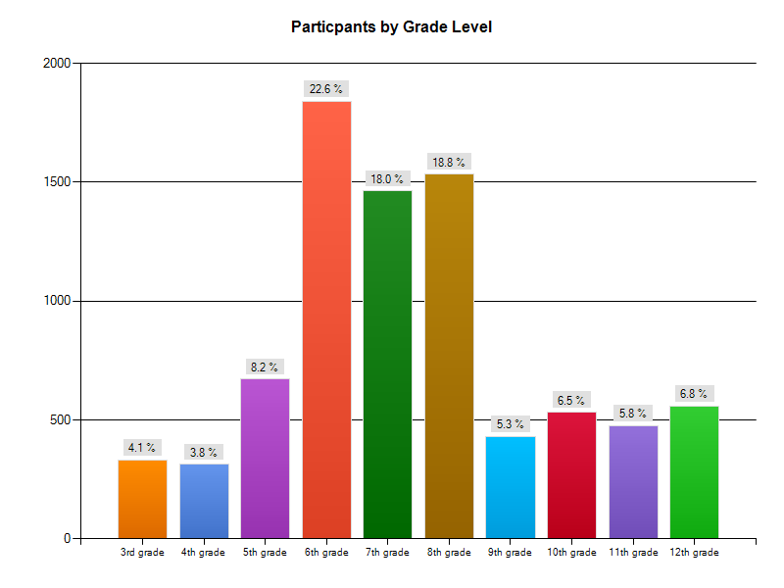

What is cyberbullying?
One of the unique factors of the New York Cyberbully Census was that it allowed children to define what cyberbullying means to them. Many surveys that have been conducted on this topic define cyberbullying first and then ask the participants if they have been a victim of cyberbullying. A generally accepted definition of cyberbullying is “electronic bullying through cell phone texting, email, instant messages, chat rooms or website postings of harmful words or photographs of an individual”.
In the New York Cyberbully Census, students were asked what cyberbullying is to them. Students were given 5 choices and could select all that apply. Out of all of the applicable responses students responded that cyberbullying is:
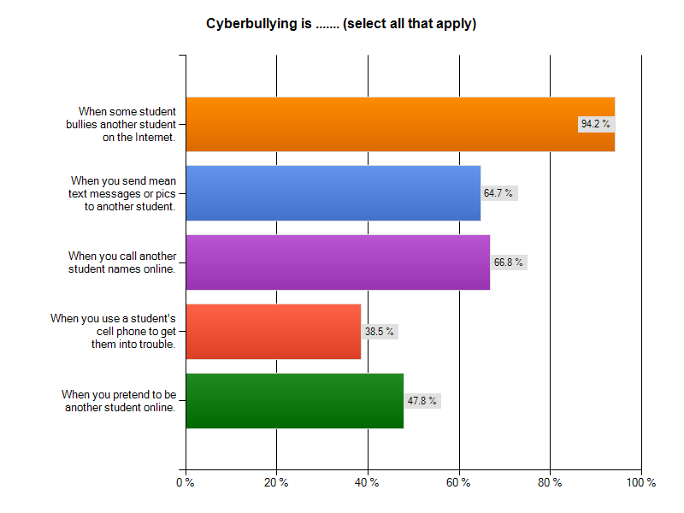
Based on these results, while most students identified with the most obvious definition of “bullying someone on the internet”, there is a 30 % drop to identifying cyberbullying as when you send mean text messages or pictures to another student, and an almost 40% drop to identifying cyberbullying as “when you pretend to be someone else online”. The lowest response rate was the students identifying using a student’s cell phone to get them in trouble as cyberbullying. Only 38% of the respondents recognized this to be cyberbullying.
These results show us that while educators and analysts might have a full concept of what cyberbullying is, it is not translating to our students. Students are possibly engaging in behavior that they think is totally acceptable since they don’t identify it as cyberbullying. Therefore, educators and parents alike must identify and discuss with their children all of the ways students can cyberbully another not only to prevent this type of harassment but to also ensure that our students don’t unwittingly engage in possibly criminal behavior with no forethought or knowledge.
Cyber bullying can take many forms. However, there are six forms that are the most common. Nancy Willard with the Center for Safe and Responsible Internet Use has developed a useable set of terms for the different forms that cyberbullying can take:

Harassment: Repeatedly sending offensive, rude, and insulting messages
Denigration: Distributing information about another that is derogatory and untrue through posting it on a Web page, sending it to others through email or instant messaging, or posting or sending digitally altered photos of someone

Flaming: Online "fighting" using electronic messages with angry, vulgar language
Impersonation: Breaking into an email or social networking account and using that person's online identity to send or post vicious or embarrassing material to/about others.
Outing and Trickery: Sharing someone's secrets or embarrassing information, or tricking someone into revealing secrets or embarrassing information and forwarding it to others
Cyber Stalking: Repeatedly sending messages that include threats of harm or are highly intimidating, or engaging in other online activities that make a person afraid for his or her safety (depending on the content of the message, it may be illegal).
More disturbingly was the response to a later question in which the survey asks students to check off statements that the students find apply to them. Almost 7% of the students surveyed identified to the response “I don’t know what cyberbullying is”. In this day and age and with the proliferation of the use of the internet, cell phones and text messaging, to have any student not be able to identify what cyberbullying is, shows a need for New York State to increase its efforts on educating our students regarding what cyberbullying is and how to identify it.

Who is being cyberbullied?
As members of the Independent Democratic Conference visited schools and talked to students, one dynamic always seemed to remain constant. When asked if anyone in the room had been cyberbullied, almost no one raised their hand. However, when asked if anyone knew anyone who was cyberbullied, more than half of the class raised their hand. These responses seemed to be reflected in the census as well, despite the anonymity of it. When asked if they had been cyberbullied, only 19.4 % of students said yes that they had been cyberbullied. However, when asked if they knew someone who was being cyberbullied 47.8 % of the students responded that they did know someone being bullied.

Who are our students talking to?
In order for any internet safety/cyberbully education awareness program to work with our students, they first must feel comfortable talking about the problem. If students don’t make us aware of what is going on, there is no way we can adequately deal with the problem at home or in the schools. When asked in the census, if you were cyberbullied did you report it to anyone, only 19.8% of students said that they did tell someone. That means only 1 in 5 New York Students actually reported their cyberbullying incident.
When students were asked to explain why they did not report it select answers ranged from:
“Because it makes it worse and people start to call you a snitch” (10th grade)
“I didn't report it because I was embarrassed” (11th Grade)
“Because they tell you not to tell” (3rd Grade)
“I didn't think there was much anyone could do” (8th Grade)
“I was scared and didn't know who to tell” (6th grade)
However, when reviewing the responses of those who did tell someone, we see that NY students are talking to adults whether it is at home or in the school. This is a surprising and encouraging result as it indicates that parents and educators are getting their message across that it is okay to tell an adult.

Who are NY Students reporting their Cyberbully Incidents To?
1. Mother | 6. Friends
2. Parents | 7. An Adult
3. Teacher | 8. Family Member
4. School | 9. Facebook
5. Police | 10. Dean/Counselor

Is cyberbullying a problem?
In order for students to want to engage in a solution, they first must think it is a problem. No piece of legislation or school program will be able to address the severity of this type of behavior if students don’t take the issue seriously. Therefore, the census asked students “How often do you think cyber bullying happens?”
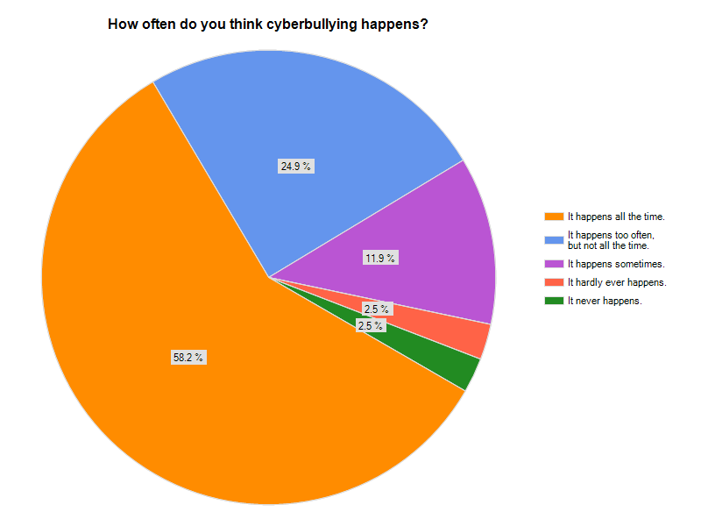
As the results show 58.2% of New York students feel that cyberbullying happens all the time while 24.9% of New York students think cyberbullying happens often. Later when asked in the census, only 7.5 % of New York students think cyberbullying is no big deal.
It is obvious from these responses that New York students recognize that there is a problem and are not oblivious to what is going on with regards to internet use and bullying. Their awareness is probably due to the fact that when asked 43.5% of New York students report that they have had cyberbully incidents in their schools.

Are you a cyberbully?
As noted earlier, it is important for students to know what cyberbullying is not only for the purpose of avoiding being victimized but also to make sure they are not engaging in any behavior which may be perceived to be bullying by someone else. When asked:

- 6.1 % of students reported that they have cyberbullied others

- 11.8 % of students reported that they had said nasty things online but don’t consider it cyberbullying

- 5.9% of students reported that they have cyberbullied someone with their friends just for fun

- 14.6% of students reported that they sent a joke to someone, but that person they sent it to thought it was cyberbullying

What can us as legislators and elected officials do to combat cyberbullying?
In the beginning when the Independent Democratic Conference along with Assemblyman Scarborough released the news of the first ever New York Cyberbully Census, the purpose behind it was clear---to ask the students of the State of New York what they would want to see included in a law dealing with cyberbullying. Approximately 70% percent of New York students feel that cyberbullying should be made illegal in the State of New York, while a close 63.7 % feel that a law should require schools to help students who were cyberbullied. The most interesting response was however that students wanted schools to teach their parents how to help their children with cyberbullying. Again this displays a comforting trend that New York students are willing to engage their parents in this issue and actually might welcome them into their conversations and experiences with cyberbullying.
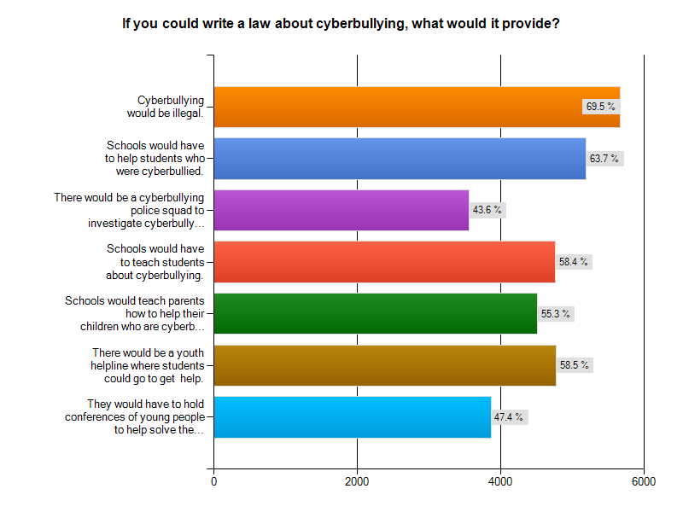
Currently before the New York State Senate and Assembly, there are two pieces of legislation that would addresses the main request of New York Students- that cyberbullying be illegal. Currently the Independent Democratic Conference has introduced Senate Bill 6132A/A.8978A, that if passed, would make cyberbullying a second degree aggravated harassment misdemeanor and a third degree stalking misdemeanor. By including cyberbullying into these two sections of the penal code, cyberbullying would also be eligible offenses under the New York State Hate Crimes Act for the first time.
Also Senator Mike Razenhofer, a Senate Republican from Western New York currently has legislation, Senate Bill 6614A/A.10176A, which would define cyberbullying as engaging in acts of abusive behavior over a period of time by communication sent by mechanical or electronic means and criminalizing such acts against any minor as a misdemeanor punishable by a fine and/or imprisonment.
The hope is that these pieces of legislation, if passed, will have a chilling effect on cyberbullying and reflect the beliefs of New York Students that cyberbullying is happening all the time and should be illegal.

What are your final thoughts on cyberbullying?
It is the final thoughts of the students of New York on cyberbullying that tells us the most and provides the most unfiltered view of what is going on in our schools, in our homes and the minds of the young people in the State of New York.
I would like grownups to know that cyberbullying could crush a kids dreams or hurt them forever. (4th grade)

I want them to know that we are struggling. ( 4th Grade)

It mentally and physically breaks down someone. some kids try to hide it and get away without out adults knowing. Cyberbullying, for me, makes me wanna throw all my electronics away, if its serious, and never be seen in public. Its embarrassing and tiring... I know someone who cuts them self and the parents don’t even know about it. I think that parents need to be there for the child more often if the child is acting unusual. Its very sad. (8th grade)

I want them to know not every child has no problems and cyberbullying is a big issue and it hurts more than you think. ( 6th Grade)

Your child may seem alright but pay attention to little things such as self consciousness. You never know when your child may be lying to you. Check their page once in a while because your child may be hurt inside. These days, kids are mean, you have to have good hair, nice body, perfect teeth, nice boyfriend. These are hard expectations and it can be depressing. (7th Grade)

I want them to know that the punishment does not fit the crime. Giving a student detention does nothing but get them more mad. They in turn tell their friend and now they turn against you. You are left out of groups and feel very isolated. This is where thoughts of killing themselves comes into play. You feel no one understands and you feel very alone. Between oovoo, Facebook, texting, formspring and twitter you are an outcast in minutes. It is very lonely. (5th Grade)
Further Analysis of Data by Gender and Age

Gender Differences
There were some significant differences in responses when the data is broken down by gender.

Girls were twice as likely to report having being cyberbullied than boys and were more likely to have reported the incident than boys as well. The percentage of boys and girls who were unsure if they had been cyberbullied was basically the same.

Across the board in question five girls were more likely to define behaviors as aspects of cyberbullying than boys were. This was most significant with regards to calling people names online, impersonating others, and sending mean texts or pictures from a cell phone. Girls were also much more likely to report that cyberbullying is happening all the time.

Responses to Question 10 confirm that girls report more cyberbullying than boys.

Boys were more likely than girls to say they did not know what cyberbullying meant and to say that it’s not a big deal. Similar numbers of boys and girls admitted to cyberbullying people themselves or saying mean things about someone else online which they did not consider cyberbullying.

Q11. If you could write a law about cyberbullying, what would it provide? | Boys | Girls
Cyberbullying would be illegal. | 66.30% | 72.00%
Schools would have to help students who were cyberbullied. | 57.80% | 68.50%
There would be a cyberbullying police squad to investigate cyberbullying. | 41.20% | 45.60%
Schools would have to teach students about cyberbullying. | 51.10% | 64.30%
Schools would teach parents how to help their children who are cyberbullied. | 48.40% | 60.90%
There would be a youth helpline where students could go to get help. | 50.00% | 65.60%
They would have to hold conferences of young people to help solve the problem. | 40.40% | 53.10%

Across the board, girls were more likely than boys to say that some action needs to be taken to combat cyberbullying, often by significant margins.

Age Differences

For the purposes of this section, kids from the 3rd and 4th Grade are classified as being in primary school, those in grades 5th through 8th in middle school and those in grades 9th through 12th in high school.

As kids aged, more of them reported being cyberbullied. Middle school kids were the most likely to report being unsure if they had been cyberbullied.

Q5. Cyberbullying is: | Primary School | Middle School | High School
When some student bullies another student on the Internet. | 87.30% | 94.50% | 95.70%
When you send mean text messages or pictures to another student. | 52.50% | 64.00% | 70.40%
When you call another student names online. | 56.10% | 66.00% | 72.40%
When you use a student's cell phone to get them into trouble. | 25.80% | 37.30% | 45.80%
When you pretend to be another student online. | 31.80% | 45.70% | 58.90%

As kids got older they were also much more likely to define certain behaviors as cyberbullying.

Even though as kids aged they were more likely to report having been cyberbullied and they label more behaviors as forms of cyberbullying, they were also far less likely to report these incidents to anyone, according to the survey. Only 14% of high school kids said they reported having been the victim of cyberbullying, while slightly more than a fifth of primary and middle school students who were cyberbullied said they reported the incidents.

Primary School kids reported that cyberbullying in their schools was rare, yet a significant portion also reported their friends being cyberbullied. As the age went up, the percentages reporting incidents of cyberbullying in their school or to their friends also increased. Older kids reported others having said mean things about them online that they ignored at much higher rates than younger kids.

Significant differences could also be seen in the attitudes of kids towards behavior that can be considered cyberbullying as they aged.

Older kids were both more likely to know what cyberbullying was and to declare it no big deal. They were also more likely to report having cyberbullied others as they aged, though high school and middle school kids reported sending jokes to others that were considered cyberbullying at similar rates.

Q11. If you could write a law about cyberbullying, what would it provide? | Primary School | Middle School | High School
Cyberbullying would be illegal. | 71.70% | 73.30% | 58.20%
Schools would have to help students who were cyberbullied. | 49.40% | 64.50% | 66.00%
There would be a cyberbullying police squad to investigate cyberbullying. | 36.50% | 45.50% | 40.90%
Schools would have to teach students about cyberbullying. | 44.40% | 59.10% | 60.80%
Schools would teach parents how to help their children who are cyberbullied. | 43.30% | 56.00% | 57.10%
There would be a youth helpline where students could go to get help. | 40.10% | 57.70% | 66.80%
They would have to hold conferences of young people to help solve the problem. | 31.70% | 47.40% | 52.30%

Older kids were far less likely to call for cyberbullying to be made illegal but overall thought that schools should be more proactive in teaching kids about cyberbullying.

Student Cyberbullying Survey

Students:

Thank you for taking this short survey. The results will provide valuable information about cyberbullying and NY students. We will not disclose your identity to your school or parents, so you should be as honest as possible in your responses. Taking this survey is voluntary.
We appreciate your time and help.
thank you.

Thank you.

1. What school do you attend?

2. Where do you live? (circle one)

- Manhattan
- The Bronx
- Brooklyn
- Queens
- Staten Island
- New York State (but not NY City)
- Another state (not NY)
- Outside of the USA

If you live in NY State, what county do you live in?

3. What is your grade?

- 3rd grade
- 4th grade
- 5th grade
- 6th grade
- 7th grade
- 8th grade
- 9th grade
- 10th grade
- 11th grade
- 12th grade

4. What's your gender?

- Male
- Female

5. Cyberbullying is … (select all that apply)

- When some student bullies another student on the Internet.
- When you send mean text messages or pics to another student.
- When you call another student names online.
- When you use a student's cell phone to get them into trouble.
- When you pretend to be another student online.

What else is cyberbullying? (please specify)

6. Have you ever been cyberbullied?

- Yes
- No
- Not sure

Please describe what happened, if you have been cyberbullied

7. If you have been cyberbullied, did you report it to anyone?

- Yes
- No

If you reported it, to whom did you report it?

8. If you didn't report it, and were cyberbullied, why didn't you report it? (If this doesn't apply, type "DNA")

9. How often do you think cyberbullying happens?

- It happens all the time.
- It happens too often, but not all the time.
- It happens sometimes.
- It hardly ever happens.
- It never happens.
- I don't know what cyberbullying is.

10. Please select all of the answers that apply to you.

- Cyberbullying is no big deal.
- Friends of mine have been cyberbullied.
- We've had cyberbullying incidents in my school.
- I have cyberbullied others.
- I have said nasty things to others online, but don't consider it cyberbullying.
- I have been cyberbullied by a close friend.
- I have had someone steal my password/cell phone and pretend to be me.
- I sent a joke to someone, but they thought it was cyberbullying.
- I've cyberbullied someone with my friends just for fun
- Others have said mean things to or about me
- online, but I don't consider it cyberbullying.

Share your thoughts about cyberbullying

11. If you could write a law about cyberbullying, what would it provide? (select all that apply.)

- Cyberbullying would be illegal.
- Schools would have to help students who were cyberbullied.
- There would be a cyberbullying police squad to investigate cyberbullying.
- Schools would have to teach students about cyberbullying.
- Schools would teach parents how to help their children who are cyberbullied.
- There would be a youth helpline where students could go to get help.
- They would have to hold conferences of young people to help solve the problem.

What else would you want a law to do?

12. What do you want grown-ups to know about cyberbullying that they don't
know? We welcome your ideas!

Kowalski, R.M., Limber, S.P.., & Agatston, P.W. ( 2008) Cyber bullying : Bullying in the digital age. Malden , MA; Blackqwell. , page 1.

