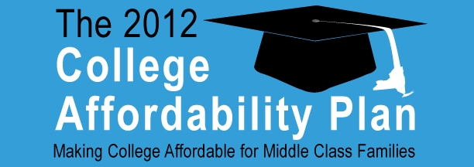
The Senate Majority wants to ensure that rapidly escalating tuition costs don’t place the dreams of an outstanding higher education out-of-reach for hardworking, middle class families across our State. We also want to ensure that New York’s young graduates can better manage their finances when they leave college and begin their careers.
That’s why we are advancing a new 2012 College Affordability Plan that will achieve the following objectives:
- Lowering the cost of a higher education for middle class families and students;
- Encouraging young New Yorkers to stay and begin their careers here at home in the Empire State; and
- Reducing overall higher education expenditures by encouraging students to graduate in a timely fashion.
Doubling Tax Credits & Deductions, New “Stay-In-New-York” Credit: The plan would immediately double the size of existing tuition tax credits and deductions to keep pace with the rising cost of higher education. It also advances a new plan to encourage young graduates to stay and work in New York State upon graduation:
- The current tax deduction would increase from $10,000 to $20,000.
- The maximum tax credit would increase from $400 to $800.
- A new “Stay-In-New-York” tax credit would provide additional relief of up to $12,000 over 4 years (up to $3,000 per year) for individuals who: graduate from a New York college or university in 4 years or less; meet a community service requirement; and who stay and work in New York State for at least 4 years after graduation. (When combined with existing credits, this means graduates would be eligible for up to $15,200 in total tax relief.)
- Prospectively, the plan would also peg these credits and deductions to the Higher Education Price Index (HEPI), to ensure that these tax benefits are not lost due to inflationary pressures.
Cutting Interest Rates in Half: The plan establishes a new $100 million Linked Deposit Student Loan Program that would make new low interest loans available to middle class families. Financed through a new public-private partnership between lending institutions and the State’s Short Term Investment Pool (STIP), the program would provide loans of up to $7,500 at rates 2 to 3 percentage points below the typical rates offered by a bank -- reducing interest rates by up to 50%.
Allowing Tuition Pre-Payment: The plan would help parents save thousands of dollars in future tuition costs by enabling them to pre-pay for their children’s college education.
Empowering Consumers – Truth in Lending: The plan would help parents and students navigate the often confusing world of student loans and higher education financing, so that they can find the best, most affordable way to finance a college education. It would:
- Designate the newly-created Department of Financial Services as an official “Truth-In-Lending” clearinghouse for information related to college affordability. It would require the department (which already has extensive interaction with financial institutions) to establish an on-line “one-stop-shop” for consumers to obtain easy-to-use, reliable information on college loans and interest rates.
- It would also require colleges and universities to provide additional financial information to parents and prospective students, including clearly outlined, easy-to-understand explanations of the debt burden a family (or graduate) would face depending on the loan they secure. (Amount of monthly payments, interest rates, and total dollar amount of interest to be paid, etc.)
###

