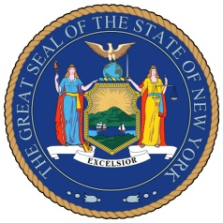
NEW YORK STATE SENATE
OFFICE OF SENATOR MICHAEL GIANARIS

For Immediate Release Contact: Anna Adams-Sarthou
January 18, 2012 718-728-0960
sarthou@nysenate.gov

STATEMENT FROM SENATOR MICHAEL GIANARIS PRAISING SLA DENIAL OF LIC STRIP CLUB APPLICATION

“I am thrilled the State Liquor Authority stood with the Long Island City community today when it voted against the Gypsy Rose liquor license application. This neighborhood is no place for a sex-based business, and today’s vote brings us one step closer to ensuring the wholesome, family-friendly environment in which an increasing number of people live and work. It is clear the SLA takes community input to heart and I commend the board for today’s decision.”

###

http://www.scribd.com/SenatorMikeGianaris

www.gianaris.nysenate.gov

