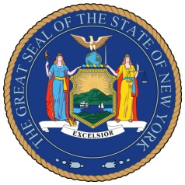

For Immediate Release: March 1, 2013
Contact: Jacob Tugendrajch│(718) 728-0960│(917) 544-1479│jtugend16@gmail.com

Senator Michael Gianaris Joins Long Island City Community and Business Leaders at LIC Partnership Elected Officials Breakfast

(Long Island City, NY) Senator Michael Gianaris this morning joined a crowded room of Long Island City small business owners, entrepreneurs, and community leaders at the LIC Partnership Elected Officials Breakfast in Long Island City. Senator Gianaris provided attendees with an update on legislative happenings in Albany and spoke about the particular laws and developments that help make Long Island City the vibrant, expanding neighborhood it is today.

“The collection of business leaders here today is a demonstration of the continuing economic vitality of New York’s most exciting up and coming neighborhood”, said Senator Gianaris.

“Long Island City is experiencing an economic boom due to legislative successes like the New York State Film Production Credit, which has been the most successful economic development initiative in the last decade. With the coming development of the Cornell-Technion campus and Hunter’s Point South, we need to continue to advocate responsible development policies that will keep our neighborhoods on the path of robust economic growth and maintain the character of the community.”

Background:

Senator Michael Gianaris has been a champion of New York’s film tax credit since its inception in 2004. Since then the New York State Film Production Credit program has attracted 665 film and television projects, generating $10.1 billion in economic activity for New York State. In 2011 alone, the film industry generated $6.9 billion in economic activity across the state and brought 30,000 new jobs to New York City. Governor Cuomo recently proposed an extension of the tax credit and Senator Gianaris will do everything he can to make sure this legislation passes.

# # #

