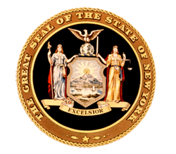
News from Senator
Toby Ann Stavisky

16th Senate District
Queens County

District Office • 142-29 37th Avenue, First Floor, Flushing, NY 11354 • 718.445.0004
***FOR IMMEDIATE RELEASE***
June 18, 2014
Contact: Elizabeth Wu – Senator Stavisky’s office (718) 445-0004

Senator Stavisky Statement on Homeless Shelter at Pan Am Hotel

Elmhurst, NY—Senator Toby Ann Stavisky (D-Eastern Queens) who is in Albany for the last week of the legislative session, gave this statement on the situation at the Pan Am Hotel:

"As of today, the Department of Homeless Services has provided no information to my office regarding the use of the Pan Am hotel as a homeless shelter. This lack of transparency is very troubling for local residents who were caught completely off guard by DHS’ relocation of homeless families to the hotel. The lack of information from DHS is doing a great disservice both to the community and the Pan Am's potential new residents. Nearly 1,000 community members rallied for more transparency and more answers last night. The residents of Elmhurst deserve answers and they deserve them now."

###

