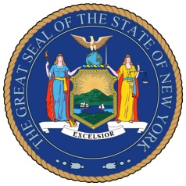
NEW YORK STATE SENATE
OFFICE OF SENATOR MICHAEL GIANARIS

For Immediate Release Contact: Anna Adams-Sarthou
November 7, 2011 718-728-0960
sarthou@nysenate.gov

SENATOR GIANARIS INVITES YOUNG STUDENTS TO PARTICIPATE IN THANKSGIVING CREATIVE CELEBRATION

Queens, NY – Senator Michael Gianaris is sponsoring the New York State Senate Thanksgiving Day Creative Celebration for western Queens elementary schools as part of this year’s holiday. Eligible students are invited to submit a piece of artwork, poem or one-page essay expressing why they are thankful on this Thanksgiving. The program is called “What Are You Thankful For?”and is offered to students in kindergarten through 6th grade.

“As Thanksgiving approaches, I encourage all our elementary school students to participate in this fun, reflective program,” Senator Gianaris said. “The program gives students the opportunity to be creative and convey thanks for their family, friends and community. I look forward to seeing all of the imaginative submissions.”

Senator Gianaris will reward each participant with a Senate certificate. All submissions will be included in the State Senate Thanksgiving Day Showcase, an online, free-to-publish booklet on the Senate’s website.

Entries are due by November 28. Thanksgiving this year is on Thursday, November 24.

###

http://www.scribd.com/SenatorMikeGianaris

www.gianaris.nysenate.gov

