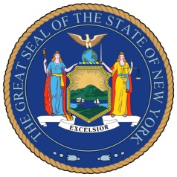
NEW YORK STATE SENATE
OFFICE OF SENATOR MICHAEL GIANARIS

For Immediate Release Contact: Anna Adams-Sarthou
November 11, 2011 718-728-0960
sarthou@nysenate.gov

STATEMENT FROM SENATOR MICHAEL GIANARIS HONORING
SERVICEMEN AND WOMEN THIS VETERANS’ DAY

Queens, NY – “Today, we honor all of the brave individuals who put our nation’s safety before their own lives. Our veterans deserve thanks every single day for their love of this country and their sense of responsibility to protect us from danger. I salute New York’s veterans as well as veterans across the country for their dedication to ensuring our safety from those who wish to do us harm. Their service is admirable.”

Senator Gianaris continues to accept nominations for the New York State Senate Veterans’ Hall of Fame. Nominations can be made to gianaris@nysenate.gov or by calling Senator Gianaris’ district office at 718-728-0960. Inductees will be announced early next year.

###

http://www.scribd.com/SenatorMikeGianaris

www.gianaris.nysenate.gov

