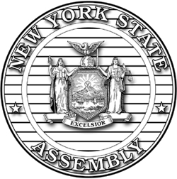
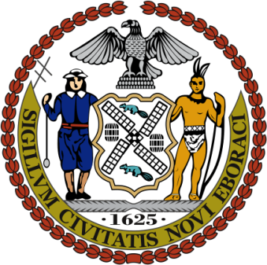
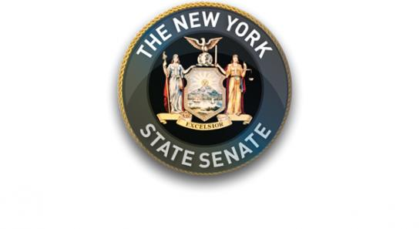

FOR IMMEDIATE RELEASE
Contact: Elizabeth Wu, Senator Stavisky’s office, (718) 445-0004
Cylas Martell-Crawford, Assemblyman Simanowitz’s office, (718) 969-1508
Stacey Eliuk, Council Member Lancman’s office, (718) 217-4969

Appalling Disrepair at Pomonok Houses after Maintenance Staff Slashed by Three-Quarters
Legislators Demand More Personnel and Resources

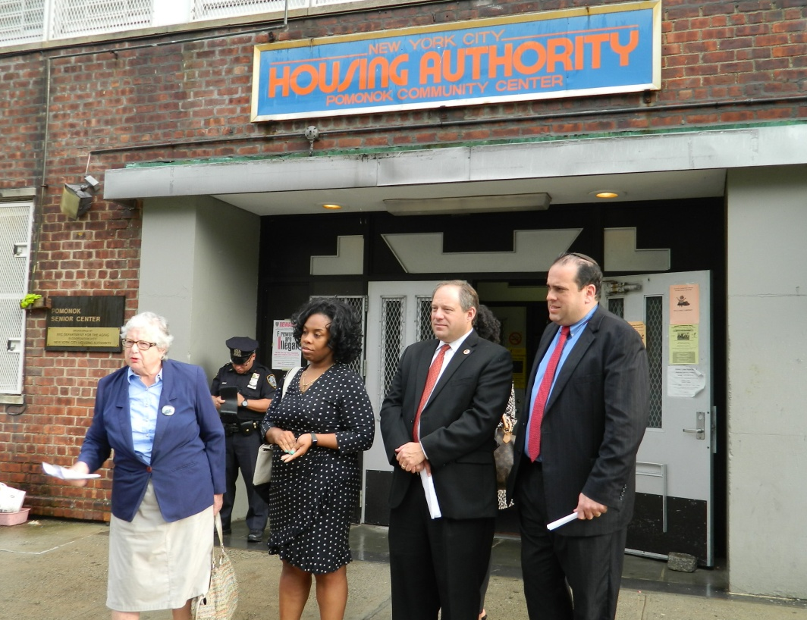
Senator Toby Ann Stavisky, Pomonok Residents Association President Monica Corbett, Council Member Rory Lancman and Assemblyman Michael Simanowitz call on NYCHA to give Pomonok Houses adequate funding and personnel.

Flushing, NY—Senator Toby Ann Stavisky (D-Flushing), Assemblyman Michael Simanowitz (D-Pomonok, Electchester), Council Member Rory Lancman (D-Fresh Meadows) and President of the Pomonok Residents Association Monica Corbett demanded more personnel and resources to respond to the increasing disrepair and decay at Pomonok Houses.

According to Corbett, the 52-acre complex was once staffed by 45 caretakers who were responsible for sweeping and mopping common areas, removing trash and maintaining the surrounding grounds. Seasonal workers were also hired for outdoor upkeep such as mowing lawns and plowing the snow.

Only 12 full-time staff remain, who, Corbett says, are constantly overwhelmed by the high volume of work. The seasonal worker program has been halted and other glaring personnel shortfalls, such as having only one small team of electricians to service all NYCHA facilities in Queens and Staten Island, have frustrated residents and resulted in deplorable living conditions.

“Nearly every day my office gets a call from a Pomonok resident who is upset and frustrated by the deteriorating living conditions and NYCHA’s extremely slow responses. Enough is enough. The residents of Pomonok deserve a complex that is clean, well-maintained and safe and I call on NYCHA to deliver that,” said Senator Stavisky.

“Staff reductions at Pomonok are yet another example of residents bearing the brunt of NYCHA's failing management. Instead of forcing tenants and the surrounding community to suffer from the unseemly conditions of unkempt grounds, NYCHA needs to step up and maintain its facilities,” said Council Member Lancman.

“Pomonok Houses like all NYCHA developments are unique and special. Our residents and frontline staff deserve better. NYCHA needs to stop treating the core NYCHA stakeholders (residents and frontline staff) as second class citizens. We are what make the fabric of NYCHA,” said Monica Corbett, President of the Pomonok Residents Association.

###

