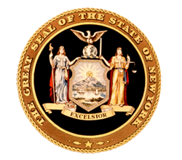
News from Senator
Toby Ann Stavisky

16th Senate District
Queens County

District Office • 142-29 37th Avenue, First Floor, Flushing, NY 11354 • 718.445.0004
***FOR IMMEDIATE RELEASE***
Contact: Elizabeth Wu – Senator Stavisky’s office (718) 445-0004

Stavisky, Mets Honor WWII Veteran Leonard Merer on his 90th Birthday

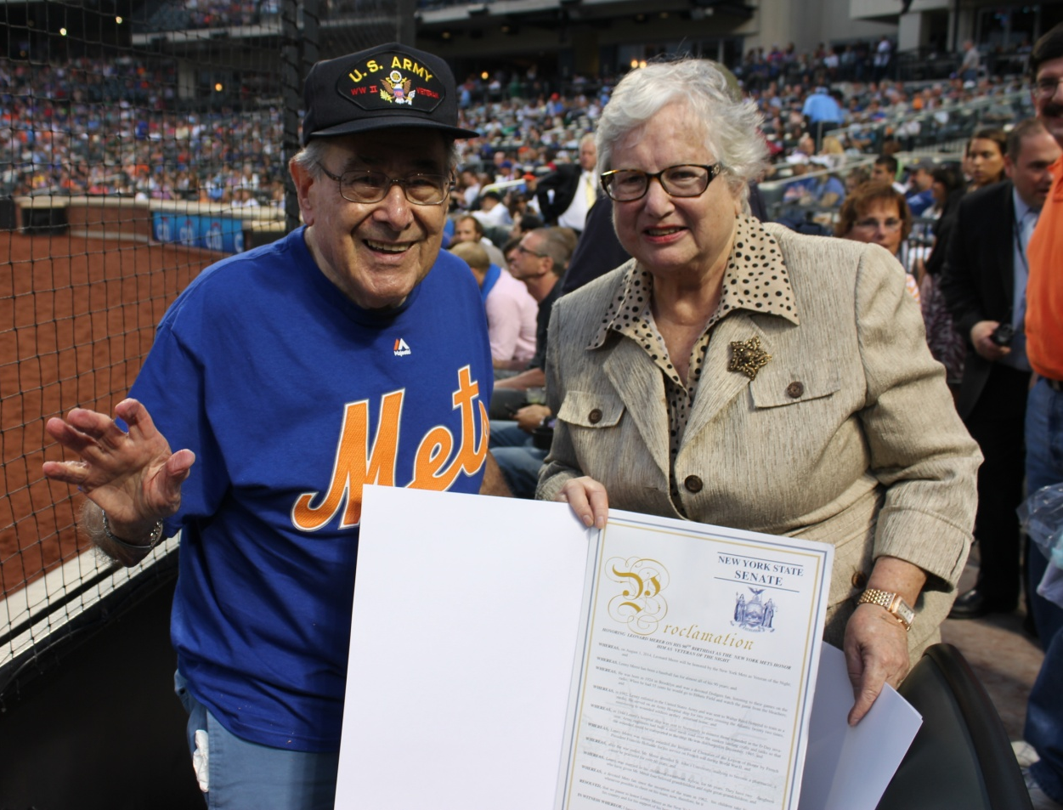

Flushing, NY—Senator Toby Ann Stavisky (D-Flushing) presents an official Senate proclamation to World War II veteran and devoted Mets fan Lenny Merer on Friday night to commemorate his 90th birthday and his selection as the Mets’ Veteran of the Night.

Merer served as a medic in WWII and tended to the wounded in Normandy after the D-Day invasion. He was recently awarded the Insignia of Chevalier of the Legion of Honor by French President Francois Hollande for his service on French soil.
###

