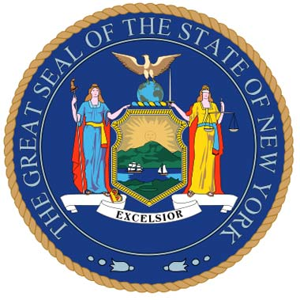

For Immediate Release: September 20, 2011
Contact: Adam D. Kramer, 518-441-5183 (Tedisco)
Peter Edman, 518-455-2181 (Farley)

TEDISCO, FARLEY INTRODUCE NEW BILL TO HELP FLOOD VICTIMS REBUILD HOMES, BUSINESSES
Legislation expands on Governor’s appliance replacement grant program by eliminating state sales tax for moving expenses, purchase of appliances,
clothing and construction materials related to flooding

Assemblyman Jim Tedisco (R,C,I-Schenectady-Saratoga) and Senator Hugh Farley (R,C,I-Niskayuna) today are introducing new legislation that would eliminate state sales tax on essentials for victims of Tropical Storms Irene and Lee.

The sales tax credits are for moving expenses (renting a truck, placing belongings in storage) and for replacing sump pumps, furnaces, refrigerators, washers, dryers, dehumidifiers, boilers, furniture, construction materials and clothing. Governor Cuomo recently announced that NYSERDA will be offering rebates for replacement of some household appliances.

“I’ve talked with many people who have had their homes and businesses torn apart by these devastating storms. My office has been directly impacted by these disasters as one of my staff members lost their home and was forced to move because of flooding,” said Tedisco, former Minority Leader and current Assistant Minority Whip. “The state stands to earn a windfall in sales tax revenue from all the thousands of New Yorkers who must rebuild their lives. This is money that was not anticipated and would never have been part of the state coffers, therefore the state should not profit off the backs of the victims of these disasters.”

“These storms have placed a severe burden on many families and businesses,” said Senator Hugh T. Farley. “The State needs to assist these persons and their communities as they seek to recover and rebuild from this devastating natural disaster. This legislation will provide some needed relief to help these families and businesses move forward.”

Eligible recipients must reside in or own a business in any New York county declared a federal disaster area and must show proof that they are a flood victim by being certified by an insurer or government official. This bill establishes a tax credit that will be applicable to individuals’ or business’ 2011 and 2012 income taxes.

A copy of the legislation and bill memo are attached.

###

