June 22, 2009
Dear Constituents:
I would like to provide you with an update on the situation in Albany:
- Earlier today, Governor Paterson called for a special session of the Senate. Although we would have had an uninterrupted legislative session were it not for the ill-advised series of events two weeks ago, we embrace the Governor’s call for a special session and support his choice of Justice Lippman to act as Presiding Officer. We also appreciate the willingness of former Lt. Governor Stan Lundine and former State Senator John Dunne to aid in negotiations.

- If all our colleagues would simply come to the table and negotiate in good faith, we would have the opportunity to resolve the quagmire they created. (Prior to the judicial ruling last week, we proposed fair, reasonable, and bi-partisan solutions that would have allowed us to get back to enacting the legislation critical to the well-being of millions of New Yorkers. All our proposals were rejected summarily because they did not surrender full control of the Senate.)

- With numerous bills for school funding, local government operation, and law enforcement awaiting action, we must put partisanship aside and work together to serve the best interests of the people of New York.

Yours truly,

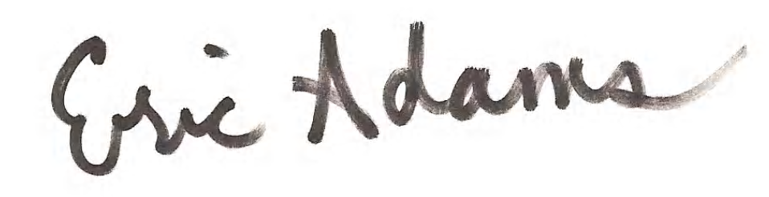

Eric Adams
NYS Senator
District #20

