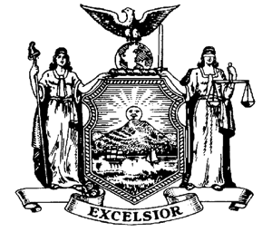

**SENATOR MARTY GOLDEN HOSTS**

***A Sandy Recovery Information Session***

**Saturday February 14th**

**1:00 p.m.-4:00 p.m.**

**AOH Hall, 2750 Gerritsen Avenue**

**Featuring**

**\*NYC Build It Back**

**\*Neighborhood Housing Services**

**Foreclosure intervention**

**Representatives will provide individual attention**

***Information also available regarding flood & homeowner insurance, and low-interest home repair loans and grants.***

**If you should have any questions, please call Senator Golden’s office at (718) 238-6044**