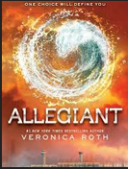
THE WORLD OF DIVERGENT:
THE PATH TO
Allegiant

BOOK RELEASE PARTY

Sponsored by: The BookMark Shoppe and Senator Marty Golden

Join Us on: Tuesday, October 22nd 6:00 p.m. at The BookMark Shoppe for the Official Release Party of Allegiant, Book III by Veronica Roth

Story Writing Contest • Faction Costume Contest
Choose Your Faction Quiz • Free Give-Aways
Prizes • Refreshments

STORY WRITING CONTEST: Kids up to Age 18, are asked to write a story related to Veronica Roth’s World of Divergent. It can range from a newspaper article, a different ending for an earlier book, creating your own faction or writing about an existing faction, re-creating history that started the dystopian society, or create a new scene related to the world of Divergent.

Be As Creative as You Can! Anything Goes! Drawings with story is optional too!

Rules: All entries are due NO LATER THAN: October 16th, 7:00 p.m. to either The BookMark Shoppe (8415 3rd Ave) or Senator Golden’s office (7408 5th Ave). Entries must have child’s name, school, age, grade and contact telephone number. Entries can be between 50 – 1,000 words. Winners will be announced on October 22nd during the Book Release Party. There will be 3 Grand Prizes and 4 Honorable Mentions.

Dress In Your Faction!
We will have a Costume Contest with a Grand Prize and 3 Honorable Mentions

PRE-ORDER ALLEGIANT AND RECEIVE 20% OFF!

Call Us for More Information!
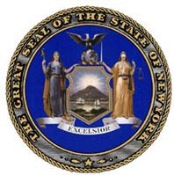
The BookMark Shoppe
8415 3rd Avenue, Brooklyn NY 11209 718.833.5115 • www.bookmarkshoppe.com
Senator Marty Golden
7408 5th Avenue, Brooklyn NY 11209
718-238-6044 • golden.nysenate.gov

