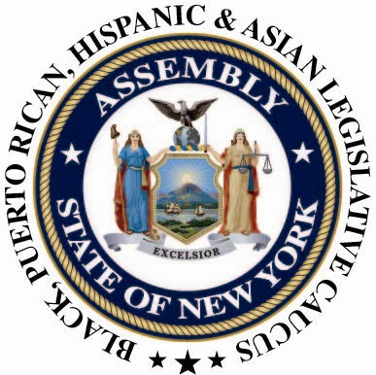

PRESS CONTACT: Nantasha Williams
Office: (518) 455-5327
bphacaucuspress@gmail.com
For Immediate Release: May 22 2013

Caucus Applauds Assembly Passage of the DREAM Act, a Caucus Top Priority
Albany, NY- The Black, Puerto Rican, Hispanic, and Asian Legislative Caucus today applauded the passage of the DREAM Act (A.2597) allowing undocumented students who meet in-state tuition requirements to access state financial aid and scholarships for higher education. This bill also opens 529 tuition savings accounts to all New York youth, and establishes a DREAM Fund Commission to raise private funds for a college scholarship program for children of immigrants.
Passing the DREAM Act during this legislative session was a top priority of the Caucus. We are delighted by the Assembly’s passage of this legislation and we hope the Senate will do the right thing for over 100,000 immigrant youth that have been denied funding by passing the Senate companion bill (S.2378).
"I would like to commend Speaker Silver, Assemblyman Moya and my Assembly collegues for their leadership on this issue. This is a proud moment for the legislature. We are doing what is right for New York and for America." said Chair Assemblyman Karim Camara (D-Brooklyn).

###

