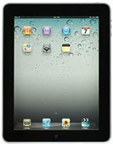

FREE ELECTRONICS ETCHING EVENT

Please Join Senator Joe Addabbo
& Officers From the Transit District 33
And 104 Precinct

Register Your Cell/Smart Phones, IPAD’s,
IPOD’s, Laptops, Portable Video Games, ETC,
To Help Protect Against Thievery

Tuesday, September, 18th 2012
From 4 PM-7 PM
At Senator Addabbo’s Middle Village Office
66-85 73rd Place, Middle Village NY 11379

For More Information Contact Pete DeLucia
In Senator Addabbo’s District Office
At 718-738-1111

