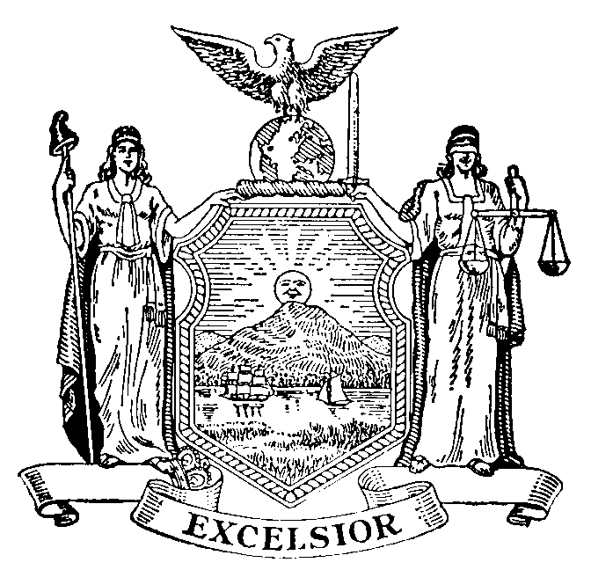

SENATE STANDING COMMITTEE ON MENTAL HEALTH AND DEVELOPMENTAL DISABILITIES
SENATE STANDING COMMITTEE ON HEALTH

PUBLIC HEARING ON
REGIONAL CENTERS OF EXCELLENCE

October 28, 2013
11:00 am
Chemung County Legislative Chambers
Elmira, NY

WITNESS LIST

- Assemblymember Donna Lupardo

- PANEL 1: Susan Kent
President
PEF

Bonnie Wood
Regional Coordinator
PEF Region 2

Lynda Albert
Council Leader of Division 223
PEF

- Andrea Smyth
Executive Director
New York State Coalition for Children’s Mental Health Services

- PANEL 2:
Rick Noreault
Legislative and Political Coordinator
CSEA Central Region 5 Office

Joseph Howard
President
Local 437

David Tokar
Vice President
Local 437

- Tom Santulli
County Executive
Chemung County

- Brian Hart
Director of Community Services
Chemung County

- PANEL 3: Fred Betschen
Family Member

Heather Mott
Family Member

- Dr. Richard Hamling
Board of Visitors

- Charles Blount
Elmira Psychiatric Center Community Clinic

- Henry Chapman
Director of Community Services
Steuben County

- Mary Beth Gillis
Psychiatric Nurse Educator
Elmira College

- Dr. Alec Whyte
Former Clinical Director
Elmira Psychiatric Center

- Sue Romanczuk
Commissioner
Tompkins County Department of Mental Health

- John Harmon, Jr.
Law Enforcement Vice President
NYSCOBA

- PANEL 4: David Cole
Sheriff
Steuben County

James Allard
Undersheriff
Steuben County

Matthew Whitmore
Major (Jail Superintendent)
Steuben County

Michael Robertson
Chief
City of Elmira Police Department

- Alice Haskins
Chief Correctional Officer
Ontario County Jail

- Art Johnston
Director of Community Services
Broome County

