CUTTING SPENDING AT THE DEPARTMENT OF CORRECTIONAL SERVICES



SenatorS Jeffrey D. Klein

& dIANE SAVINO

January 2010

Report by
Senator Klein’s and Senator Savino’s Staff

Introduction:

New York State is undergoing a severe fiscal crisis. A sharp decline in tax revenues brought about by the deep recession that the nation entered in December 2007 and which New York State entered in mid-2008 means that the State is now facing multi-billion dollar deficits. At the same time, New Yorkers are confronting one of the highest combined local and State tax burdens in the United States. At this time, any raising of taxes will put additional pressure on families and businesses already reeling from the economic downturn. The fact is that New York State must find ways to cut spending in order to balance the budget as mandated by the State’s constitution.

At the same time that New York State must cut spending to match declining tax revenues, it is critically important that it continue to provide the essential services that so many residents of the State rely on in order to live healthier and safer lives. Achieving this balance between fiscal responsibility and continuing to provide vital services is the main task the State’s government faces today. Failing to achieve either goal will hobble our ability to see New York State recover from this difficult crisis. As the closing of the Champlain Bridge and the terrible economic toll it has taken in the North Country demonstrates, allowing State services and infrastructure to crumble in order to save money is a classic example of “penny wise, pound foolish” behavior.

One of the most important ways to achieve both fiscal responsibility and quality of life is to cut wasteful and inefficient spending. Previously, Senator Klein identified possible ways to reduce costs within the State University System of New York (SUNY). This time, Senator Klein and Senator Savino have drafted a report on ways in which the Department of Correctional Services can cut costs while maintaining its mission and continuing to ensure the safety of the public and its staff.

The Department of Correctional Services:

The Department of Correctional Services (DOCS) is responsible for running the fourth largest state prison system in the country. During FY 2008-2009, DOCS was budgeted for 31, 673 full time employees, operating a system with around 61,000 inmates in 69 correctional facilities and one drug treatment center jointly administered by DOCS, the Division of Parole, and the Office of Alcoholism and Substance Abuse Services. 67% of the full-time positions at DOCS are security personnel while the remainder provide health services, facilities maintenance, inmate services, and administrative support. According to the Comptroller’s Office, DOCS spent a total of $2.8 billion, 67% of which was allocated to personnel.

The FY 2009-2010 budget reduced the number of positions at DOCS to 30,331 and implemented the closing of three minimum security facilities – Camp Pharsalia, Camp at Mt. McGregor, and Camp Gabriel – following a decade of decline in the overall inmate population. Between 1999 and 2009, the number of inmates dropped from 71,600 to roughly 10,500, respectively, thereby significantly lessening the need for low-security facilities. While facility closings and staffing cuts should continue as the inmate population further declines, the cuts have not been uniform, and data suggests that there are other avenues DOCS could explore to reduce wasteful spending.

Administrative Spending at DOCS

At the same time that DOCS consolidated facilities and proposed budgets that cut positions directly related to the supervision or care of inmates, the number of its administrative positions grew. In FY 2008-09, the state budget included funds to pay for 243 full-time employees (FTEs) in the DOCS’ central administration. Meanwhile, the same FY 2009-2010 budget that proposed the cutting of 1,342 FTEs from the Department left the number of administrative positions untouched.

In FY 2005-06, the DOCS agency budget submission included a total of 235 administrative FTEs. While eight positions may not seem like a dramatic increase, the actual increase is greater. Three years later, a Bi-Weekly Action Plan staffing report dated May 8, 2009 reveals that the number of FTEs working at the DOCS administration has risen to 295.75, which represents an increase of over 60 FTEs from 2005-06 levels and 50 FTEs over what was budgeted for in the DOCS budget allocation for FY 2009-10.

Assuming that the average salary and fringe benefit costs of each of these additional FTEs is $80,000 annually, one can conclude that the additional cost to the State from the growth in administrative FTEs is $5 million per year. It should also be noted that the only general classification of employees at DOCS to have more FTEs on payroll than was budgeted for was the central administration. All other classifications, including support staff, health services staff, inmate program services staff, and those in charge of inmate supervision, had fewer FTE positions filled than allocated for in the FY 2009-10 budget.

Map of regional administrative regions in DOCS
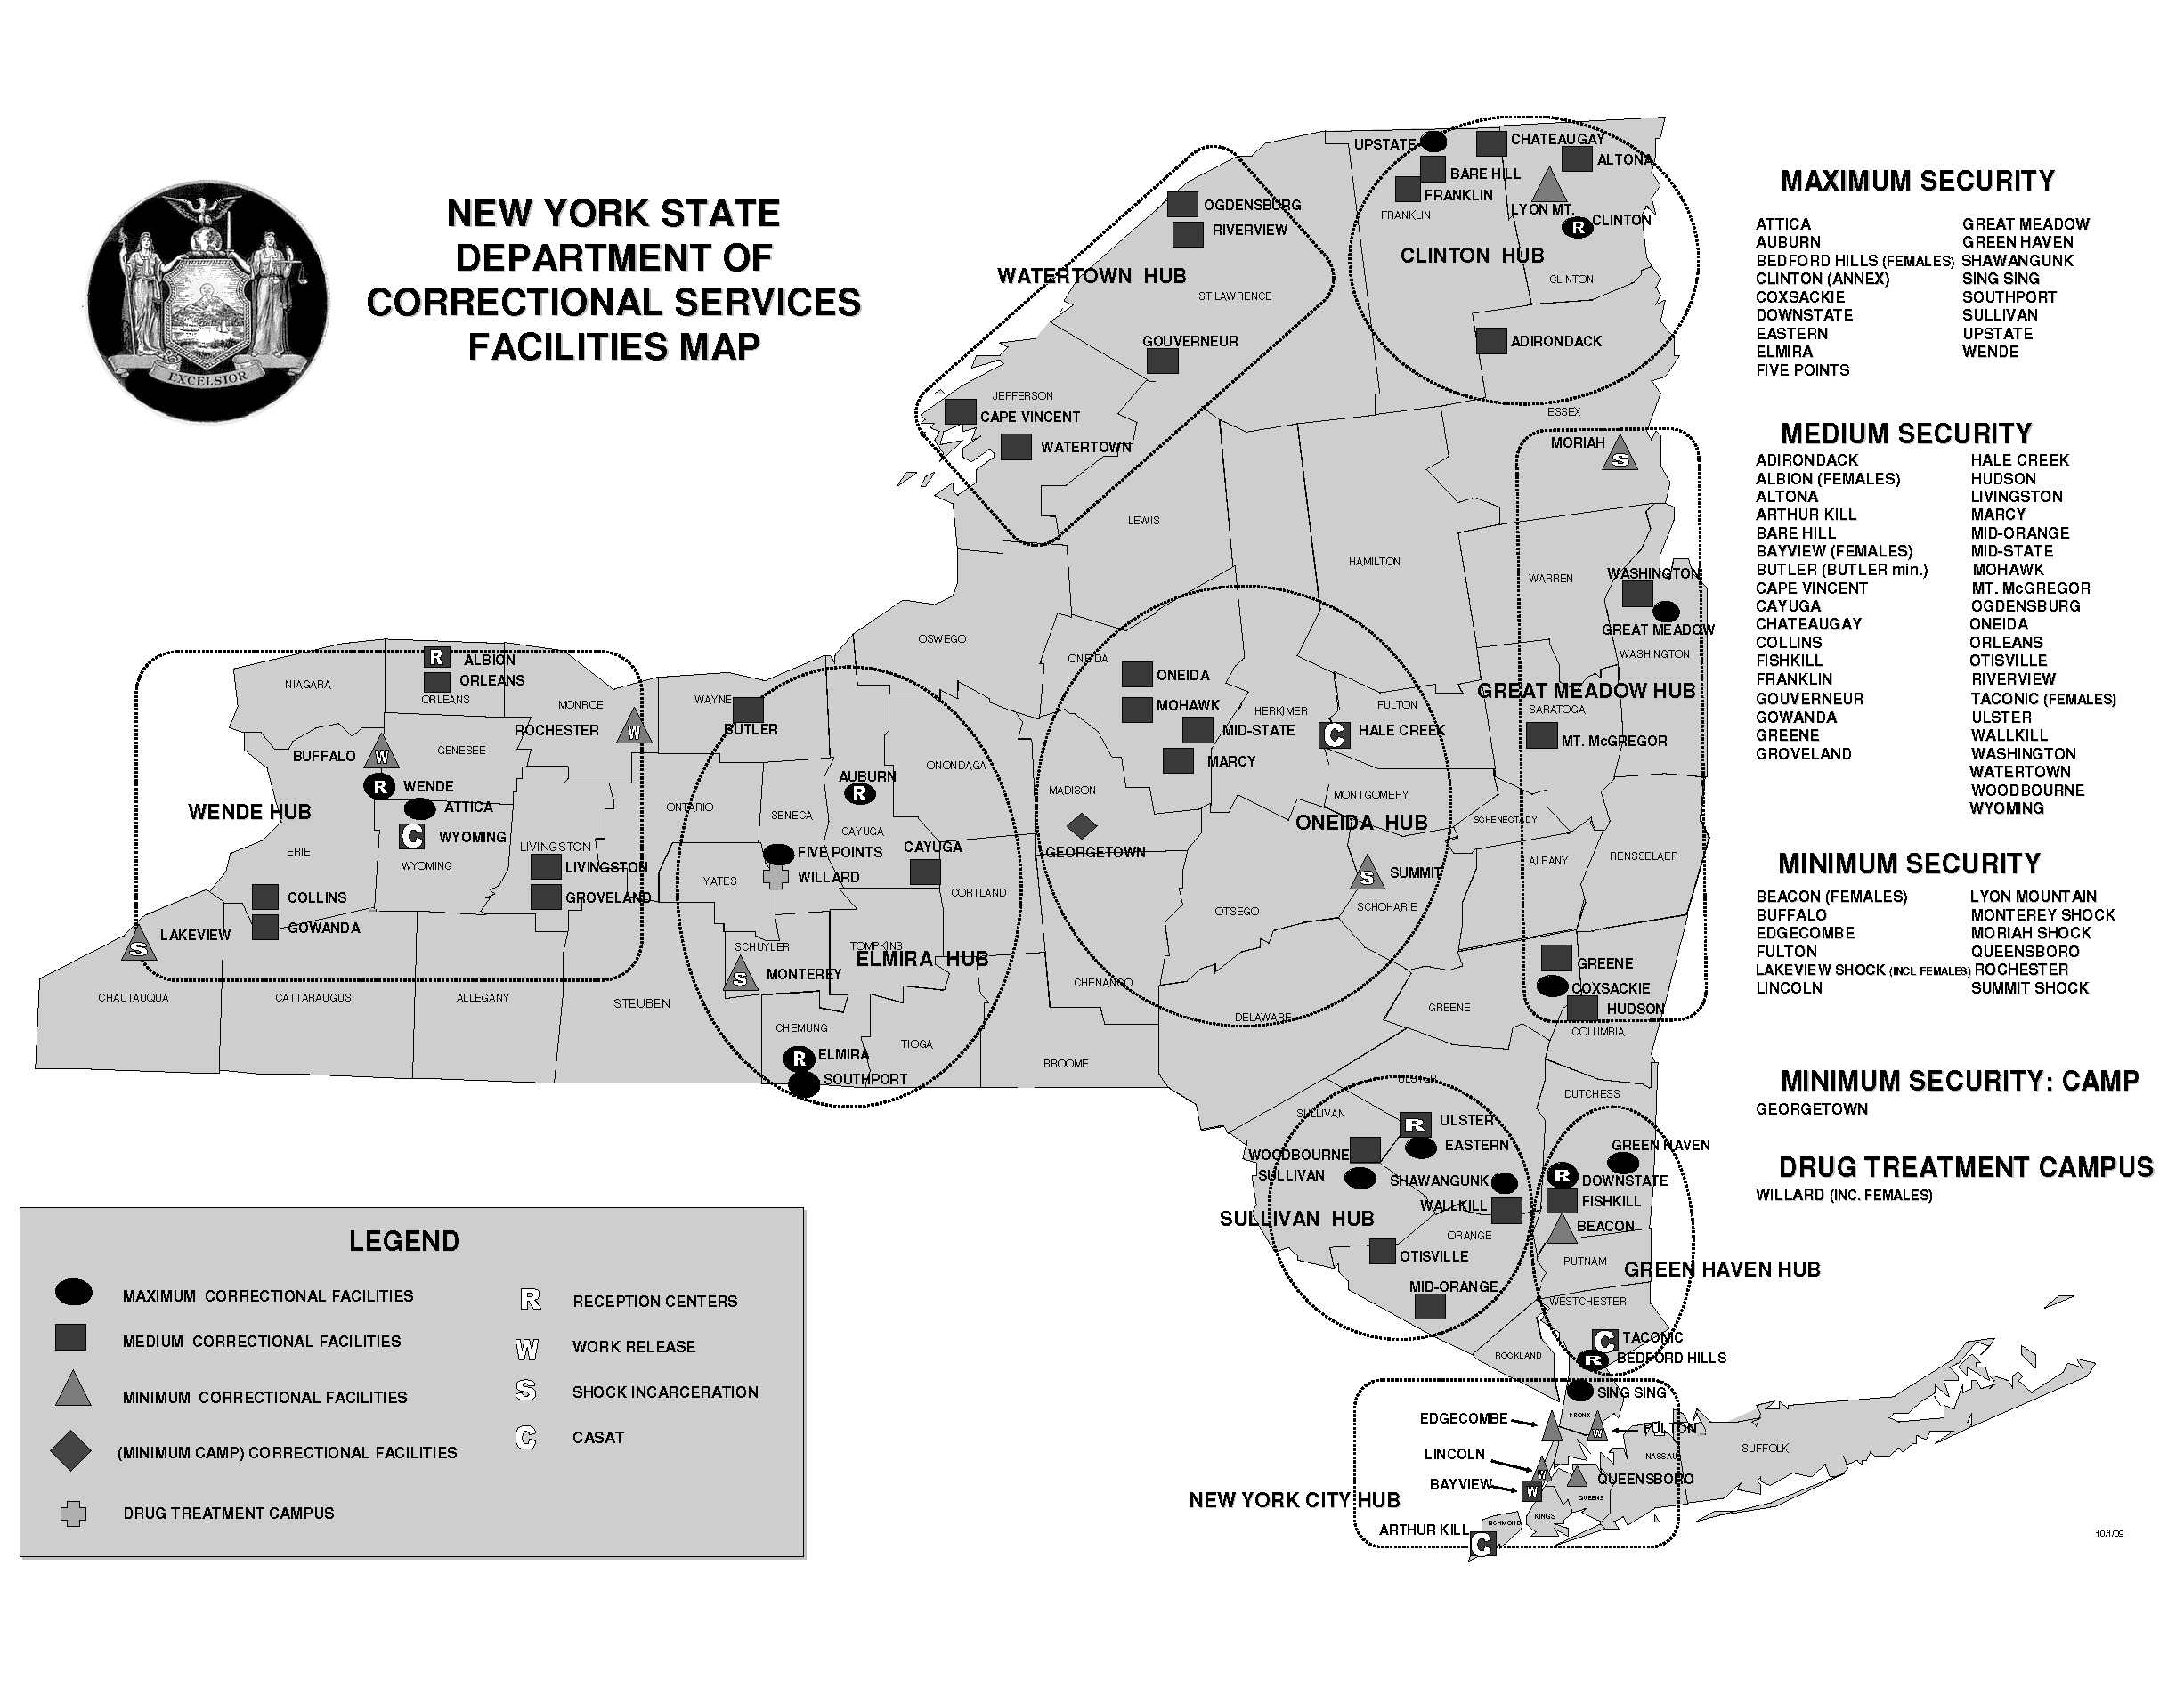
Local Administrative Spending:

It is also critical to note that there at two additional levels of administration at DOCS beyond the central administration in Albany. There are regional administrators, who administer programs at what are termed “hubs.” These hubs, which are illustrated in the map above, are groups of prisons located in certain geographical areas of the State. For example, the Green Haven hub is comprised of a number of correctional facilities located in Dutchess, Putnam, and upper Westchester counties. This hub includes:

- Downstate Correctional Facility, a high-security male facility
- Green Haven Correctional Facility, a high-security male facility
- Bedford Hills Correctional Facility, a high-security female facility
- Fishkill Correctional Facility, a medium-security male facility
- Taconic Correctional Facility, a medium-security female facility
- Beacon Correctional Facility, a minimum-security female facility

Each of these six facilities in the Green Haven hub has its own individual administration. The administrators at each facility are not only responsible for managing their own security, inmate programs, and health care functions – which is to be expected – but also their own payroll and purchasing functions as well. Interestingly enough, of the nine different hubs run by DOCS, there exist clusters of prisons that are literally located right next to each other. In the Green Haven hub, the Downstate, Fishkill, and Beacon facilities are all situated on the same estate, while Bedford Hills and Taconic are located on another estate.

These independent administrations do not come cheap. In 2009, Downstate, Fishkill, and Camp Beacon spent over $1 million on top-level administrators for these three facilities. Each facility not only had its own superintendent and institutional stewart (who is in charge of everyday business operations), but Fishkill and Downstate each also had their own deputy superintendents and assistant deputy superintendents.

FACILITY | POSITION TITLE | 2009 EARNINGS
CAMP BEACON | INST STEWARD | $ 78,750.36
CAMP BEACON | SUPT CORR FAC | $ 103,795.38
DOWNSTATE CORRECTIONAL FAC | INST STEWARD | $ 77,059.84
DOWNSTATE CORRECTIONAL FAC | SUPT CORR FAC | $ 144,138.28
DOWNSTATE CORRECTIONAL FAC | ASSNT DPTY SUPT | $ 85,857.72
DOWNSTATE CORRECTIONAL FAC | DEPUTY SUPT ADMNV S 3 | $ 105,303.12
DOWNSTATE CORRECTIONAL FAC | DEPUTY SUPT REC&CLS 3 | $ 90,524.72
DOWNSTATE CORRECTIONAL FAC | DEPUTY SUPT SECRTY S3 | $ 106,503.12
FISHKILL CORRECTIONAL FACILITY | ASSNT DPTY SUPT | $ 75,514.14
FISHKILL CORRECTIONAL FACILITY | DEPUTY SUPT ADMNV S 3 | $ 105,303.12
FISHKILL CORRECTIONAL FACILITY | DEPUTY SUPT PROGM S 3 | $ 101,695.10
FISHKILL CORRECTIONAL FACILITY | DEPUTY SUPT SECRTY S3 | $ 88,478.64
FISHKILL CORRECTIONAL FACILITY | INST STEWARD | $ 76,136.32
FISHKILL CORRECTIONAL FACILITY | SUPT CORR FAC | $ 137,194.46
 | TOTAL: | $ 1,376,254.32

The photo below shows just how close to each other these three facilities are:

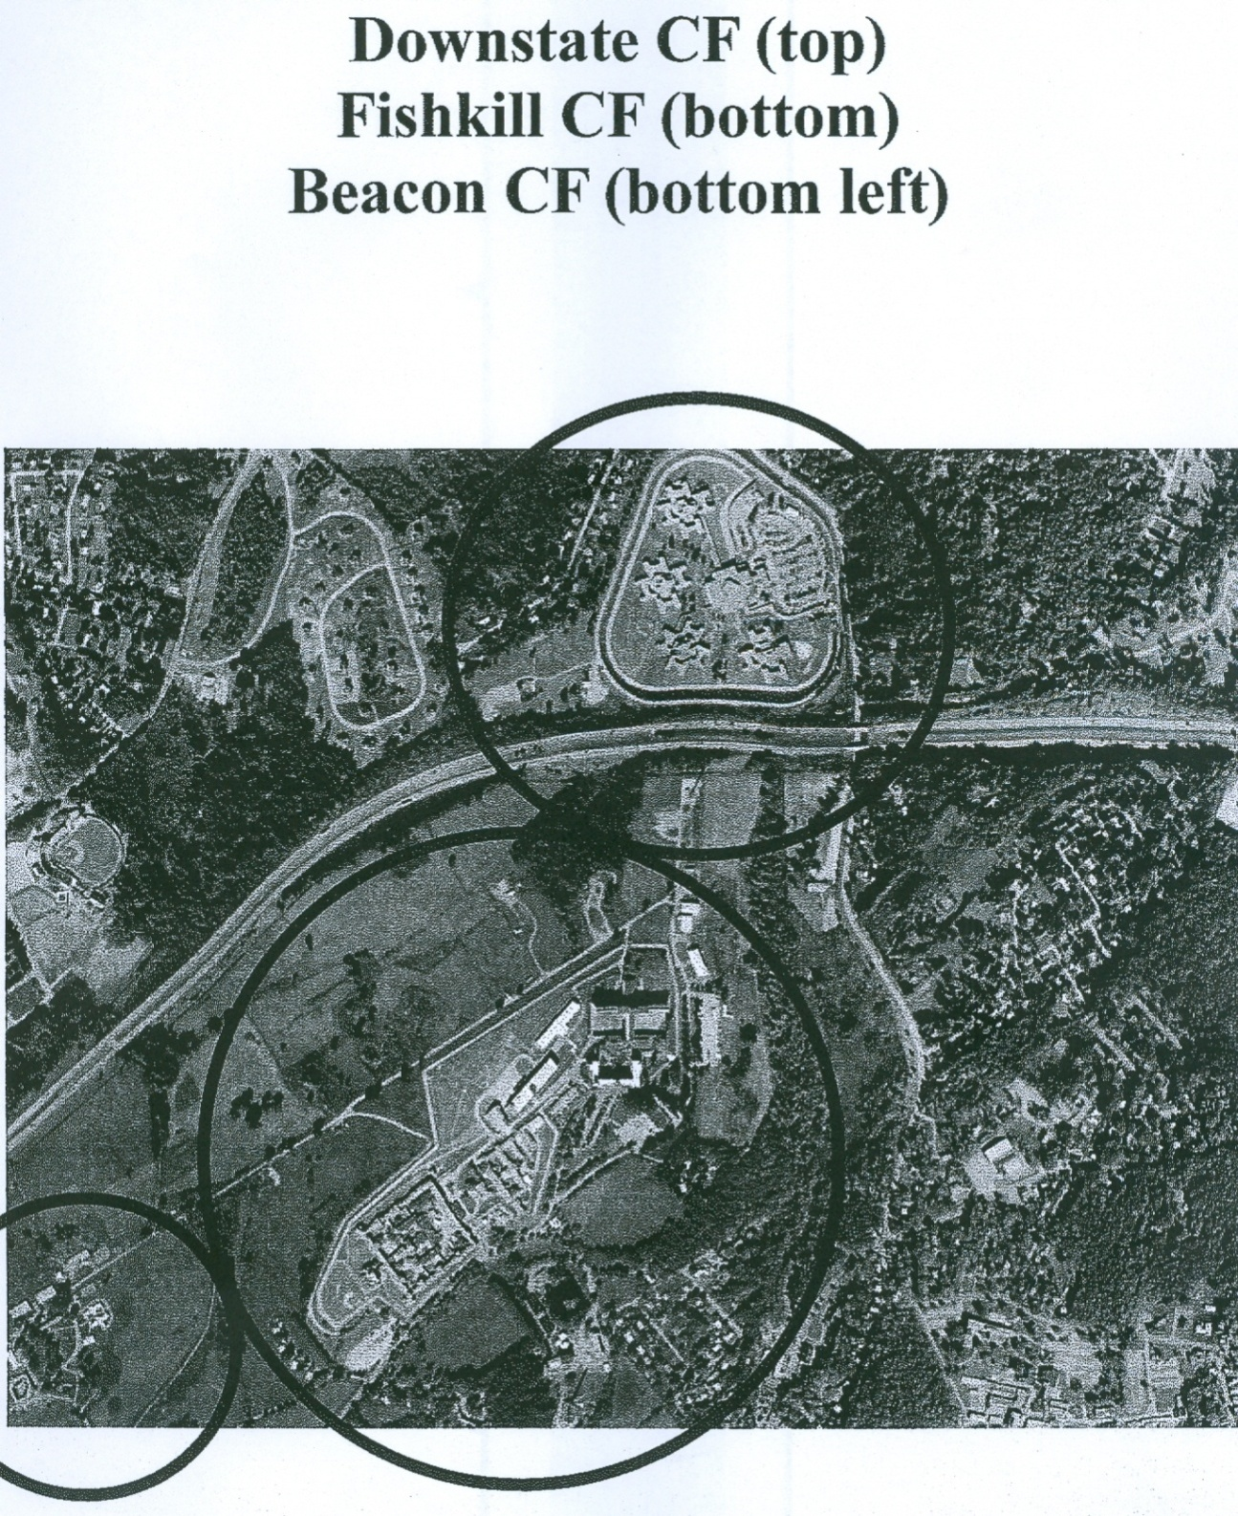

Every single correctional facility is a complex operation with varied responsibilities – not only do security requirements differ among facilities, but each facility also has its own health care requirements, different educational programs to help fulfill DOCS-mandated rehabilitation and, in many prisons, on-site industrial production facilities for license plates and other products. Yet, there are also some functions, such as payroll, that do not differ in any meaningful way among facilities.

Another administrative function that does not significantly among facilities is the process of procurement. Each facility handles its paperwork for contracts with local vendors. When facilities are in different towns or counties, this might make sense; however, when facilities such as the three illustrated in the map above are all located directly next to each other, having distinct and separate administrations to handle functions such as procurement or payroll makes little sense.

With regards to procurement, both Downstate and Fishkill Correctional Facilities contracted with the same companies to provide them with items for their commissary. If a single company is providing both facilities – which are located right next to each other – with commissary items, then why do they require two distinct contracts?

Vendor | Facility | Current Contract | Spending to Date | Contract Start | Contract End | Contract Description
ALLSTATE DISTRIBUTORS NE | Fishkill | $1,893,200 | $1,171,025 | 04/01/05 | 03/31/10 | COMMISSARY ITEMS
ALLSTATE DISTRIBUTORS NE | Downstate | $165,829 | $15,161 | 05/01/08 | 04/30/11 | COMMISSARY ITEMS
KEEFE SUPPLY CO | Fishkill | $840,430 | $616,808 | 04/01/05 | 03/31/10 | COMMISSARY ITEMS
KEEFE SUPPLY CO | Downstate | $229,270 | $31,713 | 05/01/08 | 04/30/11 | COMMISSARY ITEMS
SEDER FOODS | Fishkill | $1,725,693 | $1,118,386 | 04/01/05 | 03/31/10 | COMMISSARY ITEMS
SEDER FOODS | Downstate | $174,796 | $17,476 | 05/01/08 | 04/30/11 | COMMISSARY ITEMS

It should be noted that while Fishkill negotiated a five-year contract with these companies that begun in 2005 and ends in 2010, Downstate negotiated a three year contract that started in 2008 and runs through to 2011.

A further example of DOCS’ duplicative procurement efforts relates to healthcare and medical services for which DOCS has contracted with a single vendor to provide services electrocardiogram (ECG), laboratory, and prescription drug delivery services, respectively. While one would expect a single contract between DOCS and its vendors to suffice, the Office of the State Comptroller has identified at least one contract per vendor for each of the 67 correctional facilities, which it tracks on its website.

Vendor | Current Contract | Spending to Date | Contract Start | Contract End | Contract Description
COMPUMED | $3.3 M | $1.2 M | 2004 | 2012 | ECG Services
BIOREFERENCE LABORATORIES | $111.3 M | $50.4 M | 2004 | 2010 | Laboratory Services
KINNEY DRUGS | $103.2 M | $44.1 M | 2007 | 2010 | Prescription Drugs

The Office of the State Comptroller has conducted temporary audits of a number of correctional facilities in the last few years examining their compliance with a variety of reporting and record keeping rules. In particular, the State Comptroller’s Office detected shortcomings in procurement payment practices at the Edgecombe and Mid-Orange correctional facilities, where fines for late payments had significantly increased facility spending. A comprehensive audit of Otisville Correctional Facility also detected problems with procurement issues. It is probable that these kinds of problems, found in these three facilities, are likely present at other facilities, including these clusters.

As with the Otisville facility, additional audits by the Comptroller’s Office of Green Haven confirmed issues with its payroll practices. One significant problem occurred with civilian employees who were swapping their shifts, a practice typically only allowed for correctional officers. The Comptroller’s Office’s recommendation: greater oversight by the central administration of DOCS.

Greater oversight would be simplified if DOCS had to deal with fewer offices. Throughout 2009, there were 1,407 individuals on the Fishkill payroll, 903 individuals on the Downstate payroll, and 139 individuals on the Beacon payroll. Having a single office handle each of these facilities’ payroll is more expensive than having a single office handle the combined payroll of 2,449 individuals. In addition, it is more difficult to ensure that three offices are following DOCS personnel rules, as opposed to one.

Consolidation of back-office functions at these clustered facilities should be investigated by DOCS. In 2009 (through the December 17, 2009 paycheck), the cluster of facilities pictured in the above map spent a total of $7.9 million in payroll for individuals in administrative positions, many of which could possibly be centralized in a singular cluster facility.

EARNINGS BY INDIVIDUALS WITH ADMINISTRATIVE JOB TITLES AT CAMP BEACON
JOB TITLE | COUNT | EARNINGS
CALCULATIONS CLERK 1 | 2 | $ 67,991.43
CALCULTNS CLERK 2 | 1 | $ 40,386.48
STORES CLERK 2 | 1 | $ 38,155.73
INST STEWARD | 1 | $ 75,721.50
CLERK 2 | 2 | $ 71,106.94
INMATE RCRDS COORD 1 | 1 | $ 50,760.06
LIBRARY CLERK 2 | 1 | $ 13,731.60
KEYBOARD SPEC 1 | 3 | $ 98,695.17
KEYBOARD SPEC 2 | 1 | $ 34,034.35
MAIL&SUPPLY CLERK | 1 | $ 33,946.84
SECY 1 | 1 | $ 45,017.50
SUPT CORR FAC | 1 | $ 99,803.25
TOTAL: | 16 | $669,350.85

EARNINGS BY INDIVIDUALS WITH ADMINISTRATIVE JOB TITLES AT DOWNSTATE CORRECTIONAL FACILITY
JOB TITLE | COUNT | EARNINGS
CALCULATIONS CLERK 1 | 5 | $ 139,071.84
CALCULTNS CLERK 2 | 3 | $ 96,765.70
PRIN ACCT CLERK | 1 | $ 44,977.50
HEAD ACCOUNT CLERK | 2 | $ 57,541.60
STORES CLERK 1 | 1 | $ 60,350.54
STORES CLERK 2 | 2 | $ 80,762.14
PRIN STORES CLERK | 3 | $ 138,945.79
INST STEWARD | 1 | $ 74,096.00
CLERK 1 | 2 | $ 64,691.97
CLERK 2 | 11 | $ 377,762.49
CLERK 2 SPANISH LANG | 1 | $ 40,703.85
HEAD CLERK PERSONNEL | 1 | $ 58,325.00
INMATE RCRDS COORD 1 | 2 | $ 94,234.50
INMATE RCRDS COORD 2 | 1 | $ 55,240.11
KEYBOARD SPEC 1 | 32 | $ 935,524.26
KEYBOARD SPEC 2 | 3 | $ 111,806.96
MAIL&SUPPLY CLERK | 2 | $ 48,067.03
SENR MAIL&SUPPLY CLK | 3 | $ 38,455.07
SECY 1 | 2 | $ 52,780.80
SECY 2 | 1 | $ 54,765.50
CORRL FCLTY FOOD AD 2 | 1 | $ 66,238.35
SUPVR INMATE GRVNC PG | 1 | $ 66,322.25
DEPUTY SUPT REC&CLS 3 | 1 | $ 87,043.00
DEPUTY SUPT SECRTY S3 | 1 | $ 102,453.00
SUPT CORR FAC | 1 | $ 138,594.50
DEPUTY SUPT ADMNV S 3 | 1 | $ 101,253.00
ASSNT DPTY SUPT | 1 | $ 82,555.50
PAYROLL EXMR 2 | 1 | $ 49,466.79
SUPVG CORR CNSLR | 3 | $ 230,303.08
TOTAL: | 90 | $ 3,549,098.12
*Downstate continued
EARNINGS BY INDIVIDUALS WITH ADMINISTRATIVE JOB TITLES AT FISHKILL CORRECTIONAL FACILITY
JOB TITLE | COUNT | EARNINGS
CALCULATIONS CLERK 1 | 6 | $ 172,199.06
CALCULTNS CLERK 2 | 7 | $ 173,561.17
PRIN ACCT CLERK | 4 | $ 151,938.87
HEAD ACCOUNT CLERK | 2 | $ 29,653.14
STORES CLERK 1 | 5 | $ 117,699.28
STORES CLERK 2 | 5 | $ 149,985.43
PRIN STORES CLERK | 2 | $ 86,958.96
COMMISSARY CLERK 2 | 1 | $ 7,550.39
INST STEWARD | 1 | $ 73,208.00
CLERK 1 | 4 | $ 69,520.32
CLERK 2 | 8 | $ 268,708.73
HEAD CLERK PERSONNEL | 1 | $ 58,325.00
INMATE RCRDS COORD 1 | 1 | $ 44,153.18
INMATE RCRDS COORD 2 | 1 | $ 55,552.52
KEYBOARD SPEC 1 | 27 | $ 734,307.12
MAIL&SUPPLY CLERK | 2 | $ 57,015.34
SENR MAIL&SUPPLY CLK | 1 | $ 32,486.75
ADMNV AIDE | 1 | $ 51,122.32
SECY 1 | 2 | $ 67,453.66
SECY 2 | 1 | $ 53,652.25
NUTRITION SRVS ADMR 1 | 1 | $ 68,164.39
CORRL FCLTY FOOD AD 2 | 1 | $ 69,611.46
EDUC SUPVR GENERAL | 1 | $ 69,024.67
EDUC SUPVR VOCATIONAL | 2 | $ 12,801.14
SUPVR CORRL FAC VOL S | 1 | $ 63,568.66
SUPVR INMATE GRVNC PG | 1 | $ 63,910.37
COMTY CORRL CTR ASSNT | 1 | $ 78,299.73
FIRST DPTY SUPT COR F | 1 | $ 30,426.70
DEPUTY SUPT SECRTY S3 | 1 | $ 84,842.03
SUPT CORR FAC | 2 | $ 131,917.75
DEPUTY SUPT PROGM S 3 | 2 | $ 97,783.75
DEPUTY SUPT ADMNV S 3 | 2 | $ 101,253.00
ASSNT DPTY SUPT | 1 | $ 72,609.75
PAYROLL EXMR 2 | 1 | $ 52,164.70
SUPVG CORR CNSLR | 4 | $ 294,248.95
TOTAL: | 104 | $ 3,745,678.54
*Fishkill continued

Following are the other correctional facilities that were clustered, and what they spent on these Administrative positions during the same time period:

- Shawangunk and Walkill – $3.48 million
- Upstate ,Barehill and Franklin – $7.42 million
- Taconic and Bedford Hills – $4.07 million
- Attica and Wyoming - $6.02 million
- Collins and Gowanda – $5.72 million
- Greene and Coxsackie – $4.86 million
- Washington and Great Meadow – $5.31 million
- Mohawk and Oneida – $7.61 million (Oneida also houses hub administrative offices)

In total, these clustered facilities spent $52.5 million on administration. If DOCS were to create a comprehensive plan with the aim of centralizing back office functions (such as purchasing and payroll) at these cluster facilities by up to 20%, the State could save $10 million a year. Moves to shift as many of these functions as possible to a regional or hub level should also be explored – not only to determine whether administrative savings could also be achieved at non-clustered facilities, but also to better control some of the problems that the Comptroller’s Office has identified at local correctional facilities.

Overtime Spending

The Department of Correctional Services pays its workers more overtime than any other State Agency. In the previous fiscal year, DOCS spent $87 million in overtime, or 20% of the total spent on overtime by the State, and this fiscal year is running slightly below the spending last year in dollar amounts. Even though overtime spending at some other agencies dropped significantly, DOCS’ share of overtime spending in the current fiscal year through November 30th grew to 22%, as illustrated in the table below:

Overtime Spending DOCS
Agency Name | FY 08-09 | April 1 - Nov 30 2009 | Rate | Comparison
Agency Name | Total OT Earnings | Total OT Earnings | Rate | Comparison
ADIRONDACK CORRECTIONAL FAC | 328,730.20 | 219,026.73 | 67% | less
ALBION CORRECTIONAL FACILITY | 949,023.86 | 545,767.68 | 58% | less
ALTONA CORRECTIONAL FACILITY | 608,448.28 | 410,841.83 | 68% | less
ARTHUR KILL CORRECTIONAL FAC | 1,684,100.08 | 1,105,909.10 | 66% | less
ATTICA CORRECTIONAL FACILITY | 4,045,167.43 | 2,528,087.97 | 62% | less
AUBURN CORRECTIONAL FACILITY | 4,663,307.23 | 2,583,641.06 | 55% | less
BARE HILL CORRECTIONAL FAC | 1,467,948.14 | 1,147,320.96 | 78% | MORE
BAYVIEW CORRECTIONAL FACILITY | 693,989.34 | 339,533.52 | 49% | less
BEDFORD HILLS | 2,871,817.40 | 2,595,837.54 | 90% | MORE
BUFFALO CORRECTIONAL FACILITY | 8,556.22 | 17,673.60 | 207% | MORE
BUTLER SHOCK INCARCERATION | 427,958.48 | 423,830.73 | 99% | MORE
CAMP BEACON | 133,590.27 | 129,050.59 | 97% | MORE
CAMP GABRIELS CORRECTIONAL FAC | 130,314.16 | 14,695.08 | 11% | less
CAMP GEORGETOWN | 62,751.04 | 56,995.14 | 91% | MORE
CAMP PHARSALIA | 125,738.14 | 21,098.63 | 17% | less
CAPE VINCENT CORRECTIONAL FAC | 379,897.48 | 246,337.84 | 65% | less
CAYUGA CORRECTIONAL FACILITY | 1,053,662.32 | 672,304.21 | 64% | less
CHATEAUGAY CORRECTIONAL FAC | 224,149.83 | 143,968.37 | 64% | less
CLINTON CORRECTIONAL FACILITY | 3,853,990.14 | 2,732,362.39 | 71% | less
COLLINS CORRECTIONAL FACILITY | 845,916.77 | 709,101.39 | 84% | MORE
COXSACKIE CORRECTIONAL FAC | 3,867,643.67 | 3,396,340.11 | 88% | MORE
DEPT OF CORRECTIONAL SERVICES | 685,483.47 | 272,105.30 | 40% | less
DOCS TRAINEES | 181,403.66 | 68,017.77 | 37% | less
DOWNSTATE CORRECTIONAL FAC | 2,178,024.17 | 2,104,373.65 | 97% | MORE
EASTERN NY CORRECTIONAL FAC | 832,868.84 | 720,535.00 | 87% | MORE
EDGECOMBE CORRECTIONAL FAC | 291,487.90 | 250,626.21 | 86% | MORE
ELMIRA CORRECTIONAL&RECEP CTR | 4,418,050.22 | 3,521,890.05 | 80% | MORE
FISHKILL CORRECTIONAL FACILITY | 2,690,544.84 | 1,648,150.36 | 61% | less
FIVE POINTS CORR FACILITY | 971,448.45 | 562,150.92 | 58% | less
FRANKLIN CORRECTIONAL FACILITY | 1,442,515.80 | 825,784.90 | 57% | less
FULTON CORRECTIONAL FACILITY | 398,494.91 | 232,676.19 | 58% | less
GOUVERNEUR CORRECTIONAL FAC | 850,366.54 | 789,728.47 | 93% | MORE
GOWANDA CORRECTIONAL FACILITY | 1,448,274.22 | 1,080,432.71 | 75% | less
GREAT MEADOW CORRECTIONAL FAC | 2,905,260.22 | 2,007,495.61 | 69% | less
GREEN HAVEN CORRECTIONAL FAC | 2,607,522.23 | 1,967,216.36 | 75% | MORE
GREENE CORRECTIONAL FACILITY | 3,032,831.17 | 2,582,078.02 | 85% | MORE
GROVELAND CORRECTIONAL FAC | 684,187.36 | 501,349.48 | 73% | less
HALE CREEK ANNEX ASACTC | 303,094.12 | 197,639.26 | 65% | less
HUDSON CORRECTIONAL FACILITY | 1,363,047.42 | 765,692.90 | 56% | less
LAKEVIEW SHOCK INCARCERATION | 978,247.26 | 1,165,195.92 | 119% | MORE
LINCOLN CORRECTIONAL FACILITY | 359,546.40 | 209,534.03 | 58% | less
LIVINGSTON CORRECTIONAL FAC | 371,339.97 | 211,160.74 | 57% | less
LYON MOUNTAIN CORRECTIONAL FAC | 168,908.06 | 156,294.62 | 93% | MORE
MARCY CORRECTIONAL FACILITY | 727,444.01 | 406,087.76 | 56% | less
MID ORANGE CORRECTIONAL FAC | 493,827.86 | 301,916.96 | 61% | less
MID STATE CORRECTIONAL FAC | 957,817.00 | 500,286.50 | 52% | less
MOHAWK CORRECTIONAL FACILITY | 1,011,366.58 | 556,848.68 | 55% | less
MONTEREY SHOCK INCARCERATION | 235,170.65 | 176,719.91 | 75% | MORE
MORIAH SHOCK INCARCERATION | 193,657.38 | 166,070.12 | 86% | MORE
MT MCGREGOR CORRECTIONAL FAC | 1,345,006.25 | 919,655.19 | 68% | less
NYC CENTRAL ADMINISTRATION | 103,129.09 | 52,836.65 | 51% | less
OGDENSBURG CORRECTIONAL FAC | 392,564.64 | 320,343.25 | 82% | MORE
ONEIDA CORRECTIONAL FACILITY | 1,171,486.31 | 1,068,195.64 | 91% | MORE
ORLEANS CORRECTIONAL FACILITY | 836,343.19 | 584,454.41 | 70% | less
OTISVILLE CORRECTIONAL FAC | 745,892.48 | 357,469.95 | 48% | less
QUEENSBORO CORRECTIONAL FAC | 356,399.08 | 176,600.85 | 50% | less
RIVERVIEW CORRECTIONAL FAC | 572,918.39 | 518,606.89 | 91% | MORE
ROCHESTER CORRECTIONAL FAC | 18,733.38 | 10,747.76 | 57% | less
SHAWANGUNK CORRECTIONAL FAC | 755,807.59 | 767,533.67 | 102% | MORE
SING SING CORRECTIONAL FAC | 5,671,837.33 | 3,502,587.18 | 62% | less
SOUTHPORT CORRECTIONAL FAC | 865,362.95 | 547,046.90 | 63% | less
SULLIVAN CORRECTIONAL FACILITY | 691,203.13 | 454,591.05 | 66% | less
SUMMIT SHOCK INCARCERATION | 502,234.79 | 400,449.31 | 80% | MORE
TACONIC CORRECTIONAL FACILITY | 571,113.42 | 657,631.99 | 115% | MORE
ULSTER CORRECTIONAL FACILITY | 1,112,615.76 | 911,438.91 | 82% | MORE
UPSTATE CORRECTIONAL FACILITY | 783,801.23 | 564,368.29 | 72% | less
WALLKILL CORRECTIONAL FACILITY | 635,682.98 | 460,524.11 | 72% | less
WASHINGTON CORRECTIONAL FAC | 1,961,527.64 | 1,270,713.89 | 65% | less
WATERTOWN CORRECTIONAL FAC | 505,041.17 | 288,092.57 | 57% | less
WENDE CORRECTIONAL FACILITY | 3,858,530.23 | 3,057,672.39 | 79% | MORE
WILLARD DRUG TREATMENT CAMPUS | 919,608.90 | 940,671.06 | 102% | MORE
WOODBOURNE CORRECTIONAL FAC | 645,909.62 | 436,591.88 | 68% | less
WYOMING CORRECTIONAL FACILITY | 1,117,244.85 | 832,310.28 | 74% | less
TOTALS: | 87,348,925.59 | 63,088,916.94 | 72% | less

Those facilities shaded in yellow are spending at a faster rate than in the last fiscal year. Those in red are facilities which the FY 2009-2010 budget scheduled for closing by July 1, 2009.

An analysis of data provided by DOCS on the inmate populations at the facilities under consideration shows that there is no particular correlation between the inmate population and the rate of overtime spending. The chart below illustrates inmate population changes at some select facilities at the start of FY 2008-09, the end of FY 2008-09, and the end of 2009:

Facility | Type | # Inmates (03/31/08) | # Inmates (03/30/09) | # Inmates (12/30/09) | Change from 3/31/08 to 12/30/09
Adirondack | Medium | 545 | 458 | 435 | -110
Altona | Medium | 474 | 477 | 474 | 0
Arthurkill | Medium | 881 | 897 | 862 | -19
Attica | Maximum | 2,183 | 2,161 | 2,159 | -24
Auburn | Maximum | 1,743 | 1,743 | 1,727 | -16
Bedford Hill | Female | 815 | 832 | 761 | -54
Cayuga | Medium | 850 | 866 | 861 | 11
Coxsackie | Maximum | 1,054 | 1,009 | 1,039 | -15
Downstate | Maximum | 1,163 | 1,221 | 1,227 | 64
Eastern | Maximum | 1,007 | 1,001 | 999 | -8
Elmira | Maximum | 1,772 | 1,811 | 1,811 | 39
Gouverneur | Medium | 867 | 835 | 865 | -2
Gowanda | Medium | 1,736 | 1,590 | 1,623 | -113
Great Meadow | Maximum | 1,642 | 1,647 | 1,639 | -3
Green Haven | Maximum | 2,051 | 2,000 | 2,016 | -35
Greene | Medium | 1,611 | 1,601 | 1,537 | -74
Shawangunk | Maximum | 542 | 537 | 531 | -11
Sing Sing | Maximum | 1,767 | 1,756 | 1,744 | -23
Southport | Maximum | 887 | 900 | 843 | -44
Sullivan | Maximum | 527 | 512 | 495 | -32
Watertown | Medium | 612 | 605 | 590 | -22
Woodbourne | Medium | 792 | 780 | 769 | -23

The chart demonstrates, for example, that Adirondack saw a significant drop in population while Altona’s population stayed relatively stable – yet both spent about the same rate of overtime in FY 2009-10 compared to FY 2008-09. Shawangunk saw a sustained drop in inmate populations but already spent more on overtime in the first three quarters of FY 2009-10 than it did in all of FY 2008-09. Cayuga Correctional has actually seen an increase in inmates overall from the beginning of FY 08-09, but is spending overtime at a slower rate this fiscal year than last.

Meanwhile, Auburn has seen its inmate population drop by a rather small percentage (about 1%), but its rate of overtime spending has dropped significantly. Mt. McGregor also stands out in this analysis, as the facility spent close to 68% as much on overtime this fiscal year as during the previous fiscal year, even though it remained open just a single quarter of FY 2009-2010. The other two facilities that were closed by July 1, 2009: Camp Pharsalia and Camp Gabriel both showed dramatic drops in overtime spending with less than 25% of what was spent the previous fiscal year.

An analysis of employees earning overtime pay showed that correctional officers, nurses, and cooks – classifications that have everyday exposure to inmates at these facilities – dominated the ranks of those who earned the most. A further analysis of payroll data from 2008 showed that at least 10% of workers at DOCS had total yearly earnings that were 25% higher than their State salary. This would include overtime earnings, as well as salary adjustments based on the part of the State where they are employed.

2008 Salaries over base salaries based on 35466 positions
Over 100% of base | 0.15%
Over 90% | 0.24%
Over 80% | 0.37%
Over 70% | 0.67%
Over 60% | 1.18%
Over 50% | 2.14%
Over 40% | 3.95%
Over 30% | 8.39%
Over 25% | 11.86%

An analysis of overtime spending data from 2009 reveals that 22,845 employees earned some amount of overtime in calendar year (CY) 2009, which would include the last quarter of FY 2008-2009 and the first three quarters of FY 2009-2010. These employees represent 65% of the 35,337 individuals who were paid any given amount by DOCS during CY 2009. Even amongst those employees who earned overtime, a majority of the total paid out in overtime was paid to a relatively small portion of workers. For example, 861 employees earned over $20,000 in overtime during CY 2009. While these employees represented just 3.77% of the number of employees earning overtime, they collected 28% of the total amount paid out.

Distribution of OT spending in CY 2009
OT EARNINGS | # OF EMPLOYEES | TOTAL OT EARNINGS | % OF EMPLOYEES WHO EARNED OT | % OF TOTAL OT EARNED AT DOCS
OVER $75,000 | 10 | $ 886,023.03 | 0.04% | 1%
OVER $50,000 | 37 | $ 2,461,375.19 | 0.16% | 3%
OVER $40,000 | 107 | $ 5,563,759.61 | 0.47% | 6%
OVER $30,000 | 306 | $ 12,343,034.11 | 1.34% | 13%
OVER $20,000 | 861 | $ 25,761,256.19 | 3.77% | 28%
OVER $10,000 | 2809 | $ 52,866,365.97 | 12.30% | 57%
OVER $0.00 | 22845 | $ 93,183,454.41 | 100% | 100%

While it is understandable that individuals who need to staff 24-hour facilities would earn more in overtime than workers who work regular business hours, the overtime spent is often still excessive. A very good example of this is Bedford Hills Correctional Facility, which is the only high-security women’s facility in New York State, and conveniently located in Westchester, a high-cost county. In Westchester, as is the case across the State, hiring nurses is a challenge, and it is no surprise that nurses in prisons, like unionized nurses everywhere, earn a significant amount of overtime. At the same time, out of the top ten earners of overtime in DOCS in CY 2009 – all of whom earned over $75,000 just in overtime as seen in the previous chart – eight were nurses at Bedford Hills.

Top 10 earners of overtime in DOCS in 2009
INSTITUTION | POSITION TITLE | OT EARNINGS
BEDFORD HILLS | NURSE 2 | $ 149,290.99
BEDFORD HILLS | NURSE 2 | $ 107,406.50
FRANKLIN CORRECTIONAL FACILITY | NURSE 2 | $ 82,015.71
BEDFORD HILLS | NURSE 2 | $ 80,562.65
BEDFORD HILLS | NURSE 2 | $ 79,138.82
BEDFORD HILLS | NURSE 2 | $ 79,120.98
BEDFORD HILLS | NURSE 2 | $ 77,356.43
BEDFORD HILLS | NURSE 2 | $ 77,236.68
BEDFORD HILLS | NURSE 2 | $ 76,977.10
WASHINGTON CORRECTIONAL FAC | CORR OFFICER | $ 76,917.17
 | TOTAL: | $ 886,023.03

One nurse at Bedford Hills earned $149,290.99 in overtime in 2009. Along with her $55,716 salary and additional payments such as a salary adjustments for working in a high-cost area, her total earnings that year were $227,529.96. This made her the second-highest paid employee of DOCS. Overall, the 26 individuals who held the title of Nurse Level 2 in Bedford Hills and earned overtime were paid a total of $1,073,955.65 in CY 2009. As with the Department as a whole, the bulk of this amount was concentrated amongst the top. Ten of these nurses, or 38% of them, accounted for 78% of the total. The following chart compares the salaries, overtime earnings, and total compensation for these ten nurses at Bedford Hills.

AGENCY NAME | TITLE | SALARY | OT EARNINGS | TOTAL EARNINGS | % OF SALARY EARNED IN OT | % OF TOTAL EARNINGS FROM OT | TOTAL EARNINGS COMPARED TO SALARY RATE
BEDFORD HILLS | NURSE 2 | $ 55,716.00 | $ 149,290.99 | $ 227,529.96 | 268% | 66% | 408%
BEDFORD HILLS | NURSE 2 | $ 56,217.00 | $ 107,406.50 | $ 187,771.24 | 191% | 57% | 334%
BEDFORD HILLS | NURSE 2 | $ 56,217.00 | $ 80,562.65 | $ 161,044.80 | 143% | 50% | 286%
BEDFORD HILLS | NURSE 2 | $ 56,217.00 | $ 79,138.82 | $ 158,771.24 | 141% | 50% | 282%
BEDFORD HILLS | NURSE 2 | $ 56,217.00 | $ 79,120.98 | $ 158,385.94 | 141% | 50% | 282%
BEDFORD HILLS | NURSE 2 | $ 56,217.00 | $ 77,356.43 | $ 158,947.94 | 138% | 49% | 283%
BEDFORD HILLS | NURSE 2 | $ 56,217.00 | $ 77,236.68 | $ 157,737.56 | 137% | 49% | 281%
BEDFORD HILLS | NURSE 2 | $ 55,716.00 | $ 76,977.10 | $ 156,033.71 | 138% | 49% | 280%
BEDFORD HILLS | NURSE 2 | $ 55,716.00 | $ 63,285.05 | $ 137,074.87 | 114% | 46% | 246%
BEDFORD HILLS | NURSE 2 | $ 56,217.00 | $ 58,258.92 | $ 133,309.86 | 104% | 44% | 237%
TOTALS: |  | $ 560,667.00 | $ 848,634.12 | $ 1,636,607.12 | 151% | 52% | 292%

As illustrated above, these ten nurses cost the State a total of $1.6 million when all their earnings are accounted for. This is not a reasonable amount to spend on just ten nurses, under any setting. Moreover, studies have demonstrated that overworked medical staffs are less effective and more prone to make mistakes than are well-rested staff. New York State is liable for any mistakes made for the duration of an inmate’s care. To earn over $50,000 in overtime takes a significant number of additional hours. The Administration at DOCS and at Bedford Hills needs to examine this situation closely and devise solutions to address these excessive hours and costly overtime spending.

While the categories of employees mentioned previously dominate the list of employees who earn high overtime, individuals in administrative and clerical posts can also earn significant amounts of overtime. An analysis of CY 2008 and CY 2009 payroll for DOCS provided by the Office of the State Comptroller indicates that, at different points in time, it is specific facilities that end up paying clerical workers very high amounts of overtime. Clinton Correctional Facility in Dannemora, close to Plattsburgh, is an especially dramatic case. In CY 2008, three low-level clerks earned almost a quarter million dollars combined:

Position Title | Salary rate | Pay basis | Total Compensation | Overpay | Ratio
Clerk 1 | $35,200.00 | Annual | $98,057.56 | $ 62,857.56 | 179%
Clerk 1 | $35,200.00 | Annual | $74,482.69 | $ 39,282.69 | 112%
Clerk 1 | $35,082.00 | Annual | $69,582.57 | $ 34,500.57 | 98%
Average Salary: | $35,160.67 | Total pay | $242,122.82 | $ 136,640.82 | 130%

In fact, the top earning clerk earned more in overpay than any other employee in Clinton Correctional in CY 2008, including all of the corrections officers and medical personnel; the second clerk on the list also made the top ten that year.

Top Earners at Clinton CF by overpay in dollars in CY 2008:
Position title | Salary | Pay basis | total earnings | Overpay | Ratio
Clerk 1 | $35,200.00 | Annual | $98,057.56 | $62,857.56 | 179%
Corr Officer | $59,861.00 | Annual | $115,874.98 | $56,013.98 | 94%
Corr Officer | $59,861.00 | Annual | $114,505.60 | $54,644.60 | 91%
Corr Officer | $59,861.00 | Annual | $113,825.29 | $53,964.29 | 90%
Corr Officer | $59,861.00 | Annual | $109,862.94 | $50,001.94 | 84%
Corr Officer | $59,861.00 | Annual | $108,406.61 | $48,545.61 | 81%
Nurse Admr 1 | $65,518.00 | Annual | $111,806.79 | $46,288.79 | 71%
Nurse 2 | $54,583.00 | Annual | $94,222.58 | $39,639.58 | 73%
Clerk 1 | $35,200.00 | Annual | $74,482.69 | $39,282.69 | 112%
Corr Sergeant | $66,498.00 | Annual | $102,427.78 | $35,929.78 | 54%

While there were no examples in CY 2009 as egregious as what happened at the Clinton Facility in CY 2008, a number of clerical employees earned thousands or tens of thousands of dollars in overtime payments – payments that equaled at least 20% of their stated salary. The list below demonstrates the position, facility, and total earnings of these individuals, a number of which were part of that 12.3% of DOCS employees to earn over $10,000 in overtime. It is important to note that Elmira Correctional Facility dominated the list, having far more individuals employed as clerical staffers and earning significantly more overtime than any other facility.

POSITION | FACILITY | OT EARNINGS | SALARY | RATIO | TOTAL EARNINGS
MAIL&SUPPLY CLERK | GREEN HAVEN CORRECTIONAL FAC | $ 16,991.07 | $ 28,483.00 | 60% | $ 48,555.50
STORES CLERK 1 | ELMIRA CORRECTIONAL&RECEP CTR | $ 14,602.24 | $ 32,998.00 | 44% | $ 49,108.59
PRIN CLERK PERSONNEL | GREENE CORRECTIONAL FACILITY | $ 19,661.61 | $ 50,631.00 | 39% | $ 70,153.61
CLERK 2 | ELMIRA CORRECTIONAL&RECEP CTR | $ 13,000.04 | $ 38,593.00 | 34% | $ 52,386.35
STORES CLERK 1 | ELMIRA CORRECTIONAL&RECEP CTR | $ 9,959.63 | $ 31,192.00 | 32% | $ 42,243.52
STORES CLERK 2 | BEDFORD HILLS | $ 12,037.57 | $ 41,007.00 | 29% | $ 56,824.56
STORES CLERK 2 | COXSACKIE CORRECTIONAL FAC | $ 11,245.51 | $ 39,776.00 | 28% | $ 52,146.63
STORES CLERK 2 | CLINTON CORRECTIONAL FACILITY | $ 9,181.14 | $ 35,138.00 | 26% | $ 45,342.08
PRIN STORES CLERK | ELMIRA CORRECTIONAL&RECEP CTR | $ 10,912.49 | $ 46,449.00 | 23% | $ 58,309.49
PRIN CLERK PERSONNEL | COXSACKIE CORRECTIONAL FAC | $ 9,240.47 | $ 40,477.00 | 23% | $ 49,603.01
PRIN STORES CLERK | ELMIRA CORRECTIONAL&RECEP CTR | $ 9,365.10 | $ 41,811.00 | 22% | $ 57,015.72
PRIN ACCT CLERK | TACONIC CORRECTIONAL FACILITY | $ 9,691.29 | $ 45,431.00 | 21% | $ 57,402.44
 | TOTALS: | $ 145,888.16 | $ 471,986.00 | 32% | $ 639,091.50

The Department of Correctional Services needs to do better at curbing excessive overtime. While it is understandable that overtime spending will be significant in facilities that must remain open and active around the clock, there are clear instances in which overtime spending simply cannot be justified at the levels that have been highlighted today. It is hardly defensible that employees can double their salaries in overtime earnings alone, excluding any additional earnings they might be contractually entitled to. It is also clear that inmate populations cannot be used as an excuse for the amount of overtime spent. Evidently, management must have an impact on overtime costs at the various facilities.

As the single largest spender of overtime in the State, DOCS needs to take further steps to cut down on overtime whenever and wherever possible. Had DOCS been able to curb overtime spending in CY 2009 by just 5%, the State would have saved $4.66 million. Strict controls on the assignment of overtime need to be enforced, and DOCS should begin to examine whether changes in the way it schedules employees might help alleviate this kind of overtime spending.

Staff Housing Costs

At a June 2009 Public Hearing on DOCS Administration, the officers of the New York State Correctional Officers & Police Benevolent Association (NYSCOPBA) testified and pointed out several non-personnel areas where they believed savings could be realized. One of the issues they raised was the generous housing allowances given to top administrators at DOCS.

New York State makes housing available to a variety of State workers, particularly in positions were individuals are supposed to in close proximity to their place of work. If the State rents housing for an employee, it simply passes the rental cost onto the employee. How much housing will it cost employees to live in housing that is owned by the State, as opposed to being rented, is a matter that is negotiated between the Governor’s Office and various public employee unions. Rent payments are deducted directly from paychecks, in the form of a maintenance fee.

The size of these maintenance fees are determined by the Division of Budget and typically based on what part of the State the housing is located, with properties downstate and within 10 miles of a city with more than 50,000 residents charging the highest rates while those properties in the vicinity of towns and in rural areas charging less. In addition to their location, an employee’s rent is based on the purported quality of the housing itself. Whether a home is judged to be in excellent, good, fair, or poor condition is a determination made by each agency, though once it has categorized housing one way, it can only change its classification with the approval of the Division of Budget. Finally, if the State does not provide heat, electricity, gas or cooking fuel, garbage services, or furnishings such as a stove or a refrigerator, then the rate charged is lower.

According to the Division of Budget, the Department of Corrections is one of the agencies that owns and provides its own staff with access to housing that it owns directly.

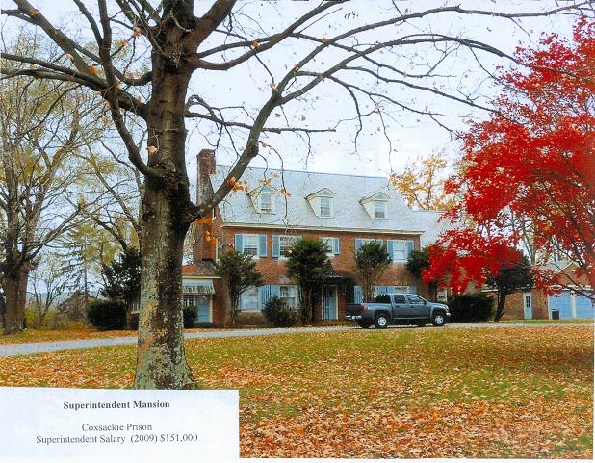

This is a photo of the residence that is provided to the superintendant of Coxsackie Prison, in Greene County. According to information provided by the Office of General Services (OGS), the house pictured to the left is 3,712 square feet in size. An online search found another house in Greene County of that same size with a layout of 5 bedrooms, 2 bathrooms, which is currently on the market for $299,000. Using the guide for how much a State employee would pay for a house of that size in an area like Coxsackie – assuming we classify this house as being excellent housing, we can calculate that the State would charge the superintendant of Coxsackie Prison $835.15 a month to live there, assuming all utilities are being paid for by the State. The realty site which provided the data on the similarly sized house estimates monthly mortgage payments of $1,278 a month – and that

is not including any property taxes, which the State employee does not have to pay.

Many other superintendants are given access to homes far more luxurious and large than the one pictured above. The superintendent of the Willard Treatment Facility would have access to this home:

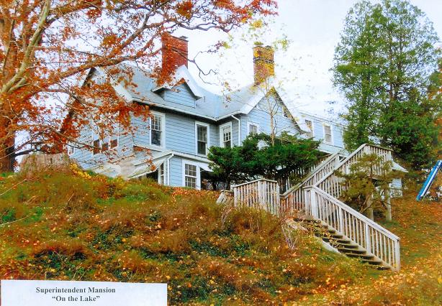

Mid-Orange Correctional Facility located in Orange County, in the town of Warwick, has a superintedent’s home that is 7,099 square-foot home, the largest in the list of superintendent homes provided by OGS. Wallkill Correctional Facility has a superintendent home of 6,968 square feet. The Wallkill Correctional Facility is located in Ulster County, in the town of Shawangunk near the town of Wallkill. Wallkill is not an inexpensive place to live: a 7,177 squarte-foot home with 13 bedrooms and 10.5 bathrooms recently sold for half a million dollars. Assuming again that we classify that half-a-million-dollar home as excellent housing and include all utilities, a state worker (or, in this case, a superintendent) would pay $1,336.25 a month to live there, due to its location in a town under 50,000 residents. The mortgage payments for a $500,000 mortgage would likely be similar to that amount, but again, the State employee does not pay the property taxes, which for that half-a-million-dollar home equaled $7,355 per year.

According to the Division of Budget, it is possible for a State agency to completely waive or reduce any fees for housing, if the housing meets the following criteria: It is located on the premises of the facility the employee works at, the employee is required to live on site, and it is in the State’s interest for that employee to live on site. Currently, superintendents fit those three conditions and DOCS has the power to waive housing fees for superintendents. According to data provided by the Office of the State Comptroller, none of the superintendents at Coxsackie, Wallkill, and Mid-Orange correctional facilities were charged maintenance fees, as laid out by the Division of Budget guide on State owned housing, in 2009.

An internal document provided by NYSCOBA reveals that DOCS considers the ability to provide housing an important recruiting tool to acquire talent, even thought the Division of Budget, when explaining the rules of what housing costs, expressly states that “the State’s wage/benefit package, not the provision of housing, should be sufficient incentives to State employment.” Given that State employees are granted generous fringe benefits, including access to a retirement plan that guarantees benefits far in excess of what most equivalently paid individuals in the private sector are likely to ever receive, the policy statement by the Division of Budget seems eminently fair. DOCS should examine whether it is truly acting in the interest of the public by having these kinds of homes available for superintendents and whether any employees should have their rental fees waived in these difficult fiscal times.

Conclusion:

The Department of Correctional Services is one of the largest agencies in the State, housing over 60,000 inmates and employing over 30,000 individuals. During this time of economic crisis, it is imperative that all State agencies look to find ways to cut costs. This report has shown that, even as the inmate population that DOCS manages has declined and the Department’s headcount has dropped, its administration has not gotten smaller – it has, in fact, grown. There is no valid rationale for a growing administration at DOCS.

Another cost concern at DOCS is the fact that each facility has its own administrative staff even in instances where these facilities happen to exist right next to each other. The 20 facilities (out of 67) under consideration spent $52 million on administrative payroll last year. Back-office functions at these clustered facilities should be centralized per cluster. If DOCS made plans to do so with a target of saving 20% in administrative costs through consolidation the State would save $10 million.

DOCS, given the nature of its mission of incarcerating and rehabilitating tens of thousands of individuals and running 24-hour facilities year-round, pays out more overtime than any other State agency. In fact, DOCS accounts for about one fifth of overtime spending in the State. While it is easy to understand why DOCS pays out so much overtime, this does not mean that all overtime in DOCS is justified. In fact, this report points out some instances in which overtime seems completely unjustified, like in cases were three low-level clerks end up earning close to a quarter of a million dollars in one year. DOCS needs to do more to reign in any unjustified overtime spending and do what it can to lower the amount it does spend in overtime. A 5% cut in overtime in CY 2010 as compared to CY 2009 would save the State $4.66 million.

Finally, DOCS needs to examine its policies regarding the homes that they have set aside for superintendents. The rates that employees are currently charged appear to be below market value, especially when you take into account the fact that the State bears the property tax burden. As we have seen, the State has some very large and luxurious homes set aside as homes for superintendents, and DOCS should perform an accounting of the full costs of those homes, and how much income the State may be foregoing for their use.

APPENDIX

State overtime spending by agency FY 2008-2009:

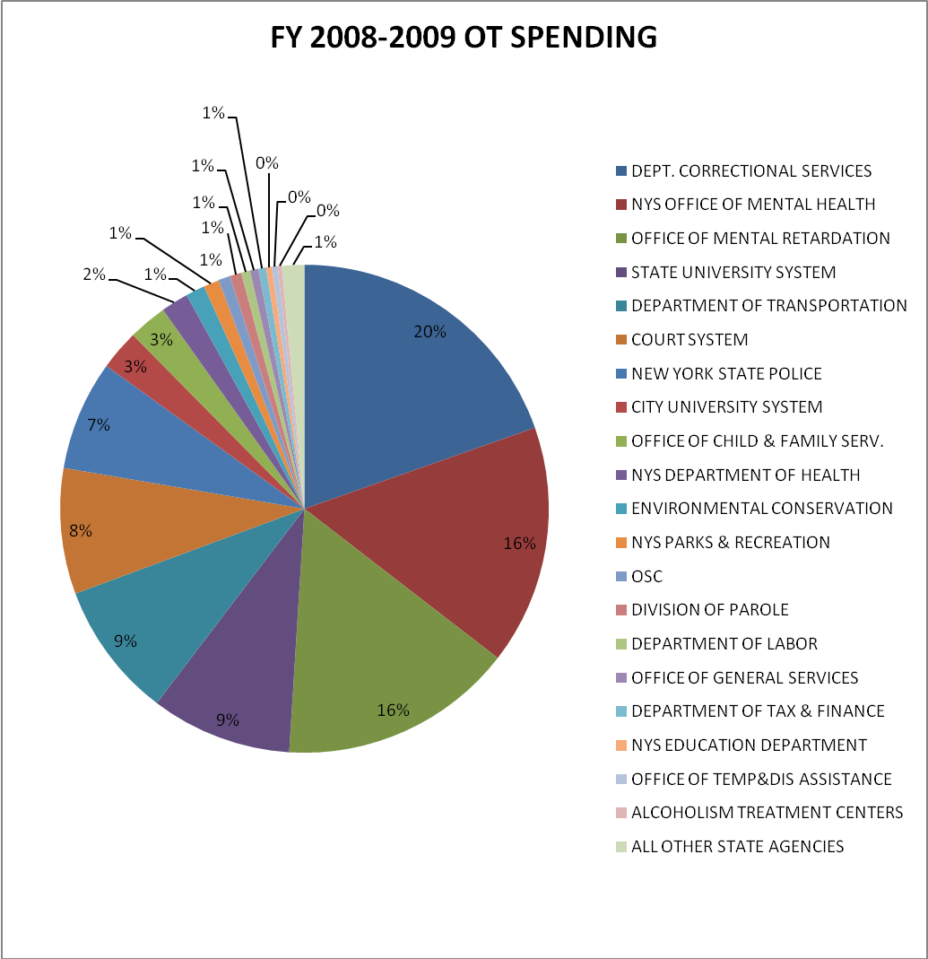

APPENDIX 2

Overtime spending in FY 2009-2010 through November 30, 2009:
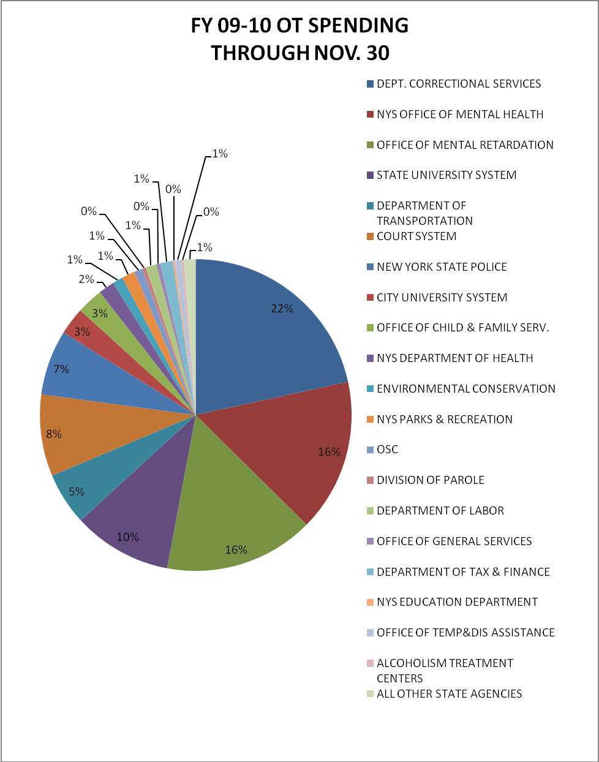

Report written by Gabriel Paniza (Senator Klein’s office) with assistance from Barbara O’Neill (Senator Savino’s office) and Gwendolyn Bluemich and Matt Reuter (Senator Klein’s office).
Information obtained from The 2008-2009 Executive Budget Agency Presentations by DOCS – pages 337 through 343: http://publications.budget.state.ny.us/eBudget0910/agencyPresentations/pdf/AgencyPresentations.pdf
Report obtained from written testimony provided On June 2, 2009 by the New York State Correctional Officers & Police Benevolent Association (NYSCOPBA): http://www.nyscopba.org/files/090602Testimony.pdf
Map provided by the Department of Correctional Services on their website: http://www.docs.state.ny.us/mapselec.html
Calendar year 2009 payroll information obtained directly from the Office of the State Comptroller
Photo obtained from NYSCOPBA testimony: http://www.nyscopba.org/files/090602Testimony.pdf
Contracting data obtained from the Office of the State Comptroller’s web portal Open Book New York: http://www.openbooknewyork.com/
Audits of specific DOCS facilities can be found on the Office of the State Comptroller’s website: http://www.osc.state.ny.us/audits/auditAgencyList.htm#Correctional Services ,Department of
Calendar year 2009 payroll information obtained directly from the Office of the State Comptroller
FY 2008-2009 and FY 2009-2010 OT spending data obtained directly from the Office of the State Comptroller
Analysis based on Calendar year 2008 data obtained through the Empire Center’s web portal See Through NY: http://www.seethroughny.net/
Calendar year 2009 payroll information obtained directly from the Office of the State Comptroller
Calendar year 2009 payroll information obtained directly from the Office of the State Comptroller
The following links to US Department of Health and Human Services: http://www.ahrq.gov/Clinic/ptsafety/chap46a.htm , and American Association of Nurse Anesthetists: http://www.aana.com/Resources.aspx?id=664 highlight the concerns with tired medical personnel.
Analysis based on Calendar year 2008 data obtained through the Empire Center’s web portal See Through NY: http://www.seethroughny.net/
NYSCOPBA provided written testimony at the hearings: http://www.nyscopba.org/files/090602Testimony.pdf
Photos of DOCS owned housing provided by NYSCOPBA
Information obtained directly from the Office of General Services
Search performed on www.zillow.com for homes in Greene County, New York.
Budget Policy and Reporting Manual B-300, dated 4/8/09; Employee Maintenance Policy and Charge Schedule for CSEA-,PEF-,UUP-, DC-37-Represented Employees and Management/Confidential Employees, provided by the Division of Budget.
Information based on a search performed on www.zillow.com for homes in the Town of Wallkill, New York.
Policy found in Budget Policy and Reporting Manual B-300, referenced above.

