
Teen Knowledge on Obesity and Its Lasting Effects: Results from the Teen Health Awareness and Education Survey

New York State Senate Majority Coalition Leader
Senator Jeffrey D. Klein

January 2014

Introduction

In the United States, the obesity crisis is now so severe that it is considered an equal, if not greater, public health threat than smoking. Illnesses stemming from obesity are projected to soon become the top avoidable cause of death in the nation. In New York, those individuals considered “obese” or “overweight” reached epidemic proportions during the past decade. In 2012, nearly a quarter (23.6%) of adult New Yorkers were obese, and just over three-fifths (60.6%) were overweight or obese. Since 1995, both categories grew by roughly 10%!

In the report F for Fat, released by the Trust for America’s Health and the Robert Wood Johnson Foundation, the State’s obesity rate is projected to reach 50.9% by 2030 if current trends are not reversed. This projection is largely due to the growth in childhood obesity. In 2012, New York was among the top 20 states with overweight or obese children aged 10 to 17. According to the National Survey of Children’s Health, 14.5% of New York’s children are obese, and 32.4% are overweight or obese. Disturbingly, the latter figure is greater than the national rate, which stood at 31.1%.

These trends must be reversed now. That is why combating childhood obesity continues to be one of my top legislative priorities. At the beginning of the 2013 Legislative Session, the Independent Democratic Conference and I kicked off the Teen Health Awareness Campaign. This campaign focuses on three major health issues: (1) alcohol and drug abuse, (2) endometriosis and (3) obesity.

As part of the campaign, the IDC launched the Teen Health Awareness and Education online survey. Over the last year, our office worked with middle schools, high schools and youth organizations to administer the survey. The online survey would allow New York’s teenagers to tell us what they really know about the health issues affecting their lives. By learning more about where our current health education is lacking, we can more effectively and efficiently distribute resources from the newly created Teen Health Education Fund. The following white paper includes the results of the obesity portion of that survey.

About the Survey

The Teen Health Awareness and Education survey, which can be found at www.TeenHealthNY.com, is a 23-question survey for teenagers in junior high and high schools throughout the State. The survey was designed to gauge knowledge on three issues that can have a great impact on teen health: obesity, substance abuse, and endometriosis. The survey is anonymous, allowing students to answer questions candidly.

As of January 8th 2013, 3,915 teenagers from across New York State responded to the survey.

Key Facts and Findings

28% of male and 26% of female teenagers do not know what the recommended amount of calories they should ingest daily

Only 45% of teenagers understand what the Body Mass Index measures, and 54% cannot identify the difference between being overweight and obesity

More than 3 in 5 teenagers understand they should get at least 1 hour of exercise a day, and limit “screen time” to 1 to 2 hours daily

New York’s teenagers are not fully aware of the breadth of weight management activities available to them. Only 55% knew about the benefits of seeking counseling if impacted by stress. Additionally, half of teenagers do not know about the benefits of a good night’s sleep on weight loss

Teenagers lack the necessary information on the health hazards of obesity, with nearly 1 in 5 respondents unable to identify even 1 complication

43% of respondents cannot identify the symptoms of type 2 diabetes, while 39% are not aware of the complications arising from the disease

Participation

Students were first asked a number of demographic questions, allowing us to gauge who exactly responded to the survey. The results are presented in the following charts. Female students were slightly more represented (56%) than their male peers (44%). Just over 40% of respondents were 12 years of age or younger. The next highest represented group were 15 to 16 year olds; making up 24% of respondents. The teenagers were followed by 13 to 14 year olds (17%), 17 to 18 year olds (13%), and 19 and older (3%).

Finally, students were asked to identify from which region of the state they reside. A quarter of respondents hailed from New York City, while nearly 75% were from the rest of the state. Other counties that were widely represented include Suffolk (1505 respondents), Albany (424), Nassau (347), Erie (148), and Washington (103).

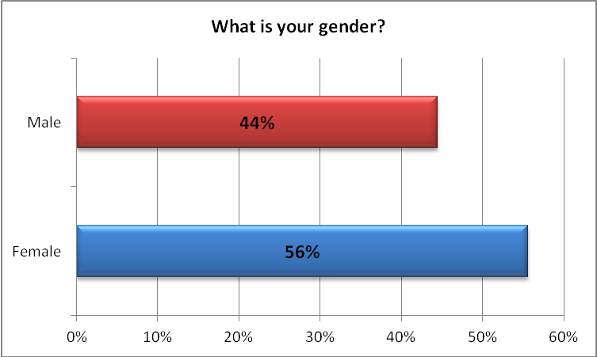

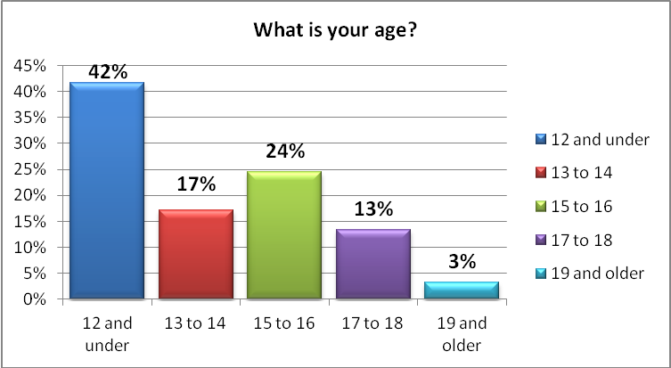

New York Teen Knowledge on Obesity Lacking
The Teen Health Awareness and Education survey offered wide ranging questions concerning proper eating habits, exercising habits, weight measurements and potential risks due to obesity. Respondents’ answers not only demonstrate gaps in education, but also how well equipped teens are form and maintain healthy habits.

Eating Habits

The survey’s first question asked how many calories they should ingest on a daily basis. According to the United States Department of Agriculture’s Dietary Guidelines, caloric intake varies depending on gender and activity level. Generally, more calories are needed as an individual matures from a child into an adult. Females also require fewer calories than males to ensure proper body growth and development.

Estimated Daily Calorie Needs by Age, Gender, and Physical Activity Level
 |  | Physical Activity Level
Gender | Age (years) | Sedentary | Moderately Active | Active
Female | 9-13 | 1,400 -1,600 | 1,600 - 2,000 | 1,800 - 2,000
Female | 14-18 | 1,800 | 2,000 | 2,400
Female | 19-30 | 1,800 - 2,000 | 2,000 - 2,200 | 2,400
Male | 9-13 | 1,600 - 2,000 | 1,800 - 2,200 | 2,000 - 2,600
Male | 14-18 | 2,000 - 2,400 | 2,400 - 2,800 | 2,800 - 3,200
Male | 19-30 | 2,400 - 2,600 | 2,600 - 2,800 | 3,000

The chart above highlights the average calories teenagers should consume based on gender, age, and activity level. Commonly, teenage girls should consume around 2,000 calories or less a day from age 9 to 30. It is recommended that females leading an active lifestyle consume over 2,000 calories to compensate for those burned off due to exercise.

Males, on the other hand, should regularly consume more than 2,000 calories. This is even the case for those who are sedentary or moderately active. In those instances, teenage boys must use caution and ensure they do not exceed a daily amount of 2,400 and 2,800 calories, respectively. Active teenagers should consume between 2,800 and 3,200 calories.

Our survey results tell us that different levels of understanding exist between teenage boys and girls when it comes to how much they should eat each day. One-third of female respondents indicated that they should eat under 2,000 calories. This is in line with the recommendations from the USDA.

However, 34% of females stated that they should consume between 2,000 to 3,000 calories. The USDA recommends only active females over the age of 14 should regularly take in greater than 2,000 calories. This means that over a third of all female respondents overestimate their recommended daily caloric intake by up to 1000 calories.

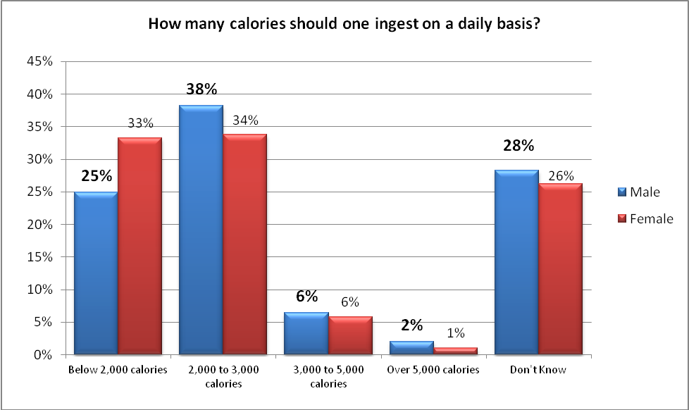

A quarter of the males surveyed responded that they should eat below 2,000 calories a day, while 38% responded that they should consume 2,000 to 3,000 calories. These results are not out of the ordinary as a plurality of respondents were 12 or under.

More disturbingly, 28% of boys and 26% of girls did not know the proper level of daily calories they should consume. Additionally, 8% of boys and 7% of girls indicated that over 3,000 calories should be ingested daily. This amount is clearly wrong.

These findings tell us that while many teenagers are informed of the proper amount of food they should eat daily, a startling number are not. Obesity education must emphasize this component, and reinforce how differences in gender and age influence eating habits. Caloric intake is a bedrock of health education. Without this critical piece of information, we cannot expect our teenagers to eat healthy and avoid obesity.

Of course it is not just how much you eat, but what you are eating that counts. Foods high in fat should be consumed less, and high-nutrition foods like fruits and vegetables should be consumed more. It is recommended by the USDA that teenagers eat 1-2 servings of fruit and 2-3 servings of vegetables daily. Our survey results show that a majority of New York’s teenagers recognize the importance of fruits and vegetables in their diets. For example, the majority of teens (57%) overestimated the number of servings of fruit they should eat daily, choosing 2-4 servings.

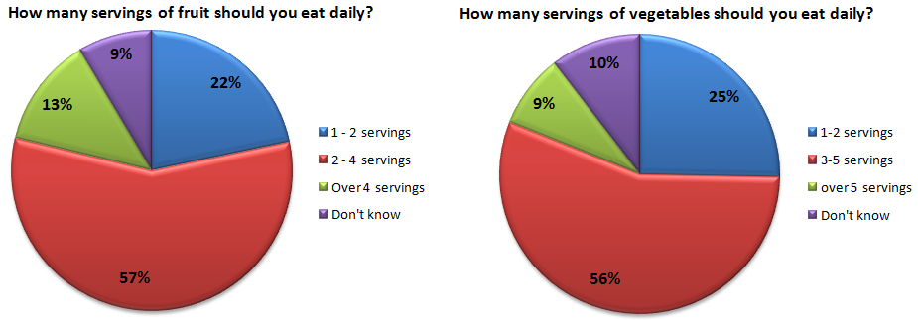

Nearly identical results were found for vegetables with 56% indicating that 3 - 5 servings should be eaten daily, and 25% choosing 1-2 servings. The only potential cause for concern is the last statistic, which indicates that there are still too many children who underestimate the number of vegetables required for a balanced diet. While only 10% did not know the proper amount of fruits and vegetables to eat daily, it reveals that we must stress this information so that every child can be reached.

Understanding How Obesity is Defined

In order to fight against obesity, teenagers must be able to understand and fully grasp what it is. Measuring one’s Body Mass index, or BMI can help teens more accurately assess their risk of suffering from obesity, weight management issues or other health factors they are

According to the Centers for Disease Control and Prevention, BMI is a number calculated from a person’s weight and height that is widely used as a screening tool for weight problems. BMI is seen as a more reliable indicator of body fatness because it takes into account the totality of a person’s physical characteristics. Therefore, two individuals may have the same BMI even if they are of varying height and weight.

According to the National Institute of Health (NIH), individuals with a BMI under 18.5 are considered underweight. Those with values between 18.5 and 24.9 are of normal weight. An individual is considered overweight if their BMI falls between 25 and 29.9. Once BMI exceeds a value of 30 an individual is obese.

BMI is a common obesity screening tool, making it that much more important that teenagers are familiar with this measure.

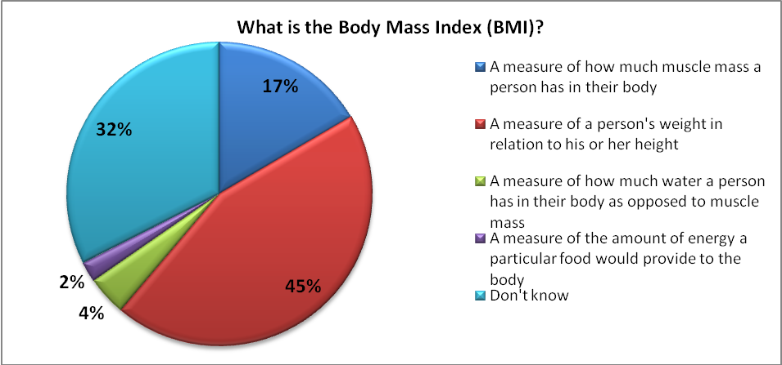

Unfortunately, knowledge of the measurement of BMI is not as widespread among New York’s teenagers as one would hope. Less than 50% of those surveyed could correctly identify what BMI measures. Teenagers were presented with four choices. The correct answer, “a measure of a person’s weight, in relation to his or her height”, was selected by only 45% of respondents. Seventeen percent selected “a measure of how much muscle mass a person has in their body”. Shockingly, almost a third (32%) answered that they did not know what BMI measured.

This is unacceptable. The first step in fighting obesity is recognizing that it is a problem, and understanding the benchmarks. BMI provides us with a way to clearly understand when we are at a normal weight, or how far we deviate from it.BMI is a critical tool in understanding one’s personal health and health education must stress the importance and value of BMI.

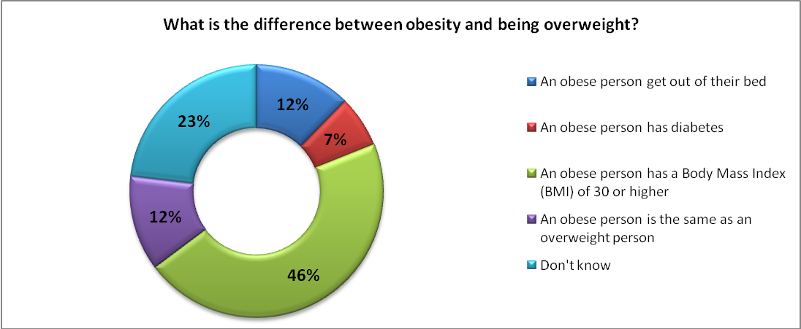

Teenagers were next asked what the difference between obesity and being overweight is. The same number of respondents who knew the correct definition of BMI also correctly identified the difference between obesity and being overweight. Just under half (46%) of individuals answered that an obese person has a BMI of 30 or higher. A quarter (23%) cannot tell the difference between the two. Additionally, 12% answered that the difference is than an obese individual cannot get out of their bed.

The failure of many children to understand these basic concepts further unveils a lack of teen health education. This lack of understanding will put teenagers at a disadvantage in reducing obesity levels. It is important that teenagers be able to differentiate between various levels of fitness as the consequences on one’s health vary for each.

Exercise Vs. Screen Time

One of the major battles in teenage fitness is making young men and women understand the importance of daily exercise. In today’s society there are numerous distractions pulling teens away from an active lifestyle. Foremost among them are the internet, videogames, and television.

Anytime spent in front of these devices is known as “screen time”. The NIH states that screen time should be limited to two hours or less a day. With the advent of smart phones and tablet devices, this is increasingly hard to accomplish. Additionally, half of children play video games, and two thirds have their own televisions.

Despite these obstacles, parents and educators must continue to stress this recommendation. Time spent in front of these devices is often time that could otherwise be spent being active, such as during after school or on the weekends. The USDA recommends that adolescents engage in at least 60 minutes of physical activity a day. Along with diet, this is the most important aspect to maintaining a healthy lifestyle. The USDA states that regular physical activity “helps people maintain a healthy weight and prevent excess weight gain”. The majority of the 60 minutes should be devoted to aerobic activity, with special attention also placed on muscle and bone-strengthening activity as well.

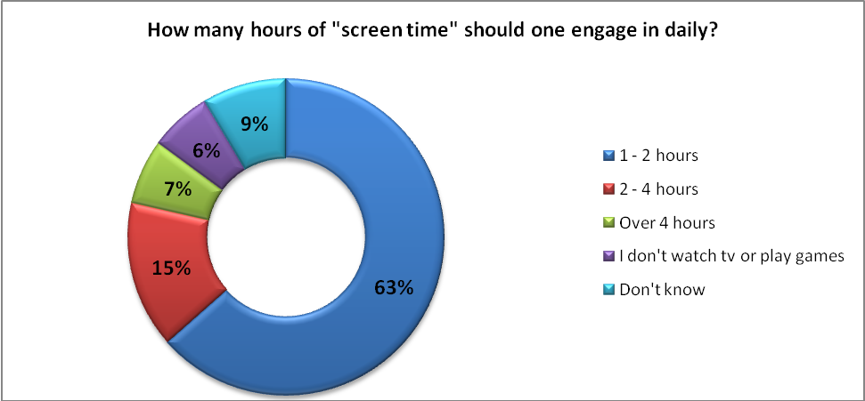

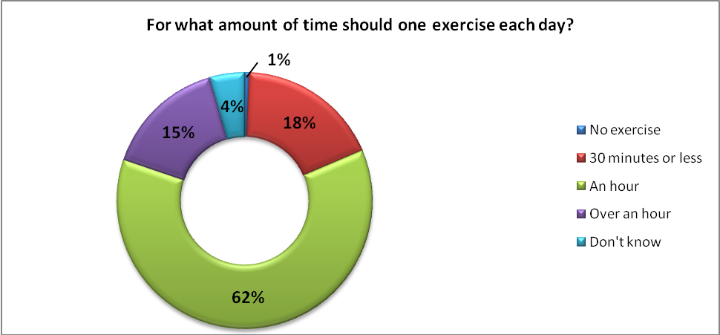

As the charts above demonstrate, New York State’s adolescents grasp the importance of limiting screen time. Over three-fifths (63%) of those surveyed answered that teenagers should only spend 1 to 2 hours engaging in screen time daily. A similar amount (62%) also correctly answered that they should get at least an hour of exercise each day. Furthermore, an additional 15% responded that teenagers should exercise for over an hour! The results of this component shows that teenagers are clearly informed on the balance that must be maintained between exercise and screen time. It is especially important given the less consistent results on questions regarding caloric intake, as discussed earlier in this report.

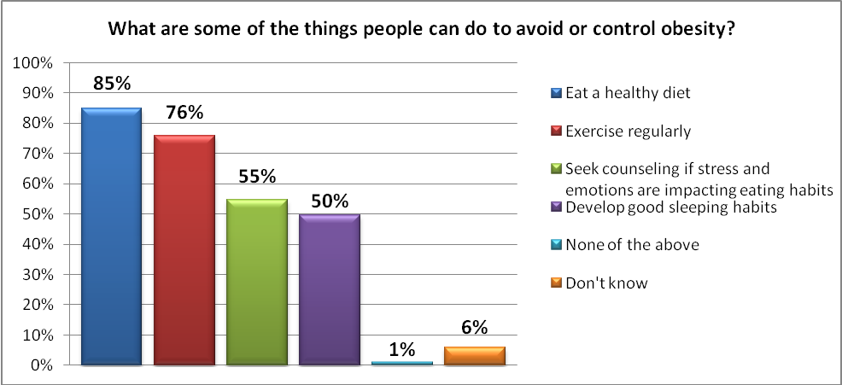

The final question regarding weight management asked adolescents to identify strategies that can be utilized to prevent or control obesity. Respondents were given four choices, and asked to select all that apply. These choices were “eat a healthy diet”, “exercise regularly”, “seek counseling if stress and emotions are impacting eating habits, and “develop good sleeping habits”. All these choices are identified as effective in the fight against obesity.

The answer most widely chosen was eating a healthy diet, with 85% of teenagers selecting this option. The second most selected was regular exercise with 76% of respondents choosing it. It is an excellent sign that nearly all adolescents participating in the survey selected these. They are the two leading strategies in preventing obesity, and it is obvious that New York’s health education provides clear instruction on these fundamentals to our children.

However, only half of respondents found the other two options useful. It is shown that individuals under high stress engage in “stress or emotional” eating to cope. Physicians recommend that learning how to handle such stress is a useful technique in managing one’s weight. Therefore, health education should make teenagers aware of counseling as a weight loss tool if they are feeling emotionally distressed.

Sleeping is also significantly related to obesity. A recent study on adolescents found that for each additional hour of sleep, the heaviest children reduced their BMI by an average of 0.28. Teenagers should be made aware of such findings. Our results show that 50% of teenagers do not realize the linkage that exists between sleep and weight levels. Health education must stress these techniques so that teenagers are aware of the full arsenal of techniques available to them in combating obesity.

The Health Hazards of Obesity

One of the most important facets of obesity education is learning about its consequences. Only through understanding these will teenagers truly appreciate the dangerous toll this disease can have on their lives. To gauge how New York’s teenagers are aware of these hazards, teenagers were given a list of conditions and asked to select all that may develop from being overweight. The chart below indicates the number of students that chose each option.
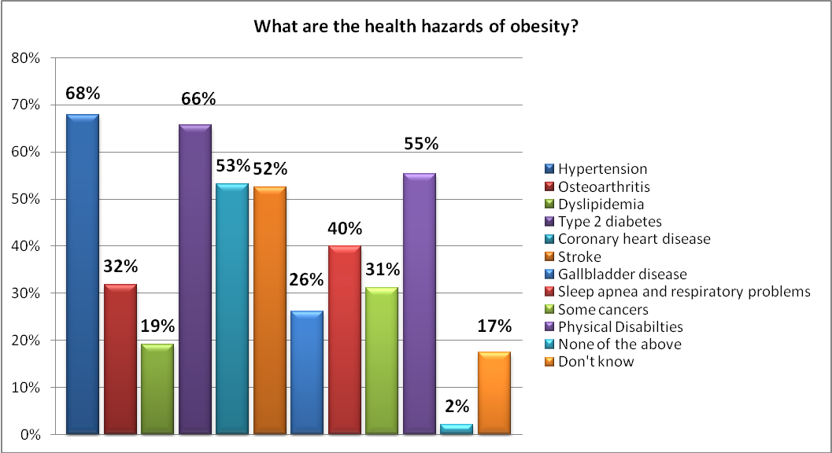

All choices are actually conditions that develop from obesity. As you can see, a majority of teenagers were only familiar with half of these. The two mostly widely understood health risks of obesity among respondents were hypertension (68%) and type 2 diabetes (66%). Half of the students also selected coronary heart disease (53%), stroke (52%), and physical disabilities (55%). While it is a positive that most students are aware of these conditions, they are also the most frequent side effects. More than half of teenagers should understand that the risk of heart disease is elevated for overweight individuals. Due to this, these results are inconsistent at best.

However, the true danger presented by these results is that many adolescents are unaware of the other serious conditions that can make life difficult. For instance, only a third of respondents (32%) selected osteoarthritis as a health hazard associated with obesity. This is one of the more common side effects of obesity. Traditionally, this is a joint problem affecting one’s knees, hips, and lower back. Being overweight puts pressure on the cartilage protecting the joints, causing it to wears away. Accordingly the bones rub together bringing severe pain, and decreasing an individual’s range of motion.

Teenagers were also unaware that obese individuals face an elevated risk for certain cancers. Obesity can result in higher levels of colon, breast, endometrial, and gallbladder cancers. Despite this, only 31% of those surveyed correctly selected this option. Another development without widespread understanding is sleep apnea, which was selected by only 40%. More fat is stored around the necks of obese individuals, constricting their airway, making breathing difficult.

Sadly, nearly one-fifth of adolescents (17%) were unable to identify any health hazards. This is simply unacceptable. Teenagers cannot appreciate the benefits of living a healthy lifestyle if they do not understand the consequences of overeating. We must do a better job of emphasizing these health hazards so students realize that poor dieting and exercise now oftentimes lead to a lifetime of bad health habits, which become increasingly difficult to reverse with age.

The final two questions relating to obesity asked students specifically about type 2 diabetes. This disease was singled out in our survey because adolescents are increasingly acquiring this disease. Prior to the 1990s, the incidence of type 2 diabetes among children was rarely seen. However, from 2002 to 2005, almost 3,600 cases occurred annually. Along with this increase, new studies show that type 2 diabetes is more difficult to treat in children. The usual oral medication used to treat this disease was found to stop working among children after a few years, while they are more effective for adults.

Unfortunately, many health consequences are brought about by type 2 diabetes. Complications include: heart disease, vision impairment, severe nerve damage, and kidney failure among others. It is important that students realize this because doctors stress that the disease must be treated immediately and aggressively if acquired.

Dr. Barbara Linder, a senior adviser at the National Institute of Diabetes and Digestive and Kidney Diseases, stated that, “You really have to be on top of these kids and individualize therapy for each person”. Accordingly, health education should teach the symptoms and complications related to type 2 diabetes to ensure that adolescents are able to identify the disease early if they are affected.

The two charts below highlight the results of our diabetes questions. What stands out most is the large number of teenagers that do not know about the symptoms or complications of type 2 diabetes. 43% percent of individuals did not know the signs that an individual contracted this disease, and 39% were unacquainted with effects on health.

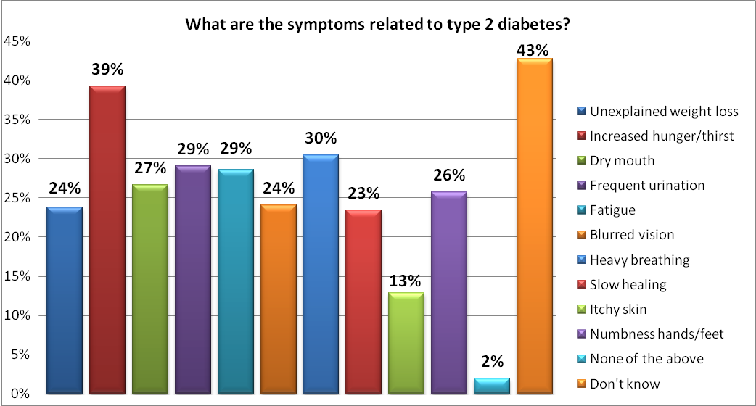

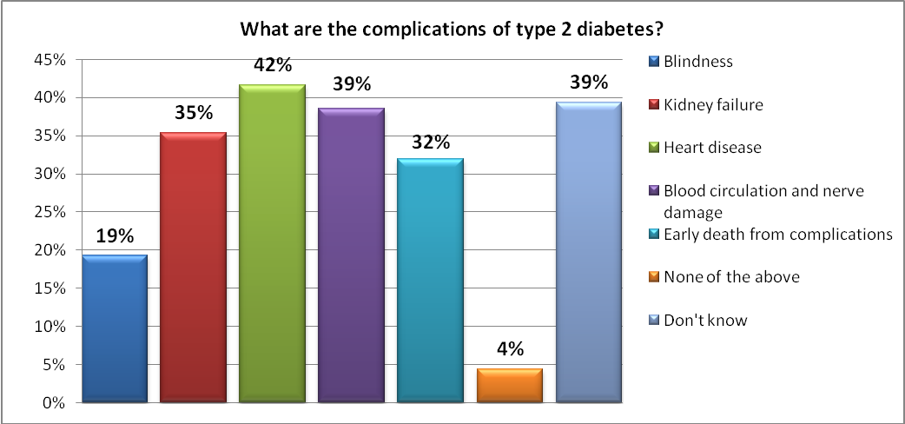

Given the necessity of immediate treatment, it is vital that adolescents learn more about type 2 diabetes. Without this knowledge, they will be less likely to effectively combat the disease should it appear in their lives. These results are extremely disappointing. Only one symptom was selected by over 30% of students, and that was increased hunger and thirst (39%). This is unacceptable, and must be improved going forward.

How New York Can Combat Adolescent Obesity

As a member of the New York State Senate, I have continually recognized the importance of fighting the rising incidence of obesity in our state. Just last session, I passed three important pieces of legislation that were recently signed into law by Governor Andrew Cuomo. These laws will have a real impact on the lives of our youth, and give them the tools needed to lead a healthy life.

These new laws would call on:

[S.2438]: The Department of Agriculture and Markets and Office of Community Gardens to increase the availability and affordability of locally produced fresh produce to areas of the state with high rates of obesity. This Department of Agriculture and Markets would also be charged with working with the Department of Health to help implement DOH’s Childhood Obesity Program and to work with the State Education Department to develop marketing campaigns to promote the consumption of healthful food in schools and in high-risk communities.

[S.2439]: The Department of Health to better inform educators on the incidence, prevention and treatment of obesity among children and adolescents by providing targeted trainings, programs and materials. Additionally, it would call on the Department of Financial Services to expand wellness education programs that combat obesity, while increasing access to these programs for insured patients; and

[S.2372]: The Department of Agriculture & Markets and the Office of Community
Gardens to work with local organizations on establishing more community gardens throughout New York State. Furthermore, this legislation would streamline the process of establishing a community garden by developing a single application for groups looking to use vacant land to establish community gardens. Finally, S.2372 would give the Commissioner of Agriculture & Markets the ability to convene a Community Gardens Task Force, bringing together the most knowledgeable minds on community gardens from relevant stage agencies, local communities and private parties.

These laws attack obesity by expanding education on the topic, and the presence of healthier foods to areas of the state in need of more nutritional foods. Our efforts do not stop here. There are a number of additional bills I hope to pass in the upcoming legislative session that will help to further reduce the incidence of obesity in New York. They include:

- S. 2331: This legislation would permit insurers and health management organizations (HMOs) providing individual or small group insurance policies to offer premium discounts or enhancements to individuals participating in qualified wellness programs. Passing this bill into law would provide a new avenue to keep health insurance rates low, while also encouraging individuals to participate in programs shown to improve physical and mental wellbeing.

- S. 2363: This bill would enact a number of provisions to curtail the incidence of asthma and other respiratory diseases, which include:
  - An Asthma Disease Management and Control Program would be established with the purpose of promoting management of the disease, and educational outreach to health care providers and the general public. DOH would also be required to study the incidence of asthma in the State, and current asthma management practices;
  - A program to prevent in-utero exposure to tobacco. Health care providers, insurers, and pregnancy programs will distribute information on the adverse effects of smoking during pregnancy;
  - New standards for the training of teachers and other personnel in identifying and responding to asthma emergencies;
  - Expansion of the law mandating the Department of Education to promulgate rules minimizing the discharge of school bus exhaust on school grounds by increasing the prohibition to all private vehicles. This will encourage drivers to turn off their engines thus reducing the emissions that can trigger asthma attacks; and
  - Increasing the number of students who can have and use an inhaler at school to include not only those with a “severe asthmatic condition”, but also individuals with “moderately severe asthmatic conditions” or “potentially life-threatening respiratory illnesses”. School districts would also be authorized to use nebulizers for students requiring such treatment.

- S. 2374: This legislation is referred to as the Omnibus Obesity and Respiratory Illness Reduction Act. While this includes a number of elements included in my legislation signed into law last session, there are a number of provisions that must still be passed. Foremost among them are:
  - Authorizing DOH to establish a voluntary artificial trans fat reduction program, and to require certain chain food establishments to disclose the nutritional information of their products;
  - Expanding the recreational areas that elementary and secondary schools provide for their students;
  - Establishing the Obesity and Respiratory Disease Research Fund. This would support the financing of projects studying these important diseases; and
  - Including a provision to alter the material taught in health, physical education, and appropriate science classes to include information on the health risks associated with childhood obesity and ways to combat it.

- S. 2437: This bill directs schools to increase screening for childhood obesity. This would be accomplished by expanding the activities that school health services engage in to examine students for the existence of diseases or disabilities relating to childhood obesity. Exams would also be able to include a diabetes risk analysis for students with a heightened risk of contracting the disease. Also, school district nutrition advisory committees will study and make recommendations on the district’s nutritional policies. Finally, to ensure that children and adolescents are getting their required daily exercise, elementary and secondary schools must ensure that student’s lunch periods are long enough to allow individuals to eat and engage in physical exercise.

Alongside these efforts, you can help as well. In the upcoming tax season, you will notice a new Teen Health Education Fund was created. This will appear on your tax return form. By checking this box you will be able to donate money to the fund, which will be used to expand health education throughout the state. Programs that most effectively address the pressing issues impacting adolescent health will receive funding.

By providing our teenagers with the information and tools necessary to lead a healthy lifestyle, they will find that it is not only easy to do so, but also in their best interest. As the survey results highlight, there is still much work that must be done. Few matters are more urgent than this. That is why I will continue to dedicate my time to accomplishing this, and ask that you join me.

Charles H. Hennekens and Felicita Andreotti, “Leading Avoidable Cause of Premature Deaths Worldwide: Case for Obesity,” The American Journal of Medicine 26.2, February 2013, http://download.journals.elsevierhealth.com/pdfs/journals/0002-9343/PIIS0002934312005475.pdf.
Press Release, Obesity Now Poses As Great a Threat to Quality of Life As Smoking, Am. Jrnl. Preventive Med., January 2010, available at http://www.ajpmonline.org/webfiles/images/journals/AMEPRE/AJPM_PR_Obesity_vs_Smoking.pdf; see also Rob Stein, Obesity Passing Smoking as Top Avoidable Cause of Death, Washington Post, March 10, 2004.
Centers for Disease Control and Prevention, Behavioral Risk Factor Surveillance System Prevalence and Trends Data, http://apps.nccd.cdc.gov/brfss/.
Trust for America’s Health and Robert Wood Johnson Foundation, F as in Fat: How Obesity Threatens America’s Future 2012, September 2012, http://healthyamericans.org/assets/files/TFAH2012FasInFatFnlRv.pdf.
The Data Resource Center for Child and Adolescent Health, National Survey of Children’s Health, http://www.childhealthdata.org/browse/survey.
United States Department of Agriculture and United States Department of Health and Human Services, Dietary Guidelines for Americans 2010, December 2010, 14, http://health.gov/dietaryguidelines/dga2010/DietaryGuidelines2010.pdf.
See the United States Department of Agriculture MYPlate and Food Pyramid Resources specifically “How Many Vegetables Are Needed Daily or Weekly” at http://www.choosemyplate.gov/printpages/MyPlateFoodGroups/Vegetables/food-groups.vegetables-amount.pdf, and “How Much Fruit is Needed Daily?” at http://www.choosemyplate.gov/printpages/MyPlateFoodGroups/Fruits/food-groups.fruits-amount.pdf.
Centers for Disease Control and Prevention, About BMI for Children and Teens, September 13, 2011, http://www.cdc.gov/healthyweight/assessing/bmi/childrens_bmi/about_childrens_bmi.html#How%20is%20BMI%20used%20with%20children%20and%20teens.
National Institutes of Health, Calculate Your Body Mass Index, http://www.nhlbi.nih.gov/guidelines/obesity/BMI/bmicalc.htm.
National Institutes of Health, Reduce Screen Time, http://www.nhlbi.nih.gov/health/public/heart/obesity/wecan/reduce-screen-time/index.htm.
Ibid.
Ibid, 17.
Edward T. Creagan, M.D., “Stress Management,” Mayo Clinic, July 23, 2011, http://www.mayoclinic.com/health/stress/AN01128.
Nicholas Bakalar, “Sleep Less, Weigh More,” The New York Times, April 10, 2013, http://well.blogs.nytimes.com/2013/04/10/less-sleep-more-weight/?_r=0.
See the National Institutes of Health “What are the Health Risks of Overweight and Obesity?” at http://www.nhlbi.nih.gov/health/health-topics/topics/obe/risks.html, and the Centers for Disease Control and Prevention’s “The Health Effects of Overweight and Obesity” at http://www.cdc.gov/healthyweight/effects/.
Denise Grady, “Obesity-Linked Diabetes in Children Resists Treatment,” The New York Times, April 29, 2012, http://www.nytimes.com/2012/04/30/health/research/obesity-and-type-2-diabetes-cases-take-toll-on-children.html?_r=0.
The Mayo Clinic, “Diseases and Conditions: Type 2 diabetes,” http://www.mayoclinic.org/diseases-conditions/type-2-diabetes/basics/complications/CON-20031902.
Grady, “Obesity-Linked Diabetes in Children,” The New York Times.

