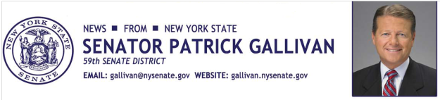

March 23, 2015
For Immediate Release
Contact: Jim Ranney
716.656.8544
716.256.9001

SENATOR GALLIVAN ANNOUNCES SENATE PASSES ALIX’S LAW FOR THE 4TH TIME

BILL TO CRACK DOWN ON DRUNK DRIVERS WHO LEAVE THE SCENE OF AN ACCIDENT IS IN RESPONSE TO 2011 DEATH OF ALIX RICE

Senator Patrick M. Gallivan (R-C-I, Elma) announces the New York State Senate has once again approved Alix’s Law, which makes it illegal to leave the scene of an accident while intoxicated. This is the fourth consecutive year that the Senate has approved the bill and sent it to the Assembly, where it has stalled in the past. The final vote in the Senate was 56-0.
The legislation (S.405) is named for Alix Rice, a Western New York teenager who was killed in 2011. Rice was struck by a drunk driver as she rode home on her long board in the Town of Amherst. The driver argued that he was not aware he had hit a person and he was acquitted on the felony charge of leaving the scene of an accident. The defendant was convicted on a lesser charge of operating a vehicle while under the influence of alcohol.
“Once again, the Senate has unanimously supported this legislation that closes a dangerous loophole in the law and holds drunk drivers accountable for their actions,” Senator Gallivan said.
The current law only requires drivers to report an accident when they know or have reason to know the accident resulted in an injury or property damage, allowing drunk drivers to flee the scene of an accident they caused and later claim they did not know any injury or damage occurred.
The legislation modifies the current statute so that drivers illegally operating their vehicle under the influence of drugs or alcohol are held responsible when they leave the scene of an accident. It also presumes that an intoxicated driver knew, or has reason to know, that damage or injury has occurred and should have stopped to investigate.
"I urge the Assembly to do the right thing by bringing this bill to the floor for a vote,” Gallivan said. “We must ensure that those who engage in reckless behavior that results in the death or injury of an innocent person are held responsible.”
Alix's Law" previously passed the Senate in 2012, 2013 and 2014 with bipartisan support, but stalled in the Assembly. This year the measure is being sponsored by Assemblywoman Crystal Peoples-Stokes (D-Buffalo).

-30-

