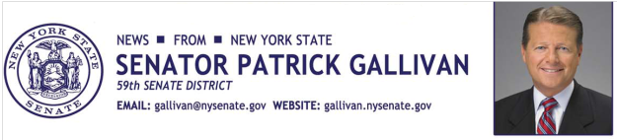
September 2, 2014
For Immediate Release
Contact: Jim Ranney
716.656.8544 or 716.256.9001

SENATOR GALLIVAN ANNOUNCES A FREE ELECTRONICS RECYCLING EVENT

RESIDENTS URGED TO DROP-OFF UNWANTED ELECTRONICS AT
WEST SENECA EAST HIGH SCHOOL

Senator Patrick M. Gallivan (R-C-I, Elma) is teaming up with Sunnking, Time Warner Cable and the East Leads student organization at West Seneca East High School for an electronics recycling event on Saturday, September 27. Residents can drop-off and properly dispose of electronic devices free of charge between 9:00 a.m. and 2:00 p.m. at the school at 4760 Seneca Street. Those dropping off items should enter the school from Center Street.

“It’s so important to our environment and future generations that we safely dispose of our old electronic devices, such as computers, TV’s and other small appliances. Many of these items contain dangerous material that cannot be placed in landfills. I invite residents to take advantage of this opportunity to get rid of their unwanted electronics and help protect the environment at the same time,” Gallivan said.

Sunnking will accept almost all devices that have a circuit board or a cord, including; computers and computer accessories, printers, ink and toner cartridges, monitors, televisions, microwave ovens, copiers and fax machines, telephones, radios, video and audio equipment and most small appliances.

Items that will not be collected include refrigerators, air conditioners, de-humidifiers, and CRT televisions and monitors with broken glass. A complete list of acceptable and non-acceptable items is available at: http://www.sunnking.com

Sunnking has electronic recycling facilities in Buffalo and Rochester and specializes in dismantling, sorting, refurbishing and reselling electronics and equipment. The “e-waste” recycling process minimizes the amount of hazardous and harmful materials that would normally end up in landfills.
-30-

