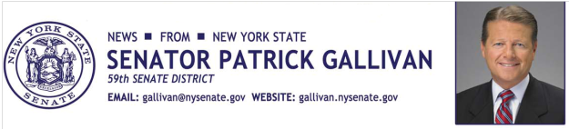

October 30, 2014
For Immediate Release
Contact: Jim Ranney
716.656.8544
716.256.9001

SENATOR GALLIVAN & ERIE COUNTY CLERK CHRIS JACOBS TEAM UP TO INCREASE ORGAN DONATIONS

BOTH SAY CHANGES MUST BE MADE IN HOW LAUREN’S LAW IS IMPLEMENTED IN ORDER TO ACHIEVE GOAL

Senator Patrick M. Gallivan (R-C-I, Elma) and Erie County Clerk Chris Jacobs say a state law designed to increase organ donations has not been implemented as intended by the Department of Motor Vehicles. Gallivan and Jacobs are calling on DMV Commissioner Barbara Fiala to make the necessary changes to the department’s computer system in order to comply with the spirit of Lauren’s Law.
The goal of Lauren’s Law is to increase the number of individuals signing up to be organ donors when they apply for a driver’s license, renew their license or apply for a non-driver identification card through the DMV. The legislation, named for heart transplant survivor Lauren Shields, was co-sponsored by Gallivan and passed by the legislature. It was signed into law in October 2012. It requires applicants to check either “yes” or “skip this question” under the organ donor registry section of the application. In the past, the question was considered optional.
“The idea behind Lauren’s Law is simple, to require applicants to consider becoming an organ donor, while still protecting an individual’s right to decline enrollment. But the DMV computer system has not been changed to comply with this policy, meaning the question regarding organ donation can still be skipped during the application process,” Gallivan said.
Jacobs suggests a minor alteration to the DMV software to make the organ donation section a “hard stop,” meaning the application or renewal process would not proceed without the organ donation section being completed.
“I encourage Commissioner Fiala to make this simple change in order to comply with the spirit of Lauren’s Law. Asking applicants who are 18 years of age and older whether they want to be an organ donor and giving them a chance to think about it, could have a profound impact on increasing organ donations and ultimately saving lives. We need to make sure DMV computers are updated to ensure the original intent of the law is carried out,” Jacobs said.
In New York State, only 22 percent of eligible people are enrolled in the organ donation program. The national average is about 47 percent. Meanwhile, more than 10,000 New Yorkers are awaiting an organ transplant.

“Last year, more than 500 New Yorkers died while waiting for transplants, and nearly 400 became too sick to stay on the waiting list. New York State has one of the lowest organ donor registration rates, and we need to do more to provide opportunities for life-saving transplants,” said Mark Simon, President & CEO of Unyts, Western New York’s organ, eye, tissue and community blood center.

Lauren Shields received a heart transplant in 2009. The Rockland County girl, now 13, had to be put on life support while waiting nearly two months for a life-saving transplant. She and her family pushed for the legislation in hopes of adding more people to the list of organ donors.

-30-

