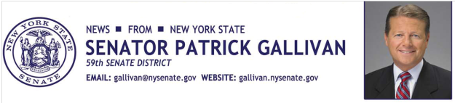
August 11, 2014
For Immediate Release
Contact: Jim Ranney
716.656.8544 or 716.256.9001

SENATOR GALLIVAN ANNOUNCES FUNDING FOR LOCAL LIBRARIES

GRANTS TO SUPPORT TECHNOLOGY BASED PROGRAMS

Senator Patrick M. Gallivan (R-C-I, Elma) announced grants for more than two dozen public libraries throughout his 59th State Senate District, which covers all of Wyoming County and portions of Erie, Livingston and Monroe counties. In all, 26 libraries will share a total of $72,500.

“Public libraries continue to play a vital role in communities across the state, providing residents with free access to books, videos, computers and the internet. As technology advances, it is critical that our libraries keep pace in order to provide a place where patrons can do research, advance their education or write a resume. These grants will help to do that,” Gallivan said.

Gallivan secured the library funding during the recently completed legislative session. The grants are to be used for technology related expenditures, including the purchase of computer equipment and software, or to support training programs for patrons.

The following libraries will receive funding:

Arcade Free Library | $2,500
Aurora Town Library | $2,500
Avon Free Library | $2,500
Boston Free Library | $2,500
Caledonia Library | $2,500
Concord Public Library | $2,500
Cordella A. Green Library | $2,500
Eagle Free Library | $2,500
Eden Public Library | $2,500
Elma Public Library | $2,500
Ewell Free Library | $2,500
Henrietta Public Library | $5,000
Lancaster Public Library | $5,000
Lima Public Library | $2,500
Marilla Free Library | $2,500
Perry Public Library | $2,500
Pike Library | $2,500
Scottsville Public Library | $2,500
Stevens Memorial Community Library | $2,500
Town of Collins Public Library | $2,500
Town of Gainesville Public Library | $2,500
Town of North Collins Public Library | $2,500
Wadsworth Public Library | $2,500
Warsaw Public Library | $2,500
West Seneca Public Library | $5,000
Wyoming Free Library | $2,500

-30-

