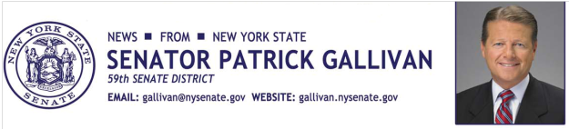

November 7, 2014
For Immediate Release
Contact: Jim Ranney
716.656.8544
716.256.9001

SENATOR GALLIVAN SAYS STATE EFFORTS ARE REDUCING THE COST OF MEDICAID FOR LOCAL GOVERNMENTS

MANDATE RELIEF PROJECTED TO SAVE WNY COUNTIES AND TAXPAYERS MILLIONS OVER FOUR YEARS

Senator Patrick M. Gallivan (R-C-I, Elma) says state efforts to provide mandate relief will save county governments across Western New York millions of dollars in Medicaid costs over the next four years. Gallivan says initiatives implemented in 2013, gradually reduce the Medicaid burden on local governments by having the state assume more of the costs associated with the program. The effort will provide counties the opportunity to pass the savings along to residents in the form of property tax cuts.
“Mandate relief is a key component of our ongoing effort to reduce New York’s high property taxes, and for county governments there is no greater burden than Medicaid. By putting a cap on the local share of Medicaid costs, we can help counties control expenses, avert program and service cuts and reduce property taxes,” Gallivan said.
Medicaid typically consumes the lion’s share of an individual county’s local property tax levy and is one of the fundamental causes for high property taxes on the local level. Since 2005, the state has capped the local increase in Medicaid costs at 3-percent. In 2013, the increase was capped at 2-percent, and in 2014 it was capped at 1-percent. In 2015, the cap will be zero, meaning no increase in Medicaid costs for local governments.

Under the Medicaid cap, the total projected savings over the next four years will be $33-million in Erie County, $28.3 million in Monroe County, $7-million in Niagara County, $4.9 million in Chautauqua County, $2.6 million in Cattaraugus County, $1.5 in Genesee County, $1.4 million in Livingston County and $855,000 in Wyoming County. Statewide, the savings is expected to be $1.17 billion.
Legislation introduced by Gallivan (S.153-A) would go even further to ease the burden of Medicaid by eventually eliminating the portion paid by local governments.
“The Medicaid cap is a great start. But we have to do more to do away with this unfunded mandate imposed on local governments by the state,” Gallivan said.
Even with a state takeover of the entire cost of Medicaid, additional tax increases are not anticipated because of reforms within the program and savings created by the federal Affordable Care Act.

-30-

