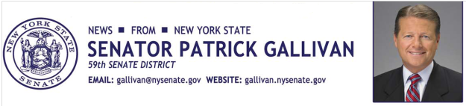

September 23, 2014

For Immediate Release

Contact: Jim Ranney

716.656.8544

716.256.9001

**SENATOR GALLIVAN DISCUSSES AGRICULTURE AT NYSAC**

*ATTENDS BLUE RIBBON TASK FORCE ON THE FUTURE OF FARMING*

Senator Patrick M. Gallivan (R-C-I, Elma) participated in a meeting today of the Blue Ribbon Task Force on the Future of Farming in New York State. The roundtable discussion was at the New York State Association of Counties’ (NYSAC) Fall Seminar at the Buffalo Niagara Convention Center in Buffalo.

“As a member of the Senate Committee on Agriculture, it is incredibly valuable for me to hear directly from local government officials on important agriculture related issues so that we can work together to improve conditions for farmers across New York State,” Gallivan said.

More than 45 county officials participate in the Task Force to confront issues that have a direct impact on New York’s agriculture industry. Topics discussed included state funding for agriculture programs, infrastructure needs in rural communities and regulation reform/mandate relief.

“Agriculture is big business in my district and across the entire state and we have to do all we can to make sure the industry remains strong,” Gallivan said.

Gallivan’s 59th Senate District includes all of Wyoming County, which leads the state in dairy production, and portions of Erie, Livingston and Monroe counties.

-30-