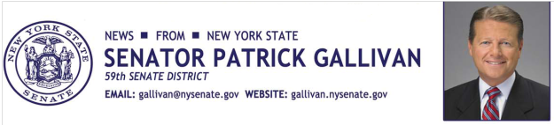
July 7, 2014
For Immediate Release
Contact: Jim Ranney
716.656.8544
716.256.9001

SENATOR GALLIVAN TO HOST NONPROFIT BUSINESS SUMMIT

JULY 23RD EVENT WILL BE HELD AT HOUGHTON COLLEGE IN WEST SENECA

Senator Patrick M. Gallivan (R-C-I, Elma) is teaming up with Houghton College and leaders in the nonprofit business community to present a special summit to address the challenges facing nonprofit organizations. The free event will be held July 23 from 7:00 p.m. to 9:00 p.m. at Houghton College’s West Seneca Campus, 2732 Transit Road.

“Guiding and growing a nonprofit business in today’s economy can be a real challenge. This summit is an opportunity for organizations to come together to network and share ideas,” Gallivan said.

Senator Gallivan is a member of the Senate’s Standing Committee on Commerce, Economic Development and Small Business. The committee is responsible for overseeing and developing legislation and policy relating to state regulations, mandates, tax credit programs, and growth incentives for all business sectors in the state. Senator Gallivan will discuss efforts in Albany to help small business succeed, including nonprofit organizations.

The summit will also feature Tom Lynch, President and CEO of Goodwill Industries. He will present a program titled “Essential For-Profit Principles for Nonprofits.” Lynch has been at the helm of Goodwill Industries since 2011. The $6 million nonprofit organization has 300 employees, a number of retail sites and provides services to thousands of Western New Yorkers.

Unyts, the area’s only organ, eye, tissue, and community blood center is a proud co-sponsor of the event. Anyone interested in attending the event can get more information by calling Senator Gallivan’s office at 656-8544. You can also register online at:

http://www.houghton.edu/adult-education/gallivannonprofitsummit/
-30-

