 | 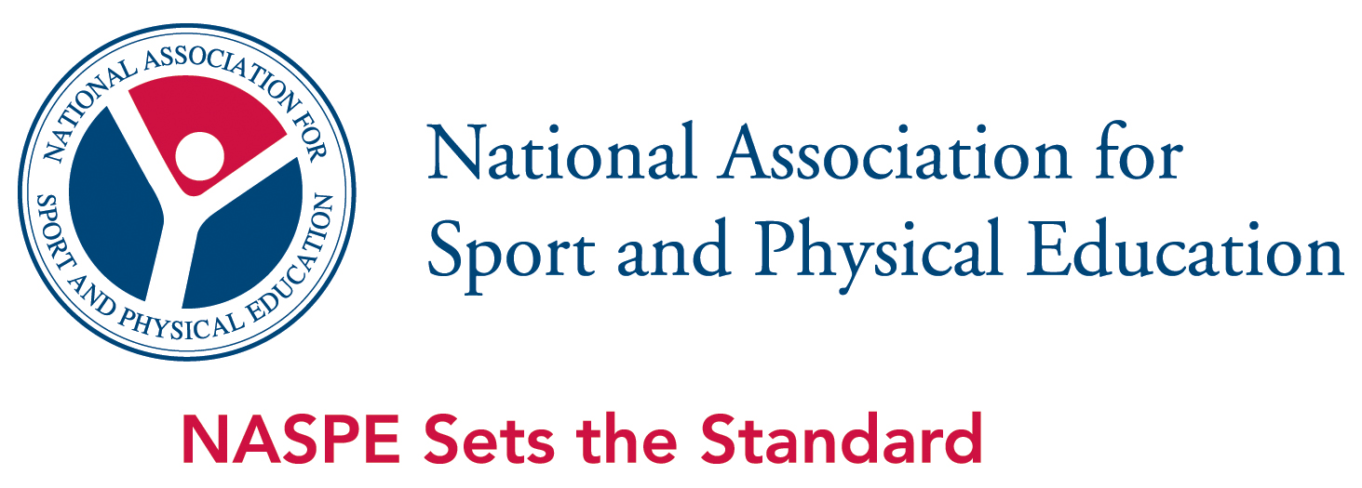
PRESS RELEASE | Atlanta, September 8, 2011

Glendaal Elementary School Receives Grant to Get Kids Moving

ING Run For Something Better School-Based Running Programs Help Students
Learn Healthy Choices and Take Responsibility for Their Own Fitness

ING today announced Glendaal Elementary School (Scotia, New York) as one of 50 recipients from 24 states across the United States to receive an up to $2,500 grant to inspire students to be more active and adopt healthy choices to carry into adulthood. In its second year, the ING Run For Something Better® School Awards Program, presented by financial services leader ING in partnership with the National Association for Sport and Physical Education (NASPE), is helping to introduce kindergarten through eighth-grade students across the country to the benefits of running and active lifestyles through school-based running programs.
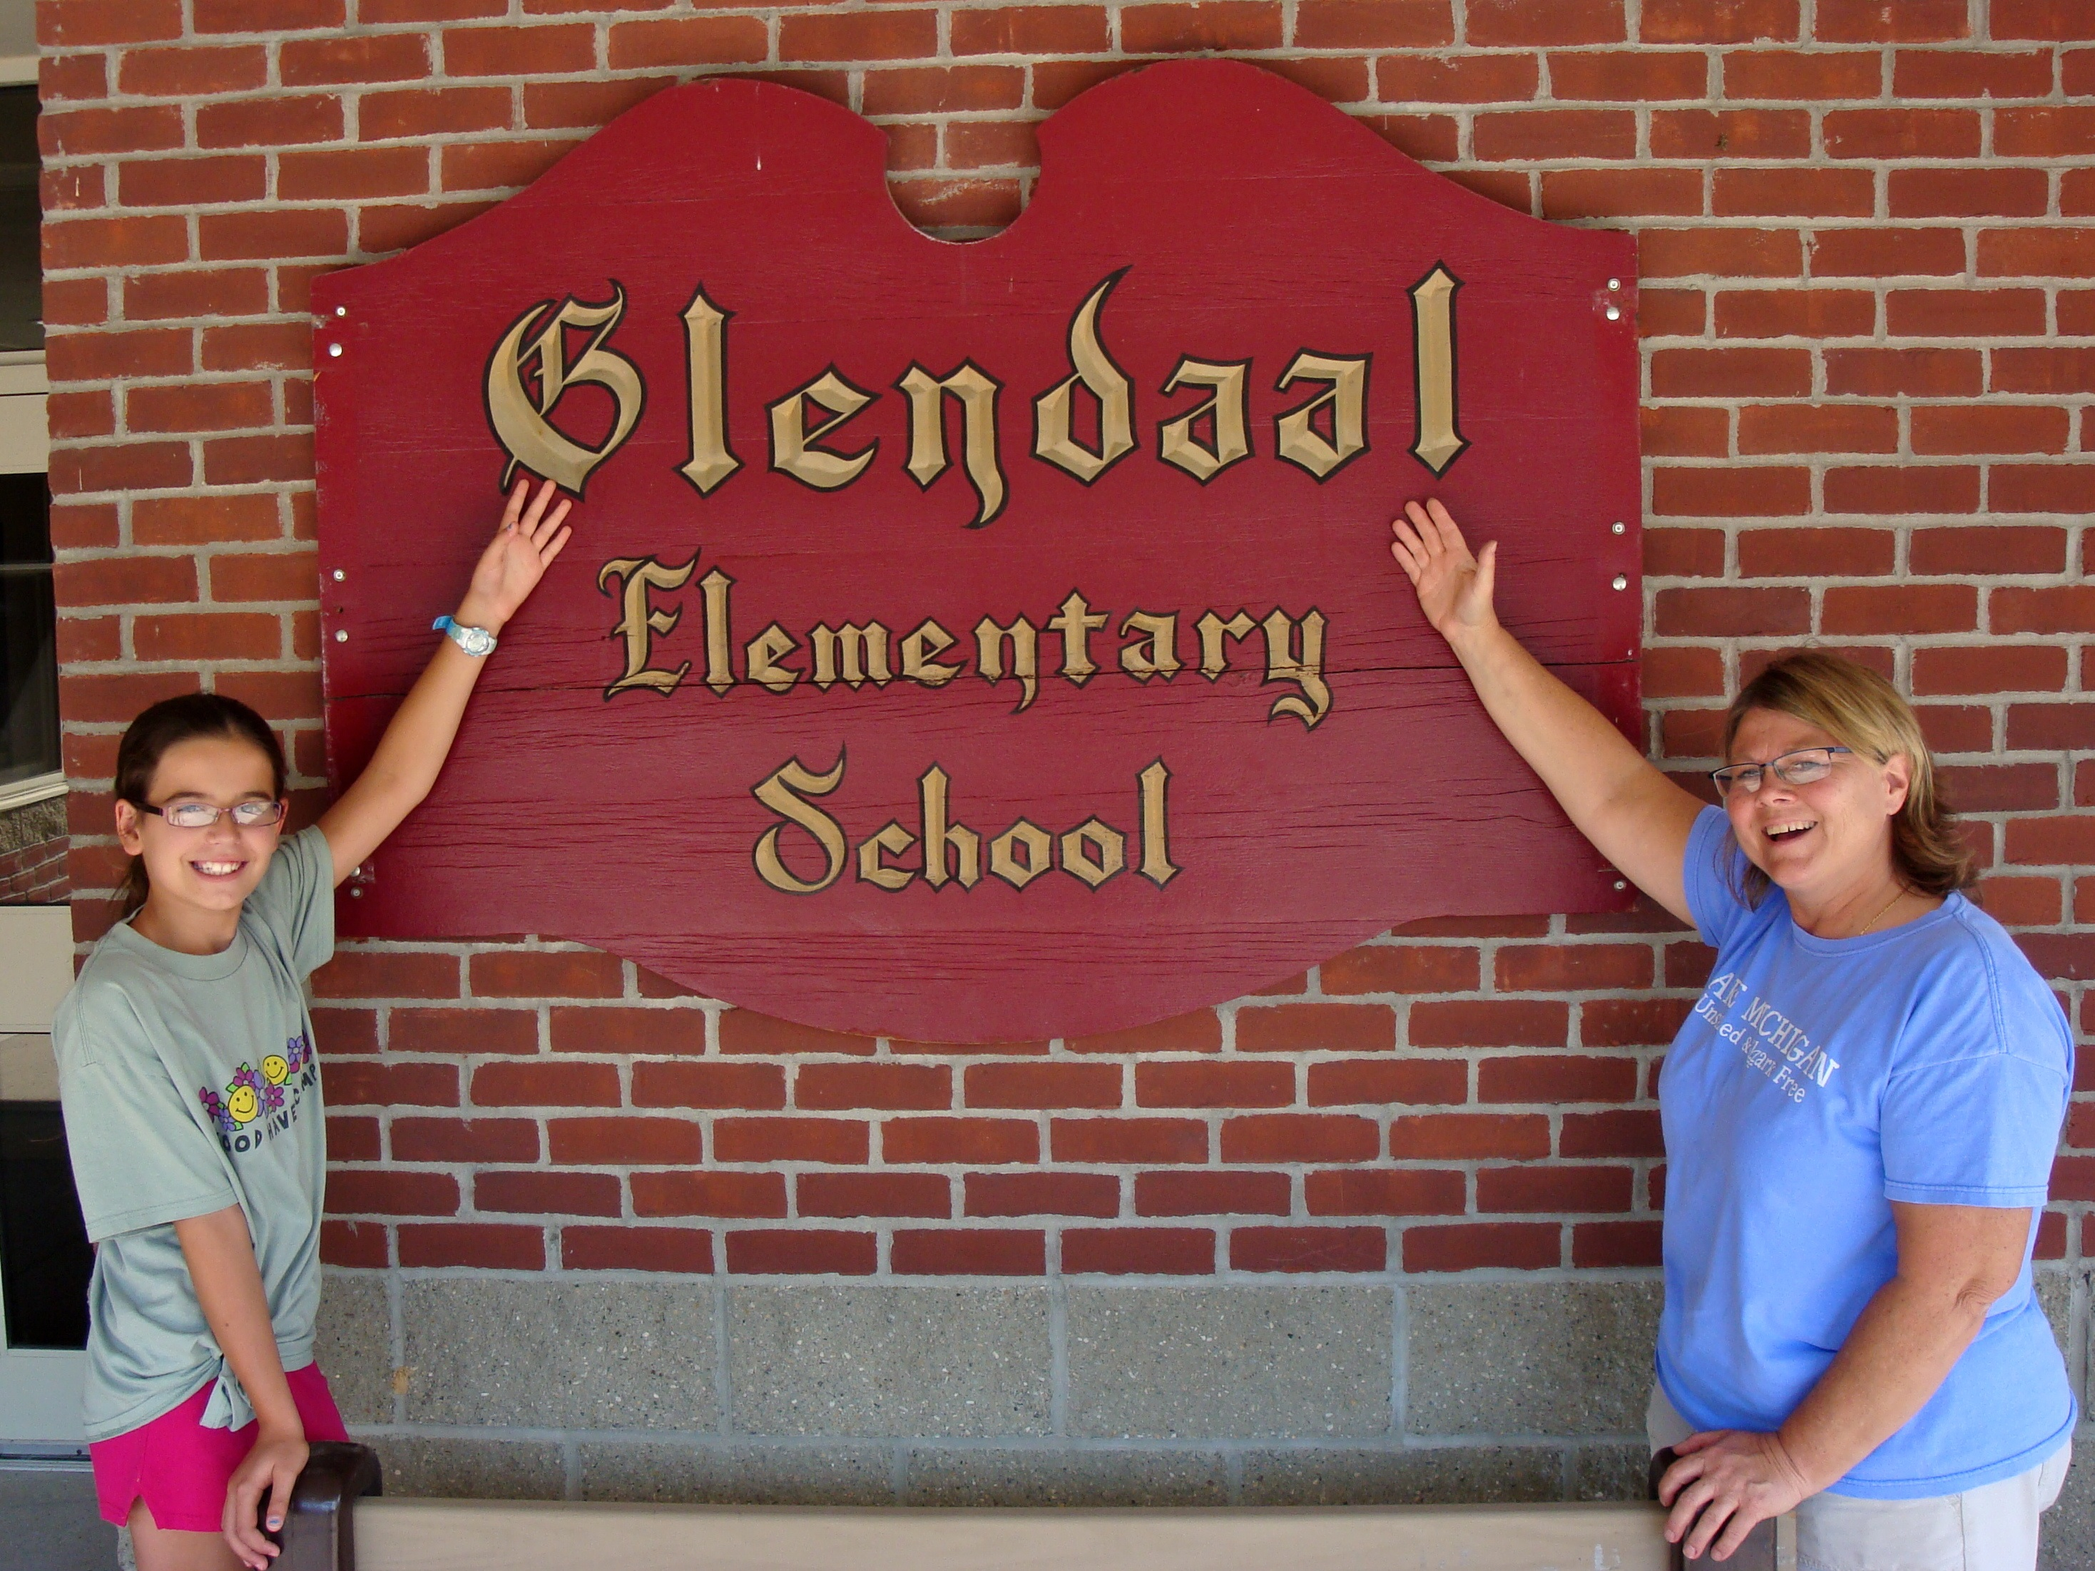
Glendaal Elementary School will receive up to $2,500 in funding to support a minimum of an eight-week running program that will conclude with a culminating running event in celebration of the students’ achievements. Glendaal Elementary School will receive $1,000 immediately, with additional funds granted based on the participation in the program. Schools can download unique running lesson plans developed by NASPE and based on the National Standards for Physical Education (NASPE, 2004) to serve as the foundation of the running program or to supplement an existing school program. Other program materials, such as sample eight-week training plans, distance logs, a running journal and access to a free timing system will aid in the development of running skills and preparation for a culminating running event.
Carol Atkins will oversee the ING Run For Something Better program

“ING is pleased to provide grants to schools across the nation to help them engage students in healthy lifestyles changes, personal development, goal-setting and group participation,” said Rhonda Mims, president of the ING Foundation and senior vice president, ING’s Office of Corporate Responsibility. “Understanding the connection between student achievement and physical well being, we are committed to making it easier for educators to empower their students to achieve a better future. ING Run For Something Better allows us to make a positive impact on educators and their students.”

Grant awards were available in all states and the District of Columbia to elementary or middle schools for running programs that targeted kindergarten- through eighth-grade students. Over 300 schools applied for the 2011 ING Run For Something Better School Awards Program. A NASPE review board consisting of 190 teachers and education administrators reviewed all applications.

In 2010, the ING Run For Something Better School Awards Program awarded 60 grants to schools in 27 states providing 4,117 students the opportunity to discover running as a fun and easy way to increase physical activity and learn how to make healthy lifestyles choices. Students participating in the program ran a total of 123,580 miles – that’s almost 41 times across the United States!

“NASPE is thrilled to see real, positive, tangible results in the student’s health over the first two years of this exciting program,” explains NASPE Executive Director, Charlene Burgeson. “Participating schools showed an average of 31.2% increase in aerobic cardiovascular endurance in students from the start to the conclusion of these running programs, double from the prior year. NASPE is proud to be part of an effort that is making real changes in the lives of our nation’s youth, giving them the opportunities and tools needed to build a foundation for healthy and active lives.”

To learn more about the impact of this program and how to get your school involved, including downloading program materials, visit www.naspeinfo.org/run.

###

Press inquiries:
Phil Margolis Paula Kun
ING NASPE
Office: 860.580.2676 Office: 703.476.3461
Cell: 860.805.7642 pkun@aahperd.org
phil.margolis@us.ing.com

About ING
ING’s U.S. operation is part of a Dutch-based ING Groep NV. In the U.S., the ING (NYSE:ING) family of companies offers a comprehensive array of financial services to retail and institutional clients, which includes life insurance, retirement plans, mutual funds, managed accounts, alternative investments, institutional investment management, annuities, employee benefits and financial planning. ING holds top-tier rankings in key U.S. markets and serves approximately 15 million customers across the nation.

ING’s diversity management philosophy and commitment to workforce diversity, diversity marketing, corporate citizenship and supplier diversity fosters an inclusive environment for employees that supports a distinctive product and service experience for the financial services consumer.

For more information, visit http://ing.us.

About the ING Run For Something Better®
The ING Run For Something Better® helps fund school-based running programs in an effort to combat childhood obesity before it ever begins. Linked to ING’s commitment to education, the program helps introduce kids to the benefits of sport, a habit of physical fitness, and a healthy lifestyle. Nationally, ING has committed over $2.5 million to fund grants and school-based running programs through ING Run For Something Better. Since 2006, close to one million dollars has also been raised by individual donors through a special charitable fund to encourage others to support the cause by making their own contributions. When someone donates $10 or more to the ING Run For Something Better, ING will recognize their contribution by giving them a special pair of orange shoelaces to wear showing that they are “tied” to supporting kids’ fitness. One hundred percent of the net proceeds go to the ING Run For Something Better fitness programs.
For more information about the orange laces, go to www.orangelaces.com.
About the ING Community Fund
The ING Community Fund’s mission is raise funds for, support, and help coordinate the ING Run For Something Better, a national multi-faceted educational program designed to introduce children to the benefits of running, physical fitness and healthy lifestyle choices. Funding for the ING Community Fund comes from donations collected through the ING Run For Something Better “orange laces” effort and by the ING Foundation.

For more information, visit www.ing-usafoundation.com.

About NASPE
The preeminent national authority on physical education and a recognized leader in sport and physical activity, the National Association for Sport and Physical Education (NASPE) is a non-profit professional membership association that sets the standard for practice in physical education and sport. NASPE’s 15,000 members include: K-12 physical education teachers, coaches, administrators, researchers, and college/university faculty who prepare professionals in these areas. NASPE seeks to enhance knowledge, improve professional practice, and increase support for high-quality physical education, sport and physical activity programs. It is the largest of the five national associations that make up the American Alliance for Health, Physical Education, Recreation & Dance (AAHPERD). For more information, visit www.naspeinfo.org.

