

Affordable New York:
The Social and Economic Need for Family Leave Insurance in New York

February 2014

Executive Summary
In these challenging economic times it is becoming increasingly difficult to raise and care for a family. These major events demand a great amount of time and devotion. Unfortunately, it is impossible for many to take a leave of absence from work to devote the necessary time to raising a newborn, or ensure their elderly parents receive proper care. Only 12% of all workers are provided with Family Leave Insurance (FLI) from their employers. That number falls to 5% for lower income individuals. Additionally, over 40% of employees nationwide qualify for unpaid leave through the national Family and Medical Leave Act.

These numbers highlight that too many New Yorkers cannot access paid leave. That is why the Independent Democratic Conference included FLI within its Affordable NY Initiative. This will provide a weekly benefit to employees to bond with a new child, or care for a relative with a serious illness. This benefit not only extends to biological mothers, but fathers; adoptive and foster care parents; and same sex couples. These individuals would be able to claim this benefit for a maximum of 6 weeks.

New York’s current Temporary Disability Insurance (TDI) program offers a weekly maximum benefit of $170 for only biological mothers. Mothers can claim this benefit for 6 weeks. Sadly, this is the only parent that qualifies. The IDC calls for a FLI maximum benefit of $449 for 6 weeks. By 2018, this benefit should rise to $705.16. Furthermore, the State will fully fund the program in Year One meaning there is no cost to employees or employees. In subsequent years, workers will be asked to make a small weekly contribution. We estimate the contribution to be $0.05, $0.15, and $0.16 in 2016, 2017, and 2018, respectively.

FLI offers significant benefits. Individuals taking paid leave are 39% less likely than those who do not to receive public assistance in the year following a child’s birth. FLI increases the likelihood that a worker will reenter the workforce, return to the same employer, and see no negative effect to their income. In California, 95% of workers taking a paid leave returned to work afterwards. According to the US Census, 97.6% of women returning to the same employer received the same or higher pay from before the leave. Therefore, FLI essentially eliminates the “caregiver penalty” seen amongst those taking leave.

It is also well demonstrated that FLI does not negatively impact businesses. Regarding worker productivity, 89% of California businesses believe FLI brought a positive or no noticeable impact. A further 91% said it brought a positive or no noticeable impact on their profitability.

The Independent Democratic Conference believes that the benefits to businesses go even further. As more workers are likely to return to the same employer following a paid leave, this will significantly decrease turnover costs. These are expenses associated with the search and training of a new employee. The IDC estimates that requiring FLI in New York has the potential to save businesses nearly $150 million in turnover costs.

Family Leave Insurance allows an individual to be fully invested in the most precious or challenging moments of one’s life. If enacted, working New Yorkers will be able to do so without fearing financial ruin. Family Leave Insurance is a social need that New York must implement now.
Table of Contents

1. Rise of the Working Mother…………………………………………………….3

2. The Only Law of the Land: Family and Medical Leave Act…………………....4

3. Time to Bring FLI to New York State…………………………………………..8

4. The Costs Associated with Caring for a New Child……………………………10

5. The Costs Associated with Caring for an Elderly Relative…………………….12

6. An Impossible Choice………………………………………………………….15

7. Emergence of FLI Policies in the States……………………………………….17

8. The Demonstrated Benefits of Family Leave Insurance……………………….20

9. Conclusion……………………………………………………………………...23

The Rise of the Working Mother

Over the last sixty years, America saw a number of upheavals fundamentally altering the way society views itself. The largest changes were evident in the most intimate of places: the family.
The “cult of domesticity” was the central paradigm of the American family during the 1950s. This claimed that a woman’s sphere of influence was relegated to the home. For the most part, the wife was unemployed and remained at home to tend to the family’s needs. In the morning she would wake the children up, prepare breakfast, and ensure they arrive at school. The remainder of the day was devoted to cleaning, household chores, and preparing dinner. She also attended to the extended family ensuring the grandparents were well taken care of and the needs of all family members were met.

Though prevalent for some time, this familial image began to crack in the 1960s and became increasingly antiquated with each passing year. This was due in large part to the Women’s Liberation Movement. Increasingly, women desired to start a career and earn an income of their own. The image of the house wife largely crumbled. In its place stood an empowered woman that was well educated and held a career.

By 2007, 34% of women aged 25 to 34 obtained a bachelor’s degree. The presence of women in the workplace also exploded. Figure 1 below highlights the composition of New York’s labor force from 1950 to 2011. In the 1950’s , NY’s labor force was incredibly male dominated with women accounting for only 30% of laborers. By 2011, this number rose to 48% with almost 4.8 million women participating in the labor force. This accounts for a growth rate of an incredible 140%.

Figure 1
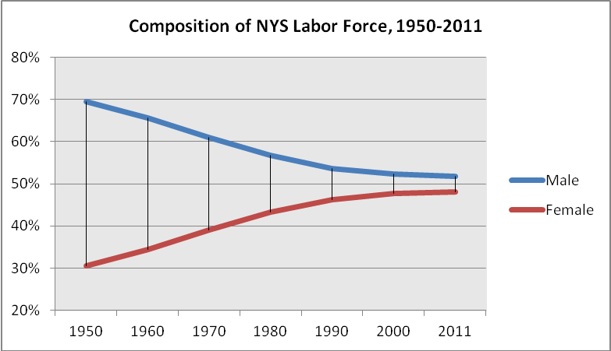
Source: Current Population Survey, US Census Bureau

What should come as no surprise, the growth in female employment brought with it additional and dramatic changes in the family structure. This new empowered women must now juggle the new constraints on her time with work and school with the ever present responsibilities of family care as well. One might think that some of these family responsibilities could fall on the partner but as statistics showed two income households became more of a necessity than an exception and single parent households more a norm than an exception.

According to a recent report from the U.S. Congress Joint Economic Committee, 48% of mothers with children under 18 work full-time. An additional 16% are employed part-time. In New York, the number of families with both parents in the workforce totals 1.6 million.

Figure 2
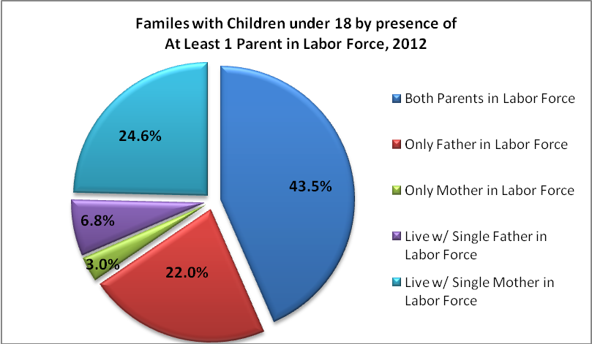
Source: 2012 American Community Survey, US Census Bureau

As seen in Figure 2 above nearly half of the State’s working families (43.5%) have both parents in the labor force, while 56% of families are lead by only a single earner. Seven in ten families include a working mother, and a quarter are single, working mother households.

The Only Law of the Land: Family and Medical Leave Act

Despite the rise of the working mother over the past 50 years, surprisingly few options exist for Americans wishing to take leave from work to care for their families. While trailblazing women were redefining the American workforce and what it means to be a mother, similar progress was lacking on a national family leave insurance policy. Sadly, it took many years for the country to come to grips with the very thought of not only working mothers, but working women in general.

This slow evolution continues to this day. As the map below highlights, the United States woefully lags behind virtually the rest of the world in mandating paid leave for workers. Out of 190 countries, the US is part of a truly select group without a right to paid maternity leave that includes Liberia, Papua New Guinea, Sierra Leone, and Swaziland.

Figure 3
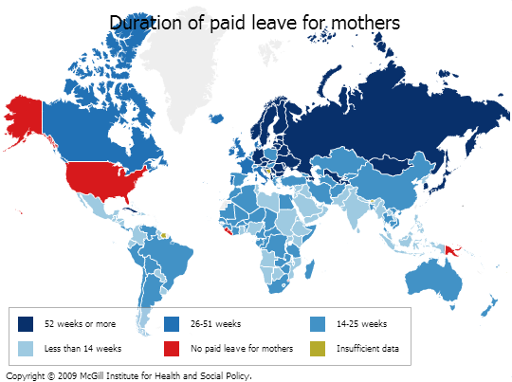

Nothing signifies the country’s stilted progress on workplace policies like this simply fact. What so many workers throughout the world consider a fundamental right is long absent in the United States. With the current formation of the US Congress, the chances of Family Leave Insurance becoming law anytime soon are dreadful.

This is unsurprising as the country has a long history of dragging their feet on workplace policies. Take for instance the Pregnancy Discrimination Act. This law forbids employers from discrimination against a worker on the basis of pregnancy or childbirth. Employees cannot use a women’s pregnancy as the basis for a decision to hire, fire, promote, or give a raise to an employee. Furthermore, pregnant workers must be treated the same as any other employee who is temporarily disabled. This means that if an employer allows leave for temporary disability, they must offer this same leave to pregnant women. What seems like a basic employment right was only passed in 1978.

It was not until 1993 that the country next made significant progress on ensuring leave for workers. That year the Family and Medical Leave Act (FMLA) became law. Upon its passage, American workers could claim guaranteed time off from work for a number of reasons, with the caveat that such leave was unpaid. These include:

- The birth of a son or daughter, or placement of a son or daughter with the employee for adoption or foster care;
- To care for a spouse, son, daughter, or parent who has a serious health condition;
- For a serious health condition that makes the employee unable to perform the essential function of his or her job; or
- For any qualifying exigency arising out of the fact that a spouse, son, daughter, or parent is a military member on covered active duty or call to covered active duty status.

Alongside a child’s biological parents, an individual can also qualify for leave that stands in loco parentis. Therefore, individuals who are not biological or adoptive parents, but assume the day-to-day responsibilities to care and financially support a child, may also claim such leave. Importantly, employees returning from leave were guaranteed restoration to an equivalent job with the same pay and health benefits afforded to them prior to the leave. This job restoration provision provided further encouragement to leave. Individuals no longer needed to worry that leave would negatively impact their employment.

With FMLA, the United States finally acknowledged that employees have lives outside of work with just as stringent demands on them as their employer. However, a number of shortcomings in the law dramatically reduced its impact on workers. Foremost among them was that FMLA did no guarantee paid leave. Without any compensation, leave is almost entirely ineffective.

Second, the FMLA failed to bring leave eligibility to a great number of American workers. To start, not all employers are covered under the Act. A number of limiting provisions severely narrowed the pool of workers to whom guaranteed leave was afforded. Recently, the U.S. Department of Labor released a report offering details on the experience of employers and employees with FMLA.

Among the findings was that “eligibility for the protection of the FMLA is far from universal”. In fact, over 40% of employees do not qualify for leave under the legislation. This is a startlingly low number, showing us that a full two-fifths of Americans continue to work without guaranteed, job-protected leave to care for their families.

For those lucky enough to access this leave, the benefits are often not great enough. Among these employees, only 16% took leave in 2012 for one of the qualifying reasons. Of those taking leave, less than a quarter were related to caring for a new child (21.1%), and additional family care represented 19% of leaves. In addition, the duration of leave was often minimal. Over 40% of leaves taken by FMLA-eligible employees last under 10 days. These figures show that many workers do not take leave, and when they do it is too short.

While not perfect, many advocates believed that the passage of the FMLA would kick start the effort toward paid leave at the state level and in the private sector. With little movement nationally toward that goal in the 20 years since its passage, it is clear that FMLA lacked this power. Without guaranteed paid leave for family care purposes, employees were instead forced to rely on the private sector to supply them with this increasingly vital benefit.

Evidence shows, however, that the private sector is failing workers in this regard as well. Only 12% of all workers are provided with paid family leave from their employers. That number falls even lower for those who cannot live without a paycheck. Paid family leave is only available to 5% of individuals whose average wage falls within the lowest quartile, and 4% of those earning in the bottom 10%. Whereas 15% of full-time workers have access to paid family leave, only 5% of part-time workers do. In regards to the Middle Atlantic states, of which New York is a member, total workers with access to this benefit stands at 11%.

Accordingly, new mothers are forced to return to work earlier following the birth of their child. From 2005 to 2007, 44.2% of women with a first birth returned to work in 3 months or less. As more women entered the workforce this figure rose dramatically from nearly 10% in the early 1960s. The presence of so many women returning to work in this timeframe indicates that private employers are not providing sufficient leave benefits.

Figure 4
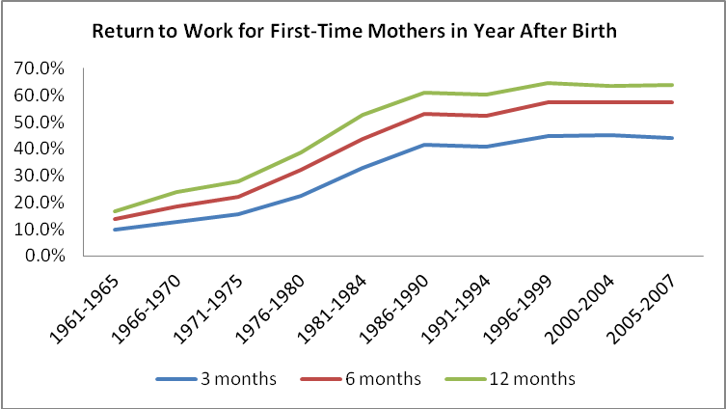
Source: U.S. Census Bureau, “Maternity Leave and Employment Patterns of First-Time Mothers”

These numbers clearly show that the private sector is unwilling to offer paid family leave by their own volition. Without national Family Leave Insurance, many workers are left without a safety net. Over the past decade, a few states took giant strides to provide this benefit despite inaction at the national level. They include California, New Jersey, and Rhode Island. Though a piecemeal approach to the larger problem, their action is vital to creating momentum for FLI in New York.

Time to Bring FLI to New York State

New York does not provide its residents with guaranteed, Family Leave Insurance. However, like California, New Jersey, and Rhode Island, the State does offer disability benefits through its Temporary Disability Insurance (TDI) program. Along with Hawaii, these are the only five states in the United States with such a system. While certainly a laudable achievement, the system does not provide enough support for New York’s families.

The New York Disability Benefits Law was passed in 1949, and became effective in 1950. This places an obligation on businesses employing one or more workers on at least 30 days in a year to provide disability benefits to its employees. Individuals are eligible for said benefits if they sustain an injury or sickness off the job causing them to be unable to perform their regular duties. This benefit applies to both full and part-time employees.

TDI offers a robust leave duration of 26 weeks; however, this generosity does not extend to the benefit payment itself. A disabled employee is entitled to a weekly benefit equal to half of their weekly wage, but not to exceed $170. To qualify for this benefit, New Yorkers must contribute one-half of one percent of their wages not to exceed $0.60 per week.

Despite the benefit’s low amount, pregnant women are eligible under New York’s TDI system. According to the Worker’s Compensation Law §201 (9)(B), a disability can include one caused by or in connection with a pregnancy. According to the New York State Insurance Fund, in general, pregnant women may receive disability benefits for the six weeks after a normal delivery and eight weeks after a Caesarian section.

However, here too we see that the TDI system does not go far enough. Under the definition of “disability” cited above, leave currently is extended only to biological mothers. This excludes a wide ranging set of parents such as adoptive and foster parents, biological fathers, and same-sex couples. In addition, the TDI system does not cover workers caring for families members with an injury or sickness.

At this time, TDI does not offer the support that New Yorkers desperately seek. Along with the sluggish economy, many families simply cannot afford to take unpaid leave to care for a newborn or other family member. That is why the Independent Democratic Conference is fighting for Family Leave Insurance.

This proposal would extend 6 weeks of Family Leave benefits to New Yorkers. Individuals would qualify for such benefits under two scenarios:

A) to bond with a new child during the first 12 months following their birth, adoption, or foster care placement; and

B) to care for a family member suffering from a serious illness or disability. This includes a child, spouse, domestic partner, parent, grandchild, grandparent, or one’s in-laws.

Additionally, this weekly Family Leave benefit will increase each year ensuring that the program will not weaken in relation to the economy at large. Eligible employers may capture 50% of their weekly wages, up to a maximum associated with the State Average Weekly Wage (AWW). This figure is calculated by the State Department of Labor. As it is an average of all employees in New York, the AWW will rise as general wages do.

In the first year of the program, 2015, the maximum family leave benefit will be 35% of AWW. The next year this will rise five percent to 40% of AWW. The final step up in 2017 will be 50% of AWW. Following this year, the maximum weekly benefit will remain at this percentage of AWW. Currently this figure stands at $1,204.81. Assuming an average inflation rate of 3.2%, this will amount to maximum weekly benefits of the following amount:

2015: $449.10
2016: $529.68
2017: $683.29
2018: $705.16

This replacement wage will make it possible for New York families to care for their families. Individuals will not only be able to afford their regular bills, but those costs associated with a new child or ill relative. Enacting this benefit means it will not be necessary for New Yorkers to make the painful choice between caring for their family and working.

New parents will be especially empowered through this proposal. Our current TDI system only provides disability benefits to biological mothers. This leaves out a whole slew of individuals. Adoptive and foster care parents are not eligible for paid leave when they bring in a child. Same-sex couples cannot qualify, and benefits are not extended to fathers either.

With the changing dynamics of families this limitation is no longer feasible. Our State must recognizes that one shape does not fit all. It makes no sense to provide a benefit to only one subset of families. What is good for one parent should be good for all. The IDC’s FLI proposal does just that. Adoptive, foster care, and same sex parents will now receive paid leave benefits for a maximum of 6 weeks. In addition, biological mothers will be able to combine this benefit with those under TDI to receive a maximum of 12 weeks of paid leave following a birth.

A Shared Responsibility

What makes this proposal especially compelling is that it will be provided to workers at a minimal cost. In fact, in Year 1 the program will be fully State funded meaning employees will receive the benefit at no cost. As the benefit level rises, New Yorkers will be asked to contribute a small amount each week from their paycheck.

Figure 5
Projected Claims and Cost of FLI in New York
 | Max Weekly Benefit | Max Benefit Per Applicant | Eligible Claims | Total Cost of Program | Annual Contribution per Employee | Weekly Contribution per Employee
2015 | $449.10 | $2,695 | 46,210 | $124,518,384.06 | $0.00 | $0.00
2016 | $529.68 | $3,178 | 46,661 | $148,295,367.30 | $2.61 | $0.05
2017 | $683.29 | $4,100 | 47,117 | $193,170,034.83 | $7.54 | $0.15
2018 | $705.16 | $4,231 | 47,578 | $201,299,139.86 | $8.44 | $0.16

Figure 8 above highlights a projected “maximum cost” scenario for FLI implementation. We estimate that in the first year, 46,000 individuals will claim such a credit. For this benefit, workers will not pay anything. When a contribution is required of employees in Year 2, it will only be a nickel per week. This is an annual cost of only $2.61. As the benefit rises, employees will not ask them to put forward a significant contribution. Why? Because it is time for our government to make it more affordable for families to live in New York.

The Costs Associated With Caring for a New Child

Each year it is becoming more expensive for families to afford basic necessities. Unfortunately, family care is often one of the largest contributors to this cost. When parents welcome a new child to their family, or when they must care for an elderly adult, their cost of living dramatically increases.

When an infant comes into a family, the expenses associated with it cause a significant drain on finances. This is just as true for families who adopt, or take a child in through foster care. Costs during the first six weeks can be especially expensive as a child is being integrated into the family unit.

According to the United States Department of Agriculture, the key drivers of child rearing costs are housing (30% of costs), child care & education (18%), and food (16%). These expenditures produce a large economic shock to many couples. Regrettably for New York’s families, child care expenditures are even higher in this region of the country. In the urban northeast, expenditures for children 2 years old and younger run about $2,000 more than the national average. It is even more difficult for single parents with only one income to absorbs all the costs.

Figure 3 lays out the average 6-week expenses for integrating a new child into a family by household income level. These costs are derived from the USDA report, and are provided for newborns, and adopted and foster care children. Expenses vary by income level because households with higher incomes are simply able to afford more items for their child. USDA notes that while expenses for necessities, such as food, did not vary much between groups, large disparities were seen on discretionary items. Specifically in the urban Northeast, the high income households were able to spend more on clothing, child care, housing, and miscellaneous expenses (personal care items, entertainment).

Information in Figure 3 additionally includes disability payments provided through New York’s Temporary Disability Insurance program (TDI). As will be explored later in the report, TDI offers a maximum weekly benefit of merely $170 if one cannot attend work due to a disability occurring outside the job. Pregnant women are eligible for six weeks of disability benefits following a normal delivery, and eight weeks after a Caesarian section. This means that pregnant women may capture a maximum benefit of $1,020. Benefits do not extend to fathers, or adoptive and foster care parents. Reimbursement rates for foster care however are provided.

Figure 6
Expenses Associated with First 6 Weeks of Child Care and State Support
Newborn Child
 | 6 Week Cost | Maximum Disability Benefits |  | Cost to Families
Lowest income Group ($60,640 or less) | $1,272.72 | $1,020.00 |  | $252.72
Middle Income Group ($60,640 - $105,000) | $1,670.76 | $1,020.00 |  | $650.76
Highest Income Group (over $105,000) | $2,700.00 | $1,020.00 |  | $1,680.00
Adopted Child (average age at adoption - 6.3 years)
 | 6 Week Cost | Maximum Disability Benefits |  | Cost to Families
Lowest income group | $1,234.62 | $0 |  | $1,234.62
Middle Income Group | $1,661.54 | $0 |  | $1,661.54
Highest Income Group | $2,687.31 | $0 |  | $2,687.31
Foster Care Child (average age of entry - 7.6 years)
 | 6 Week Cost | Maximum Disability Benefits | 6 Weeks of Foster Care Reimbursement | Cost to Families
Lowest income group | $1,234.62 | $0 | $966 | $268.62
Middle Income Group | $1,661.54 | $0 | $966 | $695.54
Highest Income Group | $2,687.31 | $0 | $966 | $1,721.31

When on unpaid or low-paid leave, families cannot access the second income upon which they have come to rely. Therefore, families depend on disability benefits to meet existing expenses—such as heat, rent, and food—and new costs, such as increased healthcare, diapers, and baby formula. This table demonstrates how unrealistic that goal is for New Yorkers.

As meager as the current support is for biological mothers, it is nonexistent for adoptive and foster care parents. These groups receive no benefits under the current system. Middle class parents who adopt their child must pay $1,661.54 out-of-pocket. While foster care parents are reimbursed by New York, it is not nearly enough to meet the demands of a new child. With support like this, it is no wonder that parents are finding it harder to afford raising a new child.

The Costs Associated With Caring for an Elderly Relative

The economic situation of New York’s families is further strained when one considers the cost of caring for older family members. The State’s elderly population is rapidly increasing for two reasons. First, Americans’ life expectancy dramatically increased in recent years. Individuals at 65 can now expect to live 19 more years, an increase of 5 years from 1960. Second, due to the mid-20th century Baby Boom there are more older adults than ever before. By 2030 one in five Americans will be an older adult (65 and older).

New York State will not escape this rising demographic tide. In 2010, individuals 65 and older made up 14% of the State’s population. However, by 2035, Cornell University projects this percentage will balloon to 19%. This increase will result in an exponentially larger number of senior health issues confronting our families.

Figure 7
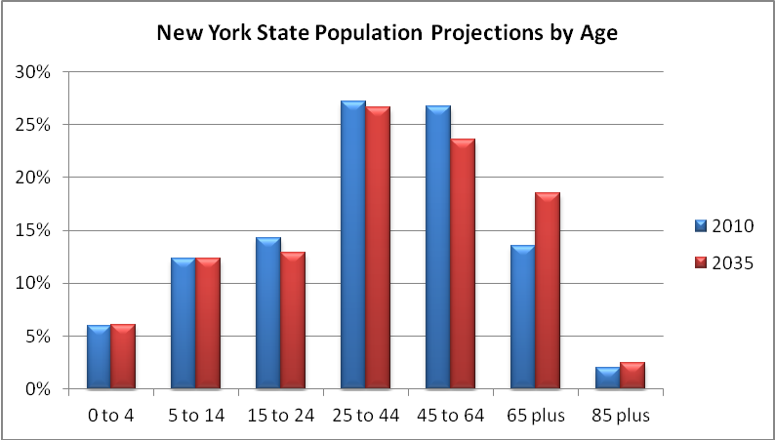
Source: Cornell Program on Applied Demographics

As is the case currently, much of this care will be provided by family members themselves. Progressively more seniors choose to live in communities they are familiar with instead of healthcare institutions. Only 11% of elderly receiving care live in nursing homes or assisted living facilities. This is compared to the 58% who live in their own homes, and 20% living with a caregiver. These numbers indicate that family caregivers are at the forefront in providing elderly care.

Such caregiving is increasingly crucial because the reliance on formal care support is in decline. According to AARP, the number of seniors receiving formal care decreased sharply between 1994 and 2004 with average weekly care duration falling from 10 to 4.9 hours. This decrease is primarily attributed to Medicare payment alterations, which raised formal care costs. AARP notes that “reliance on informal family caregivers is likely to increase even further as future changes take effect”.

New York’s 4.1 million caregivers make up a sizeable contingent of the nation’s caregivers. In fact, one in five New Yorkers (21%) assume this role at some point in their lives. These people diligently support their elderly family members, providing care that is both critical and time-consuming. Annually, these caregivers engage in 2.68 million hours of care, resulting in a total economic value of $32 million.

According to a recent survey of New Yorkers over 50 . Over a third of individuals are providing or previously provided care to a senior. This was particularly time intensive with 25% of individuals saying they provided 40 or more hours of care each week. The large majority of individuals (59%) engaged in such care outside of their job.

Caring for the elderly does not only cost families time. The monetary expenses associated with caregiving are extremely high. A study of family caregivers nationwide discovered it costs individuals $5,531 annually. Figure 5 below breaks this cost down into specific categories. “Medical expenses” along with “food, meals, and household goods” are the biggest cost drivers.

Figure 8
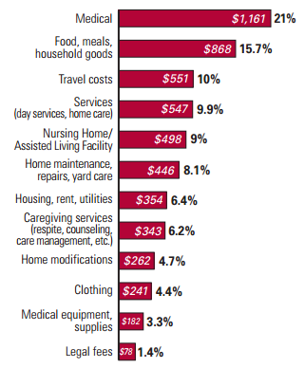
Source: Evercare and NAC, Study of Family Caregivers, 2007.

As with child care, these expenses act as a drain on household income. Many must cut back on goods or activities they would otherwise purchase. For others, this cost means forgoing the payment of certain bills, and badly damaging their credit in the process. This underscores the fact that caregivers are often placed in a no win situation; lacking the formal support necessary to fully meet their needs. Currently in New York there is no mechanism to provide economic relief to workers who need to provide care for their parents, grandparents or in-laws.

An Impossible Choice

The high costs presented by our new family reality make it so people are faced with an impossible choice. Families increasingly rely on two-incomes just to get by. For single parents there are few options that exist besides attempting to juggle work and care at the same time. As a result, not only do they suffer but their families do as well.

Consequences of Not Taking Leave

The consequences of not taking time off are vast, particularly when it comes to the health of the child and mother. The immediate period following a birth is of preeminent importance. A child’s brain develops extremely fast, and having a familiar and alert caregiver available at all times improves cognitive development significantly.

In one study, researchers followed the growth of 1,364 children over time to discover the link between such development and a mother’s return to work. Interestingly, a mother’s return within the first year of birth was found to have no significant impact on a child’s development at 15 or 24 months. However, by the 36 month employment’s impact began to be felt. It was found that children whose parents returned to work within the year scored lower on the Bracken School Readiness Scale. This test assesses a child’s knowledge of color, letter identification, numbers and counting, comparisons, and shape recognition.

Not taking leave is also detrimental to caregivers themselves. For mothers, failing to take leave increases the likelihood they will suffer from depression. The same is seen amongst family caregivers. First, seeing a loved one fall ill is stressful in itself. Secondly, when one is unable to take time off they find themselves stretched thin. A significant number of New York’s caregivers provide almost a full workweek of support (40 hours or more). When this much is demanded of individuals the risk of diminished care for others- and themselves increases dramatically.

Nationally, 65% of caregivers experience elevated levels of stress and anxiety due to this added responsibility. Half of respondents noted difficulty sleeping, and 23% were forced to forgo personal medical needs. Aside from affecting one’s health, these depressive symptoms can significantly hinder workforce productivity.

Consequences of Taking Leave in the Current Climate

Though the negative consequences of not taking leave are difficult to accept, that does not make it any easier for New York’s families to make the decision to take leave. Families in which an individual decides to take unpaid leave from work face just as many pitfalls as those returning to work. Primary among these are the money troubles that parents may face.

Even for those remaining financially solvent, the economic consequences of leaving the workforce are severe. Women typically see a negative effect on their lifetime earnings. This is referred to as the “motherhood penalty”. When a woman takes leave in order to care for a child or a sick relative, they are likely to see their income decrease when they reenter the workforce need citation. Shockingly, the wage gap between mothers and their childless peers is larger than the gap between men and women. Mothers lose approximately 7% of their wages for every child they raise.

A similar effect to the “motherhood penalty” is seen in elderly caregiving. A woman leaving the workforce to provide care can expect to forfeit $142,693 in lost wages, and $131,351 in lost Social Security benefits. When the impact on pensions is factored in, the cost impact on a female caregiver is $324,044. While less than a female, it is estimated that a male caregiver will lose $283,716 (this includes $89,107 in wages and $144,609 in Social Security benefits). Among all caregivers this is an average cost impact of $304,000.

Therefore taking leave creates a lasting impact on family income for years to come. This lost income cannot be made up later. These results tell us that taking unpaid leave is not only difficult for families in the short-term, but can easily lead to disaster in the long-term. This means that more individuals will choose to return to work earlier, leading to negative health impacts for their children, elders, and themselves.

It is clear that New York’s families are in need of assistance. As it stands, many cannot afford to care for their family given the present difficulties. This lack of support is endemic to America. The leave policies that currently exist do not go far enough. Not enough New Yorkers can access paid leave benefits that allow them to fully provide care while earning an income and not impacting their lifetime earnings.

Emergence of FLI Policies in the States

Figure 9
STATE | LEAVE TYPE | WORKER CONTRIBUTION | LEAVE DURATION | BENEFIT RATE | MAX WEEKLY BENEFIT
California   | FAMILY | 1.0%  of wages¹ | Up to  6 weeks | 55%  of wages | $1,075
New Jersey   | FAMILY | 0.1%  of wages² | Up to  6 weeks | 66%  of wages | $595
Rhode Island   | FAMILY | 1.2% of first $61,400 earned to a maximum of $736.80 | Up to  4 weeks | 60% of wages | $752
PROPOSED
New York   | FAMILY | NONE IN YEAR ONE; SMALL CONTRIBUTION THEREAFTER | Up to  6 weeks | 50%  of wages | $449
¹ Maximum annual contribution of $1,016.36
² Maximum annual contribution of $31.50

California

California was the first to bring FLI to the country. In 2002, Senate Bill 1661 passed and was signed into law by then-Governor Gray Davis. This act extended the existing State Disability Insurance (SDI) program to allow benefits payable for family leave reasons. Upon signing the bill, Gov. Davis offered a perfect summation in support of the benefit:

“Californians should never have to make the choice between being good workers and being good parents. This bill will help millions of California workers meet their responsibilities to both their family and their employers.”

The 11 year-old program offers benefits going far beyond the FMLA. Workers can qualify for a maximum 6 weeks of leave if they are unable to do their regular work for at least eight days for one of the following reasons: (1) to care for a seriously ill child, spouse, parent, or registered domestic partner; (2) to bond with one’s new child; or (3) to bond with an adopted or foster care child. Leave for child care is limited to the first year after a child joins a family, and is available to both parents. Additionally, FLI was recently extended to include care for ill grandparents, grandchildren, siblings and in-laws.

California’s program expands on FMLA as well by covering virtually all workers. To be eligible for benefits, a resident must simply earn at least $300 within the past 12 months. A Californian need not even be employed currently to receive this benefit. They must merely hit this earning threshold, and be actively searching for work. State government employees are included as well, along with workers who are covered by voluntary disability insurance programs. Therefore, this is an incredibly expansive program that brings benefits to both full- and part-time workers.

If these criteria are met, workers are eligible to receive a weekly benefit of 55% of their weekly wage to a maximum of $1,075. As of June 30th, 2013, the program paid out a total of $3.7 billion in benefits on almost 1.5 million claims. The average benefit paid out was $517 per week for 5.33 weeks of leave. The primary reason for leave-taking is child bonding, which makes up close to 88% of claims filed. Females file the vast majority of claims reaching nearly 70% for both bonding and family care.

This benefit is fully funded by employee contributions to the SDI program. In 2013, employees contributed 1.0% of their wages, up to a maximum of $1,009 per year. However, the average yearly contribution this year was $440.04. There is no direct cost to employers.

One key area in which the program is lacking is job protection. Unlike the FMLA, an individual is not afforded the guarantee that an equivalent job with pay and health benefits will await their return. Such a provision is likely to depress enrollment in the program, as workers will fear that taking a leave could potentially result in losing their job. Additionally, an employer can require an employee use up to two weeks of vacation leave or paid time off prior to receiving benefits.

New Jersey

The FLI campaign next moved to New Jersey. The fight for paid leave there last 12 years, but was finally passed into law in 2008. Family leave benefits are eligible to both private and public employees. Qualifying reasons for leave are much the same as California. Workers may use it to bond with a newborn or adopted child; or again to care for a family member with a serious health condition. Mothers, fathers, and same-sex couples are eligible for bonding claims. Family members eligible for care are not as expansive as California; and only cover one’s spouse, domestic partner, civil union partner, parent, or child.

The maximum time that may be taken is 6 weeks during a 12 month period. While the length matches California, the benefit is significantly lower. New Jersey’s benefit rate actually equals two-thirds of an employee’s average weekly wage. However, the maximum is far lower and comes nowhere near approaching $1,000. Instead, it stands at $595 per week in 2014.

New Jersey exceeds the eligible criteria of FMLA as well. One need not be a full-time worker to receive leave benefits. Instead an individual must meet a wage requirement stipulating that they earned $145 or more per week, or $7,300 or more in the 12 months prior to the week leave begins. Like California, unemployed persons are eligible for leave. This benefit is also financed by employees themselves with each contributing a maximum of $31.50 annually.

New Jersey’s program brings considerable help to families across the state. Thus far in 2013, the average total benefit is $2,615.56. Since 2009, the program has paid out a total of $314.4 million in benefits to over 121,000 individuals.

Rhode Island

Just this past July, Rhode Island joined California and New Jersey in bringing Family Leave Insurance to its residents. Similar to California and New Jersey, FLI in Rhode Island functions as an expansion of the state’s Temporary Disability Insurance (TDI) program. The Temporary Caregiver Insurance law will allow a maximum 4 weeks of bonding and family leave effective January 1, 2014. While this leave will be available to all private employees, public sector workers will be ineligible for the benefit.

In line with California and New Jersey, bonding leave is allowed for a newborn or child newly placed for adoption or foster care with an individual. Family leave is also provided to care for a child, parent, parent-in-law, grandparent, spouse or domestic partner with a serious health condition. Rhode Island’s TDI program currently offers a weekly benefit ranging from $72 to $752. The law also features job restoration for employees returning from leave.

To qualify, workers must earn $9,300 in the past year, and contribute to the TDI system. Rhode Islanders must contribute 1.2% of their first $61,400 into the TDI fund, amounting to an annual maximum of $736.80. The addition of Temporary Caregiver Insurance is expected to cost $15 million. According to the spokesperson for the Department of Labor and Training, there will no impact on the contribution rate until July 2014, at which point it will be raised by two-tenths of a percentage point.

The Demonstrated Benefits of Family Leave Insurance

Impact on Families

Where Family Leave Insurance is in place, it is shown that individuals see a wealth of advantages. Most importantly, the health of the child and mother increases dramatically with access to paid leave. For children, paid leave actually decreases infant mortality by over 3%. No such effect was found for unpaid leave. Furthermore, leave brought drops in low birth weight, which significantly impacts a child’s health.

Paid leave also improves a mother’s health. One study determined that each additional leave from work is associated with a six to seven percent decrease in depressive symptoms. Much of this depression can be related to separation anxiety, and stress being compounded by work responsibilities.

Mothers for whom FLI is available are less likely to confront such stresses. Worries about caring for their child while staying productive at work are significantly reduced. In an employee survey on the effects of FLI in California, it was clear that anxiety over child care was reduced for those taking paid leave. Both “high-quality” (jobs paying more than $20 an hour and providing employer-paid health insurance) and “low-quality” job employees (jobs failing to meet the high-quality standard) stated that paid leave positively affected their ability to care for a new child at rates of 100% and 90.8%, respectively. Additionally, “high-quality” (82.6%) and “low-quality” (97.4%) job holders were either very satisfied or somewhat satisfied with their leave. Similar results were seen amongst family caregivers.

One’s financial health is also dramatically improved when they can access Family Leave Insurance. Paid leave decreases the probability an individual will rely on public assistance to make ends meet. Individuals taking paid leave are 39% less likely than those who do not to receive public assistance in the year following a child’s birth. A nearly identical effect was seen on the use of food stamps. This not only helps low-income families, but also reduces costs for the government and taxpayer.

One of the most dramatic findings was that FLI increases the likelihood not only that a worker will reenter the workforce, but that they will return to the same employer. This holds strong consequences for both caregivers and employers. In the survey of California workers cited above, 95% of those taking family leave returned at the end of their leave, and 82.5% returned to the same employer. This is important as it means workers will not only retain their income level, but also the status in their company that is important in receiving promotions and higher wages.

Caregivers returning to the same employer often go back to positions at the same skill level and pay. This is essentially eliminates the “motherhood penalty”. According to the US Census, 97.6% of women returning to their prebirth employer received the same or higher pay level than before leave, and 98.7% held a position with the same or greater skill set. In comparison, among mothers reentering the workforce with a different employer, 30.6% and 17.7% reported lower wages and skill level, respectively.

This shows that FLI not only helps alleviate the gender gap in pay, but also makes it more comfortable for families to live. Caregivers no longer must worry that taking leave will destroy their lifetime earnings, and make their family’s financial situation more vulnerable. Additionally, the wage replacement offered by the IDC’s proposal will ensure that leave can be taken while providing money to afford those costs associated with care.

Impact to Businesses

While it cannot be argued that FLI is extremely beneficial to families, many in the business community believe it hurts their bottom line. They argue that allowing leave to employees reduces productivity, and will be especially detrimental to small businesses that do not have the capacity to replace a worker taking leave. To cope with the increase in leave taking, they will be forced to hire additional employees thus reducing revenue.

The Independent Democratic Conference fully understands these concerns, and shaped our FLI policy to address business concerns as well. Under our proposal, only businesses with 25 or more employees must provide FLI. Therefore small businesses operations will not be constrained by a requirement to allow leave, while also creating the benefit for the vast majority of New York’s employees. Furthermore, family care benefits will be provided to employees at no cost to the employer.

Businesses required to provide FLI need not worry. The Independent Democratic Conference believes that FLI can do just as much for economic wellbeing as it will for social wellbeing. Experiences in states mandating paid leave show it does not hinder business performance, and may even increase it.

When asked how FLI impacted their productivity, 89% of California’s businesses stated it brought a positive effect or no noticeable impact. Furthermore 91% said it had a positive or no noticeable impact on their profitability. When employees cannot take paid leave to care for their families their concentration wanes and they are physically tired for essentially working two jobs. FLI in New York will help businesses ensure that their employees are present and 100% focused on the task at hand.

Additionally, the IDC estimates that family leave will actually bring in cost savings to those businesses required to provide it. As noted above FLI increases employee retention, which means that more businesses will forgo turnover costs. If an employee quits their job, it means that a business must spend resources on a search for qualified candidates. Interviews must then be conducted, taking time away from other tasks. When a new employee finally comes on board they must be trained to sufficiently carry out their duties.

According to the Center for American Progress (CAP), turnover costs are extremely expensive and vary as a percentage of salary. The turnover cost associated with an employee earning $30,000 or less is 16.1% of salary. This figure grows to 19.7% for individuals earning $50,000 or less, and 20.4 % for individuals earning $75,000 or less. Therefore, for an individual earning $38,000 a business must spend nearly $7,500 to replace them. This is a significant cost, and businesses would serve themselves well by incorporating policies to avoid them when possible.

One avenue to accomplish this is FLI. If a worker returns to their position following leave, that business need not spend money on any of those items. Based off calculations by the Institute for Women’s Policy Research (IWPR), the IDC was able to calculate the potential turnover cost savings if workers were able to access FLI. Taking average annual salaries for women from the US Census, we are able to estimate turnover costs associated with each departure. Estimates on the reduction in departures are based off IWPR’s research. They noted that when maternity leave was increased at Aetna, retention of new mothers grew from 77% to 91%. As our FLI proposal would essentially be doing the same, we use this figure as well.

Figurer 10
Potential Business Cost Savings from Implementation of FLI in New York
Age | Female Employees | Adjusted Birth Rate | Annual Births | Average Salary | Turnover Cost as % of Salary | Turnover Cost per Departure | Departures Prevented | Turnover Savings
<20 | 135,862 | 6.73 | 914 | $6,178.20 | 16% | $994.69 | 128 | $127,331.79
20-24 | 369,586 | 74.07 | 27,374 | $17,254.30 | 16% | $2,777.94 | 3,832 | $10,646,228.89
25-29 | 438,823 | 97.09 | 42,607 | $37,985.80 | 20% | $7,483.20 | 5,965 | $44,637,250.25
30-34 | 410,685 | 103.87 | 42,659 | $47,451.10 | 20% | $9,347.87 | 5,972 | $55,827,688.56
35-44 | 774,168 | 34.71 | 26,871 | $51,260.90 | 20% | $10,098.40 | 3,762 | $37,990,086.70
45 + | 875,297 | 0.20 | 173 | $51,609.10 | 20% | $10,166.99 | 24 | $245,783.56
Totals |  |  | 140,599 |  |  |  | 19,684 | $149,474,369.75

As the chart above demonstrates, the Independent Democratic Conference estimates that the potential exists for businesses to reduce turnover costs by almost $150 million with the implementation of FLI. With savings like this it just makes sound economic sense for businesses to embrace family leave in New York.

Conclusion

In this day and age we are asking the New York worker to do more with less. They must raise a family, provide for that family, keep a job and be productive at work. Many are asked to do this with little or no help from the government. However this doesn’t need to be the case.

It is unacceptable that workers outside of New York are being asked to do the same thing New York workers are, but their State is investing in their family and well being by allowing them to take Family Leave Insurance. New York is generally at the forefront of the most cutting edge policies and positions for our workforce, but here we have woefully fallen behind.

The proposal put together by the Independent Democratic Conference takes into account the balance of a business trying to meet their bottom line and a worker trying to make sure they can stay invested in the lives of their families at their most vulnerable times. There is a balance that can be struck in New York with Family Leave Insurance. We must have the conversations now and we must find a way now. New York families cannot wait any longer.

Lucinda MacKethan, “America in Class: The Cult of Domesticity,” National Humanities Center, http://americainclass.org/the-cult-of-domesticity/.
Steven Ruggles, J. Trent Alexander, Katie Genadek, Ronald Goeken, Matthew B. Schroeder, and Matthew Sobek. Integrated Public Use Microdata Series: Version 5.0 [Machine-readable database]. Minneapolis: University of Minnesota, 2010, https://usa.ipums.org/usa/index.shtml.
Senator Amy Klobuchar, “Mother’s Day 2013: The Importance of Mothers for Family Economic Security,” The U.S. Congress Joint Economic Committee Democratic Staff, May 2013 , 2, http://www.jec.senate.gov/public/?a=Files.Serve&File_id=89d4243c-64db-47b3-a6df-083e53ac8948.
United States Census Bureau, 2012 American Community Survey 1-Year Estimate, http://factfinder2.census.gov/faces/nav/jsf/pages/index.xhtml.
McGill Institute for Health and Social Policy, Raising the Global Floor: Adult Labour A WoRLD Legal Rights Database, http://raisingtheglobalfloor.org/index.php.
United States Equal Employment Opportunity Commission, The Pregnancy Discrimination Act of 1978, http://www.eeoc.gov/laws/statutes/pregnancy.cfm.
United States Department of Labor, Family and Medical Leave Act, http://www.dol.gov/whd/fmla/.
Jacob A. Klerman, Kelly Daley, and Alyssa Pozniak, “Family and Medical Leave in 2012: Technical Report,” Submited by Abt Associates Inc. and prepared for the U.S. Department of Labor, September 13, 2013, http://www.dol.gov/asp/evaluation/fmla/FMLA-2012-Technical-Report.pdf.
Ibid, 2.
Ibid, 60-70.
U.S. Department of Labor, U.S. Bureau of Labor Statistics, “Table 32 Leave Benefits: Access, Civilian Workers, National Compensation Survey, March 2013,” National Compensation Survey: Employee Benefits in the United States, March 2013, September 2013, http://www.bls.gov/ncs/ebs/benefits/2013/ownership/civilian/table21a.pdf.
Lynda Laughlin, “Maternity Leave and Employment Patterns of First-Time Mothers: 1961-2008,” United States Census Bureau, October 2011, http://www.census.gov/prod/2011pubs/p70-128.pdf.
Philip Marcelo, “Bill Expanding Temporary Disability Benefits Advances in R.I. Senate,” Providence Journal, June 21, 2013, http://www.providencejournal.com/breaking-news/content/20130621-bill-expanding-temporary-disability-benefits-advances-in-r.i.-senate.ece
See Worker’s Compensation Law Article 9 – Disability Benefits and the New York State Insurance Fund “Disability Benefits” page at http://ww3.nysif.com/DisabilityBenefits/AboutDisabilityBenefits.aspx.
New York State Insurance Fund, “Disability Benefits: Claims FAQs,” http://ww3.nysif.com/DisabilityBenefits/ClaimantServices/ClaimsFAQs.aspx#seventeen.
New York State Department of Labor, New York State Average Weekly Wage, http://labor.ny.gov/stats/avg_wkly_wage.shtm.
I Mark Lino, Expenditures on Children by Families, 2012, United States Department of Agriculture, Center for Nutrition Policy and Promotions, August 2013, 11, http://www.cnpp.usda.gov/Publications/CRC/crc2012.pdf.
Ibid, 27.
Ibid, 10.
Ibdi, 27.
New York State Insurance Fund, “Disability Benefits: Claims FAQs,” http://ww3.nysif.com/DisabilityBenefits/ClaimantServices/ClaimsFAQs.aspx#seventeen.
New York State Office of Children & Family Services, Maximum State Aid Rates for Foster Care Programs and Residential Programs for Committee on Special Education Placements, 8, March 11, 2013, http://ocfs.ny.gov/main/policies/external/OCFS_2013/ADMs/13-OCFS-ADM-04%20%20Maximum%20State%20Aid%20Rates%20for%20Foster%20Care%20Programs%20and%20Residential%20Programs%20for%20Committee%20on%20Special%20Education%20Placements%20-%20Effective%20Ju.pdf.
Federal Interagency Forum on Aging-Related Statistics, Older Americans 2012: Key Indicators of Well-Being, June 2012, 24, http://agingstats.gov/agingstatsdotnet/Main_Site/Data/2012_Documents/Docs/EntireChartbook.pdf.
CDC, The State of Aging and Health in America 2013, 1.
Cornell Program on Applied Demographics, New York State and County Population Projections by Age and Sex, Cornell University, http://pad.human.cornell.edu/counties/projections.cfm.
Emblem Health and the National Alliance for Caregiving, “Care for the Family Caregiver: A Place to Start,” March 2010, 14, http://www.caregiving.org/data/Emblem_CfC10_Final2.pdf.
Ari Houser, Mary Jo Gibson, and Donald L. Redfoot, “Trends in Family Caregiving and Paid Home Care for Older People with Disabilities in the Community,” AARP Public Policy Institute, September 2010, 36, http://assets.aarp.org/rgcenter/ppi/ltc/2010-09-caregiving.pdf.
Ibid, 37.
Ibid, 27.
Cassandra Burton, “2013 AARP Survey of Registered Voters Age 50+ in New York on Caregiving and Home and Community-Based Services,” AARP, August 2013, http://www.aarp.org/content/dam/aarp/research/surveys_statistics/general/2013/2012-ny-caregiving-and-hcbs-aarp-pol.pdf.
Evercare and the National Alliance for Caregiving, Family Caregivers – What They Spend, What They Sacrifice: Findings from a National Survey, November 2007, 16, http://www.caregiving.org/data/Evercare_NAC_CaregiverCostStudyFINAL20111907.pdf.
Jeanne Brooks-Gunn, Wen-Jui Han, and Jane Waldfogel, “Maternal Employment and Child Cognitive Outcomes in the First Three Years of Life: The NICHD Stufy of Early Child Care,” Child Development 73(4): 1052-1072, July/August 2002, Acquired from EBSCOhost.
Ibid, 1055.
Human Rights Watch, Failing Its Families: Lack of Paid Leave and Work-Family Supports in the US, 2011, 45-46, http://www.hrw.org/sites/default/files/reports/us0211webwcover.pdf.
Evercare and the National Alliance for Caregiving, Family Caregivers,21.
Heather Boushey and Sarah Jane Glynn, The Effects of Paid Family and Medical Leave on Employment Stability and Economic Security, Center for American Progress, April 2012,7, http://www.americanprogress.org/wp-content/uploads/issues/2012/04/pdf/BousheyEmploymentLeave1.pdf.
MetLife Mature Market Institute, The MetLife Study of Caregiving Costs to Working Caregivers: Double Jeopardy for Baby Boomers Caring for their Parents,” June 2011, http://www.caregiving.org/wp-content/uploads/2011/06/mmi-caregiving-costs-working-caregivers.pdf.
John M. Broder, “Family Leave in California Now Includes Pay Benefit,” The New York Times, September 24, 2002, http://www.nytimes.com/2002/09/24/us/family-leave-in-california-now-includes-pay-benefit.html.
State of California Employment Development Department, Paid Family Leave Eligibility, http://www.edd.ca.gov/disability/PFL_Eligibility.htm.
Carla Marinucci, “California Family Leave Expanded to Cover More Kin,” The San Francisco Chronicle, September 25, 2013, http://www.sfgate.com/politics/article/Calif-family-leave-expanded-to-cover-more-kin-4841308.php.
State of California Employment Development Department, Quick Statistics, http://www.edd.ca.gov/About_EDD/Quick_Statistics.htm#DIStatistics.
Sarah Fass, “Paid Leave in the States: A Critical Support for Low-Wage Workers and Their Families,” National Center for Children in Poverty, March 2009, 7, http://www.nccp.org/publications/pub_864.html.
Susan K. Livio, “Divided NJ Senate Approves Family Leave Bill,” The Star-Ledger, April 08, 2008, http://www.nj.com/business/index.ssf/2008/04/divided_nj_senate_approves_fam.html.
State of New Jersey Department of Labor and Workforce Development, Family Leave Insurance Benefits – General Information, http://lwd.dol.state.nj.us/labor/fli/worker/program_info_menu.html.
Rhode Island General Assembly “H 5889: An Act Relating to Labor and Labor Relations – Temporary Disability Insurance,” http://webserver.rilin.state.ri.us/BillText/BillText13/HouseText13/H5889Aaa.pdf
Rhode Island Department of Labor and Training, 2013 UI and TDI Quick Reference Effective July 1, 2013, http://www.dlt.ri.gov/lmi/news/quickref.htm.
Rhode Island Department of Labor and Training, Employment Bulletin, November 2012, 3, http://www.dlt.ri.gov/lmi/pdf/eb/nov12eb.pdf.
Katherine Gregg, “Governor Chafee Signs Bill Expanding TDI Benefits,” Providence Journal, July 11, 2013, http://www.providencejournal.com/breaking-news/content/20130711-governor-chafee-signs-bill-expanding-tdi-benefits.ece.
Sakiko Tanaka, Parental Leave and Child Health Across OECD Countries, The Economic Journal 115 (February 2005): F7-F28.
Human Rights Watch, Failing Its Families, 42.
Eileen Appelbaum and Ruth Milkman, Leaves That Pay: Employer and Worker Experiences with Paid Family Leave in California, Center for Economic and Policy Research, 2011, 26, http://www.cepr.net/documents/publications/paid-family-leave-1-2011.pdf.
Linda Houser and Thomas P. Vartanian, Pay Matters: The Positive Economic Impacts of Paid Family Leave for Families, Businesses and the Public, Center for Women and Work, January 2012, 8.
Ibid, 9.
Appelbaum and Milkman, Leaves That Pay, 25.
Laughlin, Maternity Leave and Employment Patterns of First-Time Mothers, 18.
Appelbaum and Milkman, Leaves That Pay, 7.
Health Boushey and Sarah Jane Glynn, There are Significant Business Costs to Replacing Employees, Center for American Progress, November 16, 2012, http://www.americanprogress.org/wp-content/uploads/2012/11/CostofTurnover.pdf.
Boushey and Glynn, There are Significant Business Costs to Replacing Employees, 2.
Kevin Miller, Allison Suppan Helmuth, and Robin Farabee-Siers, The Need for Paid Parental Leave for Federal Employees: Adapting to a Changing Workforce, Institute for Women’s Policy Research, 2009, http://www.iwpr.org/publications/pubs/the-need-for-paid-parental-leave-for-federal-employees-adapting-to-a-changing-workforce-1.
Miller, Helmith, and Farabee-Siers, The Need for Paid Parental Leave for Federal Employees, 2.

