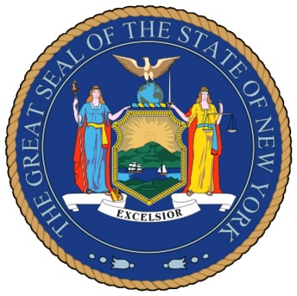
NEW YORK STATE LEGISLATURE

Senator Andrew Lanza ~ Assemblyman Michael Cusick

September 20, 2012

Chancellor Dennis M. Walcott
New York City Department of Education
Tweed Courthouse
52 Chambers Street
New York, NY 10007

Dear Chancellor Walcott:

We are writing today to reiterate our firm position on our law, Chapter 42 of the Laws of 2012, signed by the Governor to restore yellow school bus service to 7th and 8th grade students where variances would have provided them with the transportation in the 2009-2010 school year without applying the “like circumstances” rule beyond those areas. The intention of the law, to restore service irrespective of school location within relevant areas, is patently clear and unambiguous. Accordingly, legislative intent need not even be considered. However, if you are so disposed, considering the legislative intent, established primarily by the authors of this legislation, will confirm our position.
We have discussed this matter with the New York State Education Department who, as you know, weighed in on the matter by, among other ways, a written correspondence to the Mayor’s Office dated September 5, 2012. As expressed in that letter it is also the opinion of the New York State Department of Education that the intent of the law is to provide service to students who attend schools which may not have existed in the past but who are in the intended service area. Taken together with the State Education Department’s decision to grant a stay to Ms. Sgarlato-Benfante while she challenges the city’s decision not to provide school bus service for her son who attends the Marsh Avenue School for Expeditionary Learning, the interpretation of the statute couldn’t be any clearer. 7th and 8th grade students at the Marsh Avenue Expeditionary Learning School and the Staten Island School of Civic Leadership are entitled to school bus transportation pursuant to the law.
The New York City Department of Education’s position to the contrary is unfounded and not based upon any competent interpretation of the law. Moreover, the city’s stated interpretation is contrary even to statements made by city officials both during the legislative process and upon announcement of the establishment of the law.
It is clear that the position of the New York City Department of Education is wrong. The authors of the law say so, the New York State Department of Education says so, and a fair and honest look at the facts and law says so.
Each day that city lawyers continue to deny the clear meaning of the law puts students in harm’s way and denies them what they are legally entitled to. We respectfully demand that the City reverse its position and properly uphold and apply the law.

Your swift reversal of the decision to deny this service is the legal and right thing to do. We eagerly await your reply.

Sincerely,

Andrew Lanza Michael Cusick
Member of Senate Member of Assembly

