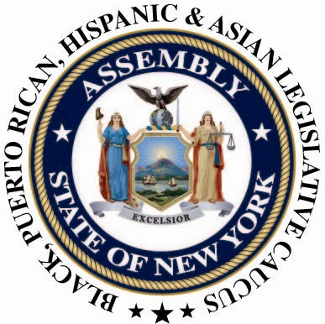

CONTACT:
Nicole Jordan or Nantasha Williams
(518) 455-5347
bphacaucuspress@gmail.com
For Immediate Release: August 28, 2013

ON THE 50TH ANNIVERSARY OF THE MARCH ON WASHINGTON, CAUCUSSAYS PROGRESS MADE, BUT WE HAVEN'T REACHED MOUNTAINTOP
The 1963 “March on Washington for Jobs and Freedom” was organized in support of civil rights legislation, and also to call attention to significant economic inequalities. As we commemorate the 50th anniversary of the historic “March on Washington”, inspired by its victories (the Civil Rights Act of 1964 and the Voting Rights Act of 1965), we must also acknowledge that there is still much progress to be made as a society and pervasive inequalities that must be addressed.
In November, the Caucus will release a bold policy plan that will detail a wide range of policy initiatives and budget demands. Those initiatives include, but are not limited to, continuing to advance policy initiatives to close the educational achievement gap; urging the city and state to pledge a significant investment to retaining and creating affordable housing; supporting initiatives for new immigrants, including policies that create a pathway to citizenship and the passing of the NYS Dream Act and Fund legislation; commitment to fighting against hospital closures and preserving access to healthcare for Medicaid and Medicare recipients.

###

