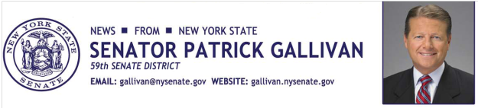
April 4, 2014
For Immediate Release
Contact: Jim Ranney
716-656-8544
MEDIA ADVISORY

WHO: Senator Patrick Gallivan

WHAT: Family Health & Safety Fair
Free health screenings & safety information from the following:

- American Red Cross Blood Donations
- Blood Pressure Screenings with ECC School of Nursing
- Roswell Park Cancer Institute
- NY State Police Demonstration
- Erie County Sheriff Child ID Program
- West Seneca Police Department Child Safety Seat Check
- Free Prescription Drug Drop Off Center
- Dent Neurological Institute
- Elder Care Solutions of WNY
- Seneca Health Care Center
- Citizens Emergency Response Team
- WNY Chiropractic
- Food Bank of WNY
- And More…

WHEN: Saturday April 26, 10 a.m. to 2 p.m.

WHERE: West Seneca Senior Center
4620 Seneca Street

Media welcome the day of the event. Great visuals!
-30-

