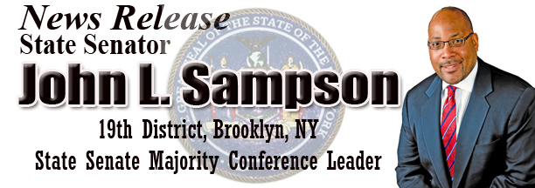
1222 East 96th Street, Brooklyn, NY, 11236 * (718) 649-7653 * Fax: (718) 649-7661

The Domestic Workers Bill Of Rights
Recognizing The Importance Of Domestic Workers

By State Senator John L. Sampson
Majority Conference Leader
New York State Senate

New York’s Senate Democrats are focused on correcting many of the injustices and wrongs that were features of the years of Republican control in Albany. In the midst of heavy criticism to bring an “on time budget,” as opposed to a late, but fair and common-sense budget, the mainstream media and the Republicans in both the State Senate and the Assembly are acting as if we’re doing nothing to improve the quality of life for all New Yorkers. From ethics reform to keeping our parks opened, to acting responsibly by authorizing “budget extenders” so as not to shut down state government, we have been doing what New Yorkers elected us to do – lead responsibly and solve some very difficult problems.

Recently, the New York State Senate passed the Domestic Workers Bill of Rights (S2311D/Savino) making New York the first state in the nation to provide new standards of worker protections for more than 200,000 employees in an industry which has gone unregulated for decades. This historic legislation, barely mentioned by the mainstream media, guarantees protection from discrimination, notice of termination, paid sick days and holidays, and other basic labor protections long denied to nannies, housekeepers, security guards and elderly caregivers employed in private homes.

At its very core the new law would help mistreated domestic workers if they've been forced to work overtime without extra pay or have been let go without warning, instances where formally, there was nothing the worker could legally do. These workers are vital to New York State’s economy and their work help in improving and maintaining the quality of our daily lives. A very large percentage of this population is women who work in industries and areas of our cities that depend on this low-wage labor. These women care for children, the elderly and the infirm and are in some cases the only daily human contact and companions for sickly home-bound seniors. They do their groceries, wash and clean for them, and make sure that they take their medications, sometimes even carrying them to their doctors’ appointments.

For too long New York have overlooked and paid scant attention to this exploited workforce, and before us Democrats rising to this challenge, lacked the courage to address this glaring injustice – until now. I am optimistic that the Assembly will pass its own version of the bill and that Governor David Patterson will eventually sign it into law. It is the right thing to do. Many of us know of some caregiver whose work allows professionals to balance the daily challenges of work, family life and leisure. Yet, the irony is that these workers who give so much to others are not entitled to sick pay and cannot afford to take time off when they or their families get sick or face some medical emergency.

In my opinion immediate passage of this bill is a moral imperative. Besides the many good reasons to make this the law in New York State there is a sense of urgency to get it done. Domestic workers have been some of the hardest hit by this recession. Low-wage workers have been losing money and facing stiff opposition from those who want to keep them in wage slavery. For example, home health aides are still making just over the minimum wage, get ridiculous pittances for raises; work long hours with no overtime pay, and have no access to health insurance or other basic worker rights.

This law will change all that. I am urging the Assembly to move quickly so that we can reconcile both versions and get this bill passed into law. Supporters of the bill have worked tirelessly for the past six years to bring this landmark legislation to this point. The Domestic Workers Bill of Rights will serve as a national model for other states seeking to improve the conditions of domestic workers.
[Senator John L. Sampson represents Brooklyn’s 19th Senate District that includes Flatlands, Canarsie, parts of Brownsville and East New York.]

