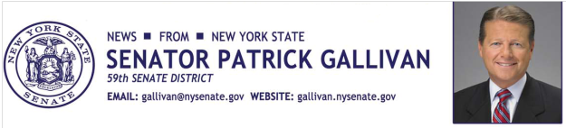

May 5, 2015
For Immediate Release
Contact: Jim Ranney
716.656.8544
716.256.9001

SENATOR GALLIVAN PRESENTS LIVINGSTON COUNTY WOMAN WITH PRESTIGIOUS AWARD

Elizabeth Sherwood Honored as “Woman Of Distinction”

ALBANY, NY - Senator Patrick M. Gallivan (R-C-I, Elma) honored Elizabeth “Betsy” Sherwood of Caledonia on Tuesday with one of the New York State Senate’s highest honors, the “Woman of Distinction” award. Sherwood is being recognized for her work in the community as a lifelong resident and president of the non-profit organization Focus on the Children.

“Betsy brings both compassion and enthusiasm to everything she does,” Gallivan said. “Her dedication to the children of Livingston County is inspirational and she serves as a role model by making our community a better place to live.”

It was Sherwood’s father, Robert B. Jones, CEO of Jones Chemical, and Merl Galusha, pastor of United Presbyterian Stone Church, who established Focus on the Children in 1993. Sherwood helped in creating the non-profit organization’s board, mission statement and constitution. She is currently president of the organization which serves children in need throughout Livingston County.

Sherwood is active throughout the community, having served as a deacon at United Presbyterian Church in Caledonia and helping to establish the PTA chapter at Caledonia-Mumford High School.

“I am truly honored and humbled by this unexpected award,” Sherwood said. I want to thank Senator Gallivan and the hundreds of people that I've had the privilege to work with at Focus on the Children, the church, and in our community. My accomplishments are only achievable because of the partnerships, and the generosity of others that have supported our endeavors to provide relief, outreach, and opportunity to the families and individuals we serve.”

Sherwood and her husband Tom have six children and numerous grandchildren.
Each year, the 63 members of the New York State Senate nominate one individual from their district to be enshrined alongside the many historical women whose contributions have had a positive impact on our state. Some of these trailblazing females include: Susan B. Anthony, Lucille Ball, Harriet Tubman, and Emma Willard, among others, all with strong links to New York State.
“This designation is an opportunity to honor and recognize contemporary women for their achievements and to thank them for the pride and dedication they bring to our communities,” Gallivan said.
Senator Gallivan presented Sherwood with the “Woman of Distinction” award at a special ceremony in the Senate Chamber on Tuesday, May 5, 2015.

-30-

