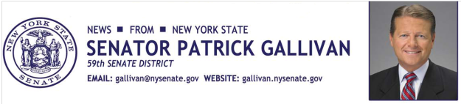
May 27, 2015
For Immediate Release
Contact: Jim Ranney
716-656-8544/716-256-9001

SENATOR GALLIVAN INTRODUCES LEGISLATION TO PROTECT INFORMATION CONTAINED IN MOTOR VEHICLE RECORDS

PERSONAL INFORMATION COULD NOT BE SHARED WITHOUT CONSENT

Senator Patrick M. Gallivan (R-C-I, Elma) has introduced legislation to better protect personal information collected by the Department of Motor Vehicles and contained in New York’s motor vehicle records. The bill (S-5668) would require the DMV to notify motorists before registration information is sold and provide individuals with a way to keep their personal information private. Exceptions would be made for instances related to motor vehicle warranties and safety recalls.

“Many people are probably not aware that the DMV often sells registration information to direct mail or other marketing agencies,” Gallivan said. “By requiring that individuals must give consent before their information is shared, we can better protect their privacy and potential identity theft. If people want to share the information collected by DMV, it should be their option.”

Under current law, the DMV is authorized to sell registration information, but it is limited to the name and address of the registered vehicle owner and basic vehicle information, including make, model, year, license number and vehicle identification number.

“I want to thank Senator Gallivan for his leadership and introducing legislation that protects motorists’ personal information from being sold by the DMV to third party interests without consent,” said Erie County Clerk Chris Jacobs. “As a former Law Enforcement Officer, Senator Gallivan is well aware of the concerns we all have today about identity theft and the general violation of personal privacy.”

The bill would still allow the DMV to share personal information for purposes relating to automobile warranties, safety recalls and statistical compilations. It has been sent to the Senate’s Transportation Committee for consideration.

-30-

